

Patrícia de Faria Pais Apura
Undergraduate in Molecular and Cell Biology

Controlling Gene Expression in Enterobacteriaceae: Studies on sRNAs and strategies for Synthetic Biology

Dissertation presented to obtain the Master Degree in Molecular, Genetics and Biomedicine

Supervisor: Doutora Cecília M. Arraiano,
Investigador Coordenador
Instituto de Tecnologia Química e Biológica
Co-supervisor: Doutora Sandra Viegas
Post-Doc Fellow
Instituto de Tecnologia Química e Biológica
Co-supervisor: Doutora Inês Silva
Post-Doc Fellow
Instituto de Tecnologia Química e Biológica

Members of the Jury:
President: Prof.ª Doutora Ilda Santos Sanches
Principal Examiner: Doutora Maria Teresa Crespo
Supervisor: Doutora Cecília M. Arraiano
[Título da Dissertação] (Tipo de letra: Arial, 10pt normal)
[Primeiro e último nome do candidato(a)] (Tipo de letra: Arial, 10pt normal)


March 2014

Patrícia de Faria Pais Apura
Undergraduate in Molecular and Cell Biology

Controlling Gene Expression in Enterobacteriaceae: Studies on sRNAs and strategies for Synthetic Biology

Dissertation presented to obtain the Master Degree in Molecular, Genetics and Biomedicine

Supervisor: Doutora Cecília M. Arraiano,
Investigador Coordenador
Instituto de Tecnologia Química e Biológica
Co-supervisor: Doutora Sandra Viegas
Post-Doc Fellow
Instituto de Tecnologia Química e Biológica
Co-supervisor: Doutora Inês Silva
Post-Doc Fellow
Instituto de Tecnologia Química e Biológica

Members of the Jury:
President: Prof.ª Doutora Ilda Santos Sanches
Principal Examiner: Doutora Maria Teresa Crespo
Supervisor: Doutora Cecília M. Arraiano
March 2014

“For every fact there is an infinity of hypotheses.”
-Robert M. Pirsig

Controlling Gene Expression in Enterobacteriaceae: Studies on sRNAs and strategies for Synthetic Biology

Copyright Patrícia de Faria Pais Apura, FCT/UNL, UNL

A Faculdade de Ciências e Tecnologia e a Universidade Nova de Lisboa têm o direito, perpétuo e sem limites geográficos, de arquivar e publicar esta dissertação através de exemplares impressos reproduzidos em papel ou de forma digital, ou por qualquer outro meio conhecido ou que venha a ser inventado, e de a divulgar através de repositórios científicos e de admitir a sua cópia e distribuição com objectivos educacionais ou de investigação, não comerciais, desde que seja dado crédito ao autor e editor.

Acknowledgments

Gostaria agradecer à comissão científica e organizadora do Mestrado em Genética Molecular e Biomedicina pela oportunidade proporcionada e pela excelência de ensino.
Agradeço à minha orientadora Prof. Dra. Cecília M. Arraiano por me ter dado a oportunidade de realizar esta dissertação de mestrado no seu laboratório, por todo o apoio, orientação, afeto e positivismo transmitido. Muito obrigada por tudo!
Fui uma privilegiada por ter trabalho ao longo deste ano sob a supervisão, não de uma, mas de duas pessoas espetaculares, a Dr. Sandra Viegas e a Dr. Inês Silva. Obrigada Sandra e Inês por toda a dedicação, orientação, todo o conhecimento que me transmitiram, toda a paciência, motivação, gargalhadas, carinho e amizade! Obrigada por todo o vosso apoio! Vocês são as maiores!
Agradeço também a todos os meus colegas de laboratório por me terem recebido tão bem, por todo o incentivo e ajuda que me deram. Um especial agradecimento à Susana Barahona, à Margarida Saramago, ao Ricardo Santos e ao Ricardo Moreira. Obrigada por toda a “galhofa” e companheirismo! Obrigada à Teresa Pinto por ter tornado esta minha jornada tão “doce”! E claro que não podia deixar de agradecer à Andreia Aires por todo o apoio que me deu, por toda a alegria e entusiasmo ao longo deste percurso, por todas as palavras amigas. Jamais o esquecerei!
Agradeço a todos os meus amigos que me acompanharam nesta etapa. À Rita, aos Diogos, à Teresa e à Daniela pela presença incansável, incentivo, pela confiança e momentos de diversão. À Gabriela Henriques por todos os momentos ao longo destes anos, toda a amizade, este percurso não seria o mesmo sem ti! Obrigada à Carolina Cassona, à Joana Viana e à Andreia Pimenta por toda a força e ânimo que me deram ao longo deste ano.
Agradeço às minhas irmãs, Sofia Torres e Madalena Torres, por estarem sempre presentes em todos os momentos mais marcantes da minha vida, pelo apoio incondicional e pela amizade constante!
Agradeço ao meu namorado João Guerreiro por me aturar ao longo deste anos, por estar sempre do meu lado, por ser uma pessoa com quem posso sempre contar. És mesmo muito importante! Obrigada por tudo!
Às pessoas da minha vida, a minha família! À minha mãe e ao Carlos, quero agradecer tudo o que me proporcionaram, por nunca terem deixado de acreditar em mim mesmo quando eu já não o acreditava, por estarem sempre comigo! Quero agradecer ao meu pai todos os conselhos, encorajamento e apoio. Ao meu irmão por todas as brincadeiras. E aos meus avós: Maria João, José e Francisco pelo carácter, entusiasmo e carinho! À minha avó Rosebelle, que mesmo ausente, me guiou sempre ao longo deste percurso.

Abstract

Transcriptional and post-transcriptional control of gene expression dictate the levels of proteins in the cell. Therefore the modulation of gene expression can have important consequences for biotechnological and/or pharmaceutical purposes. Among the types of cellular RNAs, small RNAs (sRNAs) have been an emerging class of bacterial gene expression regulators, which mostly act by base-pairing with one or more mRNA target(s) affecting their translation and/or their stability. Here, we focus on the study of SraL sRNA, more specifically in the validation of putative targets for this sRNA obtained in a previous transcriptomic analysis. Until now SraL was only shown to regulate the mRNA levels of Trigger Factor, an important protein chaperone. The information here reported give strong evidence for SraL involvement in the cysteine biosynthetic pathway, which requires further investigation. Nevertheless, our results could not provide a validation of those putative targets previously obtained by transcriptomic analyses.
Optimization of protein expression requires not only an increase of the stability of mRNA transcripts but also an optimal behavior of function-encoding DNA segments, which are often context-dependent. Building on the work of others, we have designed a set of combinatorial promoters and 5’UTRs and evaluated their effects/outcomes using Superfolder GFP as reporter. Our data shows a clear variability of protein levels within our set of constructs. The highest levels of protein were associated with the implementation of an insulation sequence flanking the promoter region and the introduction of 5’ stabilizing structures at the mRNA level. Further investigation concerning the alteration of the rate of the mRNA decay by depletion of the function of participating nucleases, might constitute an advantageous approach. The knowledge collected will be extremely important to design robust modules which substantially increase protein production.
This field is rapidly growing and much remains to be discovered about these important regulatory processes.

Keywords: small RNAs, gene expression, synthetic biology, transcriptional control, post-transcriptional control.

Resumo

O controlo transcricional e pós-transcricional da expressão génica é responsável regulação dos níveis proteicos da célula. Como tal, a modelação da expressão génica poderá trazer importantes consequências biotecnológicas e /ou farmacêuticas. Entre os RNAs celulares, os pequenos RNAs (sRNAs) têm constituído uma classe promissora de reguladores da expressão génica bacteriana, os quais principalmente modulam a tradução ou a estabilidade de alvos por emparelhamento com as sequências de mRNA. Aqui, neste trabalho focámo-nos no estudo do SraL sRNA, mais especificamente na validação de resultados anteriormente obtidos por análise transcritómica. Até hoje só foi identificado um alvo deste sRNA, a chaperona Trigger Factor, cujos níveis de mRNA são regulados pelo SraL. A informação aqui fornecida aponta para uma possível regulação por parte do SraL na via biossintética da cisteína, o que ainda requererá estudos posteriores. Contudo, os resultados reportados não conseguiram validar os anteriormente indicados pela análise transcritómica.
A otimização de níveis proteicos requer não só um aumento na estabilidade do transcrito de RNA mas também depende do comportamento dos elementos funcionais de DNA, os quais são frequentemente influenciados pelo contexto genético em que são inseridos. Com base em trabalhos anteriores, desenhámos um conjunto de promotores e 5’UTRs e avaliámos os seus efeitos/consequências na produção de uma proteína repórter, a Superfolder GFP. Os nossos resultados mostram com clareza as diferenças nos níveis de proteína obtidos para todas as construções, sendo que níveis mais elevados de proteína estão associados à presença de sequências flanqueadoras da região do promotor e à introdução de estruturas estabilizadoras a 5’ do mRNA. Investigações futuras referentes à alteração da taxa de degradação do mRNA por depleção da função de nucleases participativas, poderá revelar-se numa abordagem vantajosa.
Esta área está em desenvolvimento e muito ainda permanece por descobrir acerca destes processos regulatórios.

Palavras-chave: pequenos RNAs, expressão génica, biologia sintética, controlo transcricional, controlo pós-transcricional.

Table of contents
Acknowledgments v
Abstract vii
Resumo ix
Table of contents xi
Index of Figures xiii
Index of Tables xiv
Abbreviations xv
1. Introduction 3
1.1. Reading the Genome 3
1.2. Post transcriptional Regulation 4
1.3. sRNAs in Salmonella Typhimurium 12
1.4. Synthetic Biology 14
1.5. Aim of this thesis 16
2. Materials and Methods 19
2.1. Oligonucleotides 19
2.2. Bacterial strains and plasmids 19
2.3. Bacterial growth 20
2.4. Preparation of E. coli Competent Cells 20
2.5. Preparation of Salmonella Electro-competent cells 20
2.6. Transformation of E. coli competent cells 21
2.7. Transformation of Salmonella electro-competent cells 21
2.8. RNA extraction 21
2.9. Northern blot 22
2.9.1. Polyacrylamide 22
2.9.2. Agarose 22
2.10. Northern blot 22
2.11. Reverse-Transcription Polymerase Chain Reaction (RT-PCR) 23
2.12. P22 phage cell transduction 23
2.13. Colony PCR 24
2.14. Plasmid constructions 25
2.15. Growth of bacteria and measurement of GFP expression 29
2.16. Growth curves 30
2.17. Fluorescence Microscopy 30
3. Results 35
3.1. Analysis of SraL putative targets by RT-PCR and Northern blot 35
3.2. Quantifying elements context effects 43
4. Discussion and conclusions 53
4.1. Exploring the role of SraL sRNA 53
4.2. Synthetic Biology 54
References 61

Index of Figures

Figure 1.1 – Model of the general degradation mechanisms of Gram-negative bacteria.. 8
Figure 1.2 – Structure of trans-encoded base-pairing srnas. 11
Figure 1.3 – Regulatory outcomes from srna base pairing.. 11
Figure 1.4 – S. Typhimurium sral srna structure 12
Figure 1.5 – Map of sral RNA.. 13
Figure 1.6 - Organization of a bacterial mrna. 14
Figure 1.7 – Foundations of synthetic biology. 14
Figure 1.8 - Optimization of gene expression systems by genetic engineering. 15
Figure 3.1.2- RNA integrity.. 37
Figure 3.1.3 – Analysis of sral srna expression.. 38
Figure 3.1.4 - Analysis of sral putative targets by RT-PCR. 39
Figure 3.1.5 - Analysis of cysjih operon by RT-PCR. 40
Figure 3.1.6 – Analysis of sral putative targets by Northern blot.. 41
Figure 3.1.7 – Analysis of sral putative targets by RT-PCR and Northern blot.. 42
Figure 3.2.1 – Composition of the different constructs. 43
Figure 3.2.2 - Culture fluorescence of strains bearing the different constructs. 44
Figure 3.2.3 – Growth curves of the different constructs 45
Figure 3.2.5 – Estimation of bacterial fluorescence/OD₆₀₀ of the combinatorial library.. 46
Figure 3.2.6 – Fluorescence monitorization of the different constructs. 47
Figure 3.2.7 - Composition of the different constructs bearing the 5’ stem-loop.. 48
Figure 3.2.8 - Growth curves of the different constructs. 48
Figure 3.2.9 - Colony fluorescence of strains bearing the different constructions.. 49
Figure 3.2.10 - Total fluorescence levels of the indicated constructions.. 49
Figure 3.2.11 - Total fluorescence levels of the all the constructions. 50

Index of Tables

Table 2.1 – Strains used in this work 19
Table 2.2 – Plasmids used in this work 20
Table 2.3 – PCR Program for the 16S rrna gene analysis 23
Table 2.4 – PCR Program for the RT-PCR reaction 23
Table 2.5 – Reaction mix used in Colony PCR reaction 24
Table 2.6 - PCR Program for the Colony PCR 25
Table 2.7 – Master mix used in PCR amplification of plasmid constructions 26
Table 2.8 – PCR Program used in plasmid constructions 27
Table 2.9 – Digestion with spei restriction enzyme 27
Table 2.10 – Double digestion with spei and smai restriction enzymes 27
Table 2.11 – Ligation reaction of the digested inserts and the double digested pseva121. 28
Table 2.12 – Ligation Reaction of ompa constructs. 28
Table 2.13 - Primer sequences used for sequencing. 29
Table 2.14 – Digestion of the promotorless E. Coli MG1655 strain, control plasmid. 29
Table 2.15 – Recircularization Reaction of the vector pseva121-pgfpcontrol. 29
Table 2. 16 – List of oligonucleotides used in this work.. 30
Table 2.17 – Medium, Solutions and Buffers. 31
Table 3.1.1 – List of the putative targets selected by the analysis of the transcriptome. 36

Abbreviations

A Adenine
APS Ammonium persulfate
ATP Adenosine triphosphate
BB BlueBromophenol
CDS Coding Sequence
Cm Chloramphenicol
CTP Cytidine triphosphate
ddH₂O Double-distilled water
DNase Deoxyribonuclease
E. coli Escherichia coli
EtOH Ethanol
EDTA Ethylenediamine tetraacetic acid
GFP Green Flourescence Protein
GOI Gene of Interest
GTP Guanosine triphosphate
IGR Intergenic Region
IVS Intervening sequence
MOPS 3-(N-morpholino)propanesulfonic acid
mRNA messenger RNA
nts Nucleotides
o/n Overnight
OD₆₀₀ Optical Density at 600nm
PAPI Poly(A) Polymerase I
PCR Polymerase chain reaction
PNK T4 polynucleotide kinase
PNPase Polynucleotide Phosphorylase
rATP Ribonucleotide ATP
RBS Ribosome binding site
rCTP Ribonucleotide CTP
rGTP Ribonucleotide GTP
RhlB DEAD-box RNA helicase
RNase Ribonuclease
rNTP Ribonucleotide
rpm Rotation per minute
RppH RNA pyrophosphohydrolase
rRNAs Ribossomal RNA
RT Room Temperature
RT-PCR Reverse transcription - Polymerase chain reaction
rUTP Ribonucleotide UTP
S. Typhimurium Salmonella Typhimurium
SD Shine-Dalgarno
SDS Sodium Dodecyl Sulphate
SOB Super Optimal Broth
SOC Super Optimal broth with Catabolite repression
SPI Salmonella pathogenicity island
sRNA small RNA
SSC Saline Sodium Citrate
T3SS Type-3-Secretion System
TAE Tris-acetate-EDTA
TBE Tris-borate-EDTA
TEMED Tetramethylethylenediamine
TF Trigger factor
tmRNA Transfer messenger RNA
tRNA Transfer RNA
U Uracil
UTP Uracil triphosphate
UTR Unstranslated Region
UV Ultra-violet ray
XC Xylene cyanol
w/v Weight/volume

Introduction

Introduction

Reading the Genome

The DNA-encoded information in the genome has to be translated following the correct instructions to produce the constituents of the cell, their biochemical properties and ultimately the distinctive features of each species.

Transcription

The first step in decoding the genome is a process called transcription in which an RNA molecule is synthesized using a specific DNA segment as a template. The accuracy of this process relies on the recognition by RNA polymerase of the sites of transcription start and transcription stop. The initiation of transcription represents an important point in gene expression control, since it constitutes the primary step at which transcription is regulated. The bacterial RNA polymerase core enzyme is a multisubunit complex that synthesizes RNA using a DNA template as a guide. A separable subunit called sigma (σ) factor associates with the core enzyme, helping it to find the start initiation signal in the DNA sequence (Ross et al., 1993). There are many σ factors in bacteria that allow the recognition of different sets of promoters (Browning and Busby, 2004). The bacterial core enzyme together with sigma (σ) factor are designated as the RNA polymerase holoenzyme and this complex slides along the DNA molecule until it finds a region called promoter, which indicates the starting point for RNA synthesis (Alberts et al., 2002). The synthesis of RNA is always made in the 5′ to 3′ direction. Upon the transcription of the terminator it is originated an RNA structure that destabilizes the polymerase’s hold on the RNA, allowing the release of the newly made RNA molecule and the DNA template. The free RNA polymerase can then reassociate with an σ factor for another round of transcription (Alberts et al., 2002).

The RNA World

For many years RNA molecules were viewed as simple carriers that would convert genetic information contained in DNA into proteins. The signs of their versatility only became unravelled in the early 1990s, when biologists discovered the small non-coding RNA (sRNA) molecules that control the expression of several genes (Krol et al., 1990; Napoli et al., 1990). Nowadays, RNA is recognized as the central molecule in gene expression in all domains of life.
The RNA molecule has unique characteristics that support its crucial and specific role in the cell activities. These characteristics are related to its 2’-OH group on ribose, which contributes to its unsteadiness of structure, and to the lack of a complementary strand, which allows it to adopt some particular secondary and three-dimensional conformations. RNAs can have structured-based functions, such as tRNAs, or provide distinct catalytic properties, as demonstrated by ribosomes, RNase P, self-splicing introns and even the spliceosome. Both the single structure and the chemically reactive nature of RNA make it well suited to function as a transient messenger or to serve as a substrate for maturation reactions. The control of RNA synthesis, processing and degradation is essential for cells in order to avoid undesired depletion of functionally important molecules (Arraiano et al., 2013).

mRNA Metabolism

Contrarily to what is found in eukaryotic cells, the absence of compartmentalization in bacteria lead to a coupling in time and space of transcription, translation and even mRNA degradation, making these organisms capable to rapidly respond to external and internal stimuli very quickly. This is fundamental to bacteria, since they need to rapidly adapt, survive and develop in a constant challenging environment.
Considering the mRNA as the interplay between genes and proteins, its rapid degradation constitutes one of the major points of gene regulation in prokaryotic organisms. Consequently, the RNA degradation process is crucial for controlling the steady-state levels of gene expression. The fact that degradation directly affects protein synthesis by restraining the amount of mRNA available for translation, allows the regulation of mRNA decay and can provides an effective way to promptly change protein synthesis. The rate of decay of an mRNA molecule can be determined by its half-live, which in prokaryotic cells has an average shorter than 10min. The different half-lives of an mRNA molecule are related to its physiological role, its genetic localization, to the presence/absence of structured elements and to environmental and development signals (Arraiano et al., 2010; Bernstein et al., 2002; Selinger et al., 2003).
After the synthesis of an mRNA molecule, it is subjected to post-transcriptional regulation mechanisms. In bacteria, these mechanisms can act independently, but in parallel, and target different sites with different efficiencies. Several factors are determinant for the accessibility of RNAs for post-transcriptional regulation, such as the RNA structure, protection by translating ribosomes and polyadenylation status.

Post transcriptional Regulation

Ribonucleases

Ribonucleases (RNases) are enzymes essential for the biogenesis, processing and turnover of all types of RNAs, including sRNAs, tRNAs and rRNAs (Viegas and Arraiano, 2008). These enzymes act together establishing a global regulatory network, which controls, monitors and adapts the RNA levels to the cell demands. Some exhibit a functional overlap and can be replaced by other RNases and others are indispensable. RNases can act by themselves or they can cooperate in RNA degradation complexes. Additionally, they play an extremely important role in cellular metabolism, in the recycling of ribonucleotides for the synthesis of new RNA molecules, and also carry out surveillance, by promoting the destruction of aberrant RNAs (Arraiano et al., 2010).
There are several factors that can influence the decay mechanism: the RNA sequence/structure that might act as a stabilizer or destabilizer element to specific RNases; the presence of ribosomes during active translation which might protect some RNA loci vulnerable to RNases; the polyadenylation status, since poly(A) stretches are the preferred substrate for several RNases; trans-acting factors (e.g. Hfq) that when bound to the RNA might expose or hide RNA sites that are preferential targets for RNases; other factors like helicases that can act in trans and contribute to RNA degradation by unwinding RNA structures and making RNA molecules more accessible to RNases (Arraiano et al., 2010; Evguenieva-Hackenberg and Klug, 2011).
Ribonucleases can be classified according to the type of reaction catalyzed: endoribonucleases that cleave RNA molecules internally and exoribonucleases that cleave the RNA through one of its extremities. Additional aspects can be considered such as the capability of these enzymes to cleave single and/or double stranded RNA, the nature of the products released, the specificity of the enzyme for substrates with a define shape and/or sequences, their ability to digest DNA besides RNA, and their processive or distributive action in cells (Arraiano et al., 2013).
The number of ribonucleases identified has increased in the last years and much remains to be understood.

Endoribonucleases

Endoribonucleases were initially identified by their involvement in the maturation of tRNA and rRNA precursors, being later also implicated in the mRNA decay process (Condon and Putzer, 2002). They are usually the initiators in the degradation process by promoting the initial endonucleolytic cleavage of the target RNA molecule. The major endoribonucleases involved in RNA degradation in Gram-negative bacteria are presented below:

- RNase E
- It is essential for cell survival and catalyzes the cleavage of A/U-rich single stranded regions of RNA, yielding a 5’-monophosphorylated products. RNase E plays a central role in the processing of rRNA (Apirion and Lassar, 1978; Li et al., 1999; Misra and Apirion, 1979), tRNA (Ow and Kushner 2002), tmRNA (Lin-Chao et al., 1999) and the M1 RNA component of the RNase P ribozyme (Ow and Kushner, 2002). It is also involved in the initiation of decay of non-coding RNAs and mRNAs (Arraiano et al., 2010; Kaberdin et al., 2011);
- RNase G
- It is a paralogue of RNase E, being dispensable for cell viability. It has a cleavage preference for the same regions as RNase E. It is also involved in the degradation and processing of RNA, like the precursor 16S rRNA gene (Carpousis et al., 2009; Wachi et al., 1999). Finally, it seems to have a role in the regulation of central metabolism (Lee et al., 2002; Sakai et al., 2007);
- RNase III
- It is widely distributed between prokaryotic and eukaryotic organisms with structural and functional resemblance. In bacteria it is not essential though its lack leads to a slow-growth phenotype (Nicholson, 1999). It is a specific double-stranded RNA endoribonuclease that generates a 5’-monophosphate and a 3’-hydroxyl terminus. This enzyme is involved in the maturation of tRNA precursors and rRNA, in the processing of 16S and 23S from a 30S rRNA gene precursor and also in the decay of several mRNA species (Babitzke et al., 1993). In Salmonella and other members of Alphaproteobacteria RNase III is also responsible for the cleavage of the intervening sequences (IVS) found in the 23S rRNA gene (Evguenieva-Hackenberg and Klug, 2000);

Exoribonucleases

Exoribonucleases are enzymes that catalyze the degradation of RNA molecules by removing terminal nucleotides from one extremity. In E. coli they act only in the 3’-5’ direction, whereas in B. subtilis there are 5’-3’ exoribonucleases. They generally act on the endonucleolytic breakdown products by promoting their exonucleolytic digestion. The activity of the 3’-5’-exoribonucleases is promoted by the 3’-polyadenylation of the RNA substrates whereas the activity of 5’-3’ enzymes is stimulated by the monophosphorylated state of the 5’-end. The major exoribonucleases involved in RNA degradation are presented below:

- PNPase
- It is not essential for cell survival at optimal temperature, unless either RNase II or RNase R is also missing. However, it becomes essential for growth at low temperatures (Luttinger et al., 1996; Piazza et al., 1996; Zangrossi et al., 2000). PNPase catalyzes the 3’-5’ phosphorolytic degradation of RNA, releasing nucleoside 5’-diphosphates. Its activity is stalled by the presence of secondary structures on RNA molecules (Spickler and Mackie, 2000); this problem can be overcome when acting with other proteins. A minimal 3’-overhang of 7-10 unpaired ribonucleotides is required by PNPase for binding to an RNA molecule (Py et al., 1996). PNPase also possesses the ability to add A-rich heteropolymeric tails to the 3’-hydroxyl termini of RNA molecules (Mohanty and Kushner, 2000a);
- RNase II
- It is not essential for cell survival, unless PNPase is also missing. RNase II has a sequence-independent hydrolytic exonuclease activity that degrades RNA in the 3’-5’ direction, producing 5’-nucleoside monophosphates. Like PNPase, the activity of RNase II is also blocked by secondary structures on the RNA molecules (Cannistraro and Kennell, 1999; Spickler and Mackie, 2000). This enzyme has a major preference for homopolymeric poly(A) rich substrates which might result in the protection of some RNAs from degradation by impairing the access to other exoribonucleases (Coburn and Mackie, 1996; Folichon et al., 2005.; Hajnsdorf et al., 1994; Marujo et al., 2000; Mohanty and Kushner, 2000b; Pepe et al., 1994). It is involved in the processing of tRNA precursors and in the decay of unstructured RNAs (Arraiano et al., 2010; Kaberdin et al., 2011);
- RNase R
- It is not essential for cell survival. RNase R is a 3’-5’ hydrolytic exoribonuclease and has the ability to degrade highly structured RNAs (Awano et al. 2010; Cheng and Deutscher, 2002, 2003). Its activity is dependent on a single stranded 3’-overhang and possesses both exoribonuclease and helicase activity. It is involved in the degradation of defective tRNAs and rRNAs (Awano et al. 2010; Cheng and Deutscher, 2003). Together with PNPase, RNase R eliminates aberrant fragments of the 16S and 23S rRNA genes (Arraiano et al., 2010; Kaberdin et al., 2011);
- Oligoribonuclease
- It is essential for cell viability since it is responsible for the elimination of the short oligoribonucleotides that result from the degradation process of the other ribonucleases (Niyogi and Datta, 1975; Stevens and Niyogi, 1967). Thus, it is seen as a “finishing enzyme”. Its activity is processive in the 3’-5’ direction and it has a preference for 5-mer oligoribonucleotides. It requires a 3’-OH end and is not sensitive to the 5’-phosphorylation state of the RNA (Datta and Niyogi, 1975);

Ancillary RNA-modifying enzymes

In addition to these major degrading enzymes, a number of ancillary RNA-modifying enzymes also contribute to the RNA turnover.
- RppH
- It is not essential for cell viability. This RNA pyrophosphohydrolase catalyzes the removal of pyrophosphate groups from the 5’-end of triphosphorylated single-stranded RNAs. It promotes the endonucleolytic cleavages of transcripts by other ribonucleases by promoting the formation of 5’-monophosphorylated products (Celesnik et al., 2007; Deana et al., 2008);
- Poly(A) Polymerase I (PAPI)
- Catalyzes the addition of homopolymeric poly(A) tails to 3’-hydroxyl termini of RNA molecules using ATP as a substrate. Thus, it facilitates the 3’-5’ exonucleolytic decay of structured RNAs (He et al., 1993; Mohanty and Kushner, 1999; O’Hara et al., 1995; Xu and Cohen, 1995; Xu et al., 1993);
- DEAD-box helicases
- They unwind the double-stranded RNAs in an ATP-dependent manner. Contribute to the destabilization of structured RNAs facilitating their degradation by exoribonucleases (Arraiano et al., 2010; Kaberdin et al., 2011).
Figure 1.1 – Model of the general degradation mechanisms of Gram-negative bacteria. This process usually begins with an endonucleolytic cleavage by RNase E, if the substrate has a 5’-monophosphorylated terminus, or RNase III, if the substrate is double-stranded or structured. RNase E cleavage is favoured by the RNA pyrophosphohydrolase RppH, which converts the 5’-triphosphorylated terminus of primary transcripts to monophosphate. Some substrates are cleaved by RNase E regardless of the 5’-phosphorylation status, through an alternative pathway called ‘bypass’ or ‘internal entry’, which involves the direct entry of RNase E at single-stranded sites. After endonucleolytic cleavage, breakdown products are subjected to exonucleolytic digestion by any of the three main exonucleases in this bacterium, RNase R, RNase II or PNPase. Exonucleolytic activity is promoted by the 3’-polyadenylation of substrates. A second alternative pathway is the direct exonucleolytic degradation of full length transcripts (represented by a dashed arrow). Exonucleolytic degradation releases short fragments which are subsequently degraded to mononucleotides by oligoribonuclease. Adapted from (Silva et al., 2011).

The Degradosome

As mentioned above, RNases can act by themselves or in complexes. In bacteria, it was identified a large multiprotein complex, denominated degradosome, that is involved in RNA degradation. The components of the degradosome seem to act in a cooperative way towards RNA decay and their association contributes to the coordination of the endo- and exoribonucleolytic cleavage (Bandyra et al., 2012). In E. coli, the degradosome is composed by four major protein components, the RNA degradation enzymes RNase E and PNPase (Carpousis et al., 1994), as well as the ATP-dependent RNA helicase B (RhlB) and the glycolytic enzyme enolase (Py et al., 1996). The carboxyl-terminal half of RNase E serves as a scaffold for the degradosome assembly (Vanzo et al., 1998).
The composition of the degradosome can suffer changes depending on the conditions of growth or stress (Gao et al., 2006).

Small RNAs

In the last decade, sRNAs have gained special importance due to their involvement in post-transcriptional regulatory mechanisms, in both eukaryotic and prokaryotic cells (Viegas and Arraiano, 2008; Waters and Storz, 2009, Saramago et al., 2014). In the global scenario of RNA turnover, they have become an important factor to consider, since the degradation of specific mRNAs can be triggered from their action. In prokaryotes, these RNAs range from 50 to 500 nucleotides in length (Gottesman and Storz, 2010), they are generally untranslated and can be found in the intergenic regions (IGRs) of bacterial chromosomes (Sharma, 2005).
sRNAs are generally divided in two classes: the ones that modulate protein activity and the sRNAs that base-pair with the mRNA target.

Modulators of protein activity

These sRNAs act by mimicking secondary structures of other nucleic acids (Gottesman and Storz, 2010). They interact with proteins in order to regulate their activity, usually by sequestering them from normal targets. Since they work by mimicry, the sRNA contains several repetitions of the protein recognition site on its sequence (Storz et al., 2011). An example of this type of sRNAs is the CsrB and CsrC that form a regulatory feedback loop with the global post-transcriptional regulator CsrA by binding and consequently controlling the active pool of this protein (Babitzke and Romeo, 2007). Another well-known example is the E. coli 6S RNA, which was found to tightly bind and inhibit the housekeeping form of the RNA polymerase (σ⁷⁰-RNAP) by changing the holoenzyme’s promoter recognition sequence (Wassarman, 2007).

Base-pairing sRNAs

The most common are the sRNAs that act by base pairing with one or more target mRNAs, called antisense RNAs (Gottesman and Storz, 2010). The first report of the existence of an antisense RNA was made in plasmids, in which the sRNAs were found to modulate the expression of genes involved in replication and stable plasmid inheritance (Stougaard et al., 1981; Tomizawa et al., 1981). Antisense RNAs are diffusible and highly structured molecules that bind to target RNAs (sense RNAs) and consequently regulate their gene expression (Brantl, 2007). These groups of sRNAs are classified in cis- and trans- according to their relative genomic localization regarding its mRNA target(s).

Cis-encoded sRNAs

The cis-encoded sRNAs are transcribed from the opposite strand of their target and thus bind to it with a perfect and extensive complementarity. They were seen to be involved in the control of the basal expression levels of potential toxic proteins (Fozo et al., 2008; Gerdes and Wagner, 2007), in the direct cleavage of their target such as the E. coli GadY RNA (Opdyke et al., 2004), biofilm formation and motility (Caldelari et al., 2013; Gottesman and Storz, 2010) and replication of plasmids, such as the antisense RNA CopA (Givskov and Molin, 1984; Stougaard et al., 1981). This type of sRNAs was also found to be associated with the regulation of virulence, with bacteriophages and transposons and a growing number is being found to be encoded in the bacterial chromosome (Brantl, 2007; Thomason and Storz, 2011).

Trans-encoded sRNAs

The most well studied regulatory sRNA molecules are those that act by base pairing with partial complementarity with their target RNAs, referred as trans-encoded, since they are encoded on a genomic location different from their targets. Considering that trans-encoded sRNAs interact by short and imperfect base-pairing with their targets they are usually involved in multiple regulations. Many of the trans-encoded sRNAs require the RNA chaperone Hfq for target base-pairing. They are normally induced under specific growth conditions ranging from limiting iron (Fur-repressed RyhB sRNA), oxidative stress (OxyR-activated OxyS sRNA), outer membrane stress (σ^{E}-induced MicA and RybB sRNAs), elevated glycine (GcvA-induced GcvB sRNA), high glucose-6-phosphate concentrations (SgrR-activated SgrS sRNA) and glucose starvation (CRP-repressed Spot42 sRNA and CRP-activated CyaR sRNA) (Görke and Vogel, 2008; Storz et al., 2004; Gottesman, 2005; Papenfort and Vogel, 2009). All these characteristics raised large expectations about their involvement in almost every global response in bacteria.
These base-pairing sRNAs have similarities to eukaryotic microRNAs and small interfering RNAs since they share the ability to modulate mRNA stability and translation. They are usually transcribed as single transcripts of around 100 nucleotides in length, and they are generally not processed. The majority of the bacterial sRNAs known base pair with the target mRNA in its 5’ untranslated region (5’UTR), although some later discoveries point out sRNAs, that base pair with the coding sequence of their target mRNA, such as MicC sRNA / ompD mRNA (Pfeiffer et al., 2009). Additionally, the bacterial sRNAs act stoichiometrically, being degraded along with the mRNA after pairing. For an effective pairing between sRNAs and mRNA it is usually involved a seed region of 6-8 contiguous base pairs, despite longer pairing regions had been described (Gottesman and Storz, 2010).
Trans-encoded sRNAs generally present a structure composed of three different domains (Figure 1.2). The first domain, usually called seed region, is highly conserved and is responsible for the base-pairing to the target RNA(s); the second domain corresponds to the binding site for Hfq; and the third domain is a structured 3’-end followed by poly(U) which promotes the Rho-independent transcription termination and protects the sRNA against 3’-exonucleases (Storz et al., 2011). This poly(U) region can be also recognized by Hfq, possibly serving as a loading site (Otaka et al., 2011; Sauer and Weichenrieder, 2011).

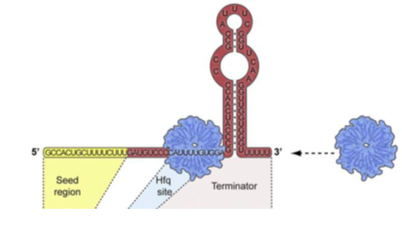
Figure 1.2 – Structure of trans-encoded base-pairing sRNAs. Adapted from (Storz et al., 2011).

The regulatory outcomes that result from sRNAs base pairing with mRNAs are diverse (see Figure 1.3). The interaction between the sRNA and its target mRNA can result in prevention or activation of translation via blocking or promoting the ribosome binding to mRNAs, and also can lead to degradation or stabilization of mRNAs by increasing or decreasing accessibility to ribonucleases, the enzymes responsible for the processing and turnover of sRNAs (Storz et al., 2004). These outcomes have physiological impact on bacteria such as repression of outer membrane protein synthesis, remodeling of metabolism and modulation of the synthesis of key transcription factors.
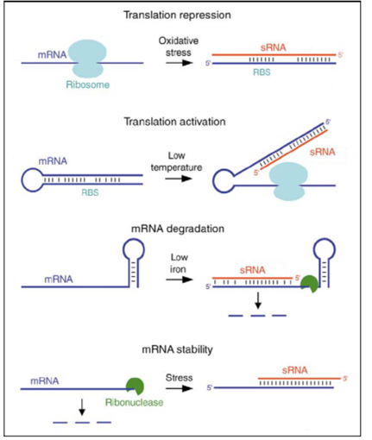

Figure 1.3 – Regulatory outcomes from sRNA base pairing. sRNAs represented in red and mRNA targets represented in blue. Adapted from (Storz et al., 2004).

sRNAs in Salmonella Typhimurium

Salmonella Typhimurium is an attractive model for RNA research. This Gram-negative bacterium has an evolutionarily close relationship with E. coli and possesses many pathogenic-specific aspects. As previously described, small non-coding RNAs have been recognized as crucial components of the post-transcriptional regulatory mechanisms. Many of the sRNAs known in Salmonella were originally identified in E. coli, providing identical functions in conserved general pathways or acquiring new ones more suitable to the pathogenic lifestyle of this organism (Vogel, 2009). This bacterium harbors large gene cassettes within its chromosome that are called Salmonella Pathogenicity Island (SPI). SPI-1 and SPI-2 constitute the major virulence regions, both encoding the type III secretion systems (T3SS). SPI-1 encodes a T3SS-1 that translocate bacterially-encoded proteins into the host cell cytosol, which promote the internalization of the bacteria by endocytosis (Galán and Curtiss, 1989); and SPI-2 encodes a second type of secretion system T3SS-2 known to play key roles in intracellular survival of Salmonella in macrophage and for systemic disease (Ochman et al., 1996; Shea et al., 1996). The need for so many virulence determinants is thought to reflect the complex interactions of Salmonella with the infected host. Additionally, bacterial survival in the host appears to result from a delicate balance of many gene products acting at the correct time in the correct location.
The first part of this work is focused on the Salmonella SraL sRNA. In the last years, the incoming of new RNomic techniques has brought the opportunity of the discover of new sRNAs. One of them was the SraL sRNA, also known as RyjA (Figure 1.4).

Figure 1.4 – S. Typhimurium SraL sRNA structure predicted by the Mfold program. Adapted from (Silva et al., 2013).

This antisense sRNA is composed by 140 nucleotides and was firstly reported in 2001 by two independent extensive genetic studies in E. coli, in which a combination of comparative genomics and microarrays allowed the identification of novel sRNAs (Argaman et al., 2001; Wassarman et al., 2001). Later, this sRNA was also identified in Salmonella enterica serovar Typhimurium (Viegas et al., 2007). SraL sRNA is localized between the genes encoding SoxR and a putative glutathione S-transferase (STM4267) but it is transcribed in the opposite strand (Figure 1.5). It is expressed in cells upon entry into stationary phase (Argaman et al., 2001; Viegas et al., 2007; Wassarman et al., 2001), being most prevalent in late stationary phase. In addition, its expression was also highly detected under Salmonella-pathogenicity island-2 (SPI-2) inducing conditions, indicating a possible role of this sRNA in Salmonella virulence, more specifically, upon internalization of Salmonella into host cells (Silva et al., 2013; Viegas et al., 2007).
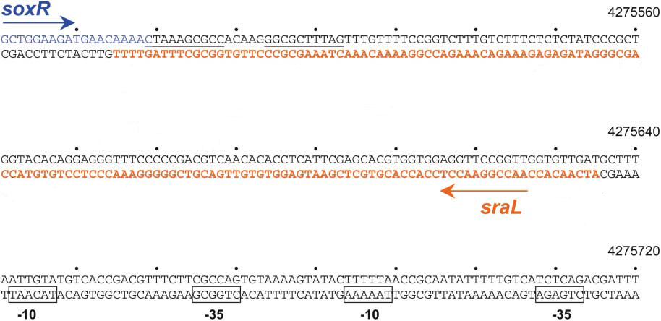
SraL is also expressed in the intracellular environment of S. Typhimurium persisting inside eukaryotic cells (Ortega et al., 2012).

Figure 1.5 – Map of SraL RNA. Orange color indicates the DNA sequence of SraL RNA and the blue color indicates the soxR mRNA. Adapted from (Argaman et al., 2001).

Through the use of several Salmonella ribonucleases mutants, this sRNA was shown to be post-transcriptionally controlled by RNases like PNPase and the degradosome complex (Viegas et al., 2007). Besides, PAP I seems to be also involved in the control of the stability of this sRNA (Viegas et al., 2007), which is in agreement with previous 3’-RACE studies where the presence of 3’ A-tails of different lengths in the E. coli SraL transcript was detected (Argaman et al., 2001). In a recent work, RpoS was identified as the transcriptional regulator of this sRNA in Salmonella (Silva et al., 2013).
The biological role of SraL was only very recently discovered. In the work developed by Silva et al., the authors unveiled one SraL target, the Trigger Factor (TF). This is one of the three major cytosolic chaperone proteins found in eubacteria that is involved in protein folding and it is the only ribosome associated chaperone known in bacteria. By mutational analysis, they showed that SraL represses tig mRNA through a short stretch of complementarity in the tig 5’UTR near the Shine-Dalgarno region. This report constitutes the first link between sRNA and protein folding (Silva et al., 2013).

Synthetic Biology

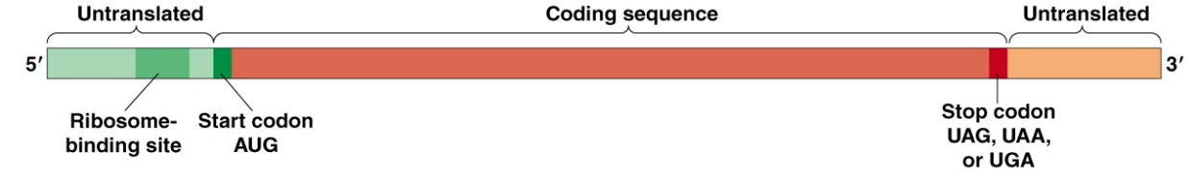
Understanding natural systems and the consequences of steady-state levels of gene expression in the cell is critical for optimization of biosynthetic pathways. Generally, steady-state protein levels can be controlled by using combinations of variable-strength promoters to change transcription rates, by employing different ribosome-binding sites to alter translation efficiency and by adding degradation tags to adjust rates of protein turnover (Alper et al., 2005; Salis et al., 2010; Wong et al., 2007). Stability elements in the 5’ and 3’ UTR of the mRNA can also change transcripts stability and impact on the amount of mRNA available for translation.

Figure 1.6 - Organization of a bacterial mRNA.

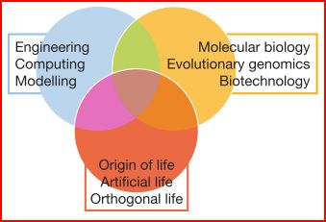
Synthetic biology is a new engineering discipline that is focused in the design and construction of complex artificial biological systems merging the knowledge acquired by other fields, such as biology, biotechnology, engineering and computing, sharing their universal perspective (Figure 1.7) (Andrianantoandro et al., 2006; de Lorenzo and Danchin, 2008).
Figure 1.7 – Foundations of synthetic biology. Adapted from (de Lorenzo and Danchin, 2008)

It pursues the development of new organisms by combining standardized biological parts that are out of their natural context (de Lorenzo and Danchin, 2008). A major problem in doing this is the current inability to fully predict the functions of these biological parts with precision and reliability since they are context-dependent and are also subjected to a series of phenomena’s like gene expression noise, mutation, cell death, extracellular environment and interactions within cellular context. For these reasons, synthetic biology requires the implementation of genetic layout architecture rules that exclude the functional uncertainty arising from the reuse of transcription and translation elements with any gene of interest (Mutalik et al., 2013a). The success of reusing these well-characterized components relies on the assumption that such devices are functionally composable, with predictive properties in a new context (Davis et al., 2011). The sharing of their precise characterization and manufacturing protocols provides a more efficient, predictable and design-driven genetic engineering science. Hence, setting standards is of uttermost importance since it ensures that each device and system created will work as advertised (Arkin, 2008; Kelly et al., 2009). Examples of this kind of repository can be seen in the Registry of Standard Biological Parts that provides protocols for easy cloning and physical linking of biological parts on a DNA strand (Knight, 2003) or in the Standard European Vector Architecture that helps in the choose of optimal plasmid vectors for the de-construction or re-construction of different phenotypes (Silva-Rocha et al., 2013).
Recent studies have focused in the different outcomes that can arise from genetic elements interactions. For instance, promoters, 5’UTRs and Genes of Interest (GOIs), which are typically considered to be well defined, functionally independent genetic elements, can generate irregular gene expression by their element-element boundary (Mutalik et al., 2013b). Particularly, spacing between sequence elements has been seen to have a marked effect in the efficiency of translation (Chen et al., 1994).
Efforts regarding the optimization, reliability and predictability of gene expression systems by the combination and evaluation of libraries of different transcription and translation control elements have also been made (Figure 1.8).
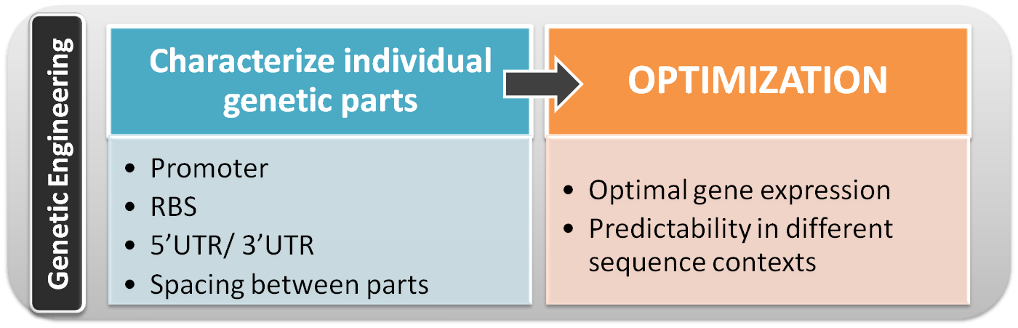

Figure 1.8 - Optimization of gene expression systems by genetic engineering.

Tools for synthetic biology

The development of collections of reusable standardized biological parts has simplified the construction of biological synthetic systems (Kelly et al., 2009). The biological parts are presented in formatted segments that can be joined through compatible restriction sites. Among these standardized biological parts are:
- Promoters: they are usually seen in synthetic biology as a device that convert an external signal into an internal signal;
- Ribosome binding sites (RBS);
- 5’/3’UTR: variable untranslated region input on messenger stability;
- Protein coding sequence (CDS): the most common used are reporters that function as a measure of gene expression or other intracellular event, transcriptional regulators and selection markers, proteins that confer a selective advantage or disadvantage. They are usually coded in a plasmid;
- Terminators;
- Plasmids: Most of the other biological parts are maintained and propagated on plasmids. Thus, construction of biological parts, devices and systems usually requires working with plasmids.
The lego-ization of all these parts allows the creation of biological devices with defined properties and ultimately systems that can perform more complex functionalities.

The practical applications of synthetic biology will revolutionize the incoming years by allowing the production of cheaper drugs, the increase in available “green” fuels and an accuracy increase of targeted therapies that will ultimately result in a stronger combat response to diseases (Khalil and Collins, 2010).

Aim of this thesis

This Master Thesis comprises two different work projects and as such it is divided in two parts.
In the first part we used Salmonella Typhimurium as our research model. The main goal of this part was to further unveil the biological role of the sRNA SraL by elucidating other possible biological targets. As mentioned above, sRNAs are crucial players in the post-transcriptional regulation in bacteria. Silva and co-workers (Silva et al., 2013) gave the first insights into the biological role of the sRNA SraL in Salmonella. Trigger Factor (TF), one of the major cytosolic chaperone proteins, was identified as a target of this sRNA, constituting the first link between sRNAs and protein folding (Silva et al., 2013).
The work here performed focused on the validation of possible putative targets identified by previous transcriptomics analyses, through the comparison of RNA levels between a mutant strain lacking this sRNA, other overexpressing it and a wild-type strain, either using RT-PCR and/or Northern Blot techniques.
In the second part Escherichia coli was used as our research model. The aim of this work was to improve the mRNA stability and consequently the protein synthesis through the combination of a set of promoters and translation enhancing elements in the 5’UTR of the mRNA. The quantitative behavior of function-encoding DNA segments, like promoters, RBSs or enhancers, is most often context dependent. This refers not only to the action of adjacent sequences, but also to longer-range effects, for instance the formation of secondary mRNA structures, cellular content, such as transcription factors or ribosomes, and to growth conditions (Davis et al., 2011; Mutalik et al., 2013a.; Vimberg et al., 2007).
In this study, we have analyzed the influence of genetic elements in the mRNA stability and expression pattern in E. coli MG1655, by fluorescence intensity measurements and fluorescence microscopy.

2. Materials and Methods

2. Materials and Methods

2.1. Oligonucleotides

All oligonucleotides used in this work are listed in Table 2.16, and were synthesized by STAB Vida.

2.2. Bacterial strains and plasmids

Bacterial strains and plasmids used are listed in Table 2.1 and Table 2.2, respectively. All Salmonella strains used in this study are isogenic derivatives of the wild-type Salmonella enterica serovar Typhimurium strain SL1344 and CMA-659.
The S. Typhimurium ΔsraL ΔaraA pLtetO araE mutant and the S. Typhimurium wild-type ΔaraA pLtetO araE mutant were obtained by P22 transduction from SV6244 and SV5998 strains, kindly provided by Josep Casadesus Lab. The transductants were confirmed by colony PCR, using the primer pairs araA_FORW/araA_REV and araE_FORW/araE_REV listed in Table 2.16.
Bacterial strains were stored in 10% glycerol/ 10% DMSO at -80ºC.

Table 2.1 – Strains used in this work

Strain | Relevant Markers / Genotype | Source/Reference
S. Typhimurium,  SL1344 | StrR hisG rpsL xyl | (Hoiseth and  Stocker, 1981)
S. Typhimurium,  CMA-651 | SL1344 sraL (ΔsraL::Cm^{R}) | (Silva et al., 2013)
S. Typhimurium,  CMA-659 | SL1344 sraL (∆sraL) | CMA lab strain
E. coli DH5α | recA1 endA1 gyrA96 thi-hsdR17  supE44 relA1 ΔlacZYA-arg FU169 f80dLacZDM15 | New England Biolabs
E. coli MG1655  (CGSC 6300) | MG1655 F⁻ λ⁻ rph-1 | (Guyer et al., 1981)
S. Typhimurium  SV6244 | ∆araA pLtetO-araE hilA::lacZ (Km^{R};Cm^{R}) | Josep Casadesus Lab
S. Typhimurium  SV5998 | ∆araA::Km^{R}(Km^{R}) | Josep Casadesus Lab

Table 2.2 – Plasmids used in this work

Plasmid | Comments | Origin/marker | Reference
pBAD::SraL | pBAD-driven expression of sraL | pBR322/Amp^{R} | CMA lab plasmid
pBAD | pBAD-driven expression of an 50-nt nonsense transcript derived from the rrnB terminator | pBR322/Amp^{R} | (Papenfort et al., 2006)
pSEVA121 | Backbone vector; T0/T1 Terminators; replication protein/trfA; beta-lactamase/bla | RK2/Amp^{R} | (Silva-Rocha et al., 2013)
pBAD BBa_I746908 | araBAD promoter (pBAD); inducible plasmid expressing SuperFolder GFP | Amp^{R} | (Pédelacq et al., 2006) kindly provided by Victor de Lorenzo

2.3. Bacterial growth

All strains were grown in Luria-Bertani (LB) broth at 37ºC and 220 rpm throughout this work, unless stated otherwise. Electroporation and heat-shock procedures were used for transformation of Salmonella and E. coli, respectively. Growth medium was supplemented with the following antibiotics where appropriate: streptomycin, chloramphenicol, carbenicillin and kanamycin.

2.4. Preparation of E. coli competent cells

An overnight culture of the strain of interest was diluted in LB to an initial OD₆₀₀ of 0.05. The culture was then incubated at 37ºC with agitation until reaching an OD₆₀₀ of 0.4-0.5. Then the culture was kept on ice for 15 min and centrifuged for 10 min, at 4ºC at 3824g. The supernatant was discarded, and the pellet was gently resuspended in 0.4 volumes of chilled TFB I. The suspension was incubated on ice for 15 min and centrifuged again, in the same conditions. The pellet was resuspended in 0.04 volumes of chilled TFB II solution, and the suspension was kept on ice for 15 min. Competent cells were aliquoted, snap frozen in liquid nitrogen and stored at -80ºC.

2.5. Preparation of Salmonella electro-competent cells

An overnight culture of the strain of interest was grown and diluted to an initial OD₆₀₀ of 0.05 in Super Optimal Broth with Catabolite repression (SOC) medium plus the respective antibiotics. The culture was then incubated at 37ºC with agitation until reaching an OD₆₀₀ of 0.5. Then the culture was kept on ice for 30 min and centrifuged for 15 min, at 4ºC and at 3824g. The supernatant was discarded, and the pellet was gently resuspended in 200 ml of cold sterile ddH₂O. A second centrifugation was made in the same conditions. The supernatant was again discarded and the pellet resuspended in 100 ml of cold sterile ddH₂O. The centrifugation process was repeated and the pellet was then resuspended in 4 ml of cold glycerol 10%, followed by another centrifugation. The pellet was then resuspended in 500 µl of cold glycerol 10%. Electro-competent cells were aliquoted and stored at -80ºC.

2.6. Transformation of E. coli competent cells

DNA (ligation mixture)/plasmid was added to 200 µl of competent cells. The cells were incubated for 1 h, heat shocked at 42ºC for 90 s, and immediately placed back on ice for 1 min. 600 µl of Super Optimal Broth (SOB) medium was added and the tubes incubated at 37ºC with agitation 120 rpm for 45 min. Cells were plated on LB-agar medium plates containing the antibiotics for selection and incubated at 37ºC until the appearance of bacterial colonies.

2.7. Transformation of Salmonella electro-competent cells

Electro-competent cells were thawed on ice and the plasmidic DNA/ligation mixture was added to the cells. The mixture was then transferred to an electroporation cuvette. Electroporation was made using a Biorad Gene Pulser Xcell (Biorad) at 25 µF, 2.5 kV e 200 Ω. After electroporation cells were transferred to an eppendorf tube containing 800 µl of SOC medium and incubated at 37ºC for 1 h at 120 rpm. Cells were plated on LB-agar medium plates containing the antibiotics for selection and incubated at 37ºC until the appearance of bacterial colonies.

2.8. RNA extraction

Overnight cultures were diluted to an initial OD₆₀₀ of 0.05 in fresh medium and grown to a cell density of 1.5 at OD₆₀₀. Induction of the strains carrying the pBAD plasmid was performed with L-arabinose at a final concentration of 0.2% for about 10 min. 10 ml of culture samples were then collected and mixed with 1 volume of ice cold TM stop solution, and harvested by centrifugation for 10 min, 5204g, at 4ºC. RNA was isolated by the phenol/chlorophorm extraction method, as follows: the pellet was resuspended in 0.5 ml of lysis buffer, the suspension was transfered to a 2 ml eppendorf with screw cap containing 1 volume of glass beads and 1 volume of phenol (for RNA). The cells were lysed in the Tissue Lyser (FastPrep)-speed 6, 3 times for 45 s. The samples were incubated at 65ºC for 30 min, vortexed every 10 min and then centrifuged for 10 min, at 4ºC, 20817g. In order to eliminate the contaminant DNA, the aqueous phase (containing the RNA) was incubated at 37ºC, 1 h with 10 U of Turbo DNase (Ambion), RNase free. One volume of phenol was added to the samples, which were vortexed for 2 min, centrifuged for 10 min, at 4ºC, 20817g. The aqueous phase was treated with 1 volume of CHCl₃:Isoamyl alcohol (24:1), vortexed for 1 min, centrifuged for 10 min, at 4ºC, 20817g. 0,11 volumes of NaOAC 3M and 2.5 volumes of cold EtOH 100% were added to the aqueous phase, the samples were incubated at -80ºC for 2 h and centrifuged for 1 h, at -9ºC, 20817g. The pellet was washed with 1 ml of EtOH 70% and centrifuged again for 15 min in the same conditions. The RNA pellet was dried and resuspended in 100 µl of RNase free water. Samples were quantified on a Nanodrop 1000 machine (NanoDrop Technologies) and integrity of the RNAs was checked by electrophoretic analysis in a 1.5% (w/v) agarose gel.

2.9. Northern blot

2.9.1. Polyacrylamide

For Northern blot analysis, 15 µg of total RNA was separated under denaturing conditions by 6% polyacrylamide gel in TBE buffer 1x. RNA samples were mixed with the RNA loading buffer. The samples were denatured for 10 minutes at 80ºC and run at 400V until the dye reached a determined distance in the gel. The transfer of RNA onto Hybond-N⁺ membranes (GE Healthcare) was performed by electroblotting for 1 h 50 min, 24V and 4ºC in TAE buffer. Immediately after the transfer the RNA was UV crosslinked to the membrane, (1200J for 3 min). Membranes were pre-hybridized in PerfectHyb Buffer (Sigma) for 1 h at 68ºC or 43ºC, in the case of riboprobes and oligoprobes, respectively. The probe of interest was denatured at 100ºC, added to the hybridization solution and the membrane was incubated o/n, at 68ºC for riboprobes and 43ºC for oligoprobes. After hybridization, membranes were washed in a three subsequent 15 min steps in washing solution ((2, 1 or 0.5x SSC, respectively)/0.1% SDS) at 63ºC for riboprobes and 41ºC for oligoprobes, always with monitorization of the probe signal’s intensity between washings. Signals were visualized by PhosphorImaging (Storm Gel and Blot Imaging System, Amersham Bioscience).

2.9.2. Agarose

For Northern blot analysis, 20 µg of total RNA was separated under denaturing conditions by 1 or 1.3% agarose MOPS/formaldehyde gel. The RNA samples were mixed with the RNA loading buffer. The samples which were denatured for 10 min at 80ºC and quick chilled on ice for 5 min, were span-down and kept on ice. The gel was equilibrated in 1x FA running buffer for at least 30min. The denatured samples were loaded onto the gel and ran at 90V. Immediately after gel electrophoresis, the gel was soaked in RNase free H₂O for 10 min, with gentle shaking, then soaked in a 50 mM NaOH / 10 mM NaCl solution for 15 min and finally soaked in a 10x SSC solution for 10 min. The transfer of RNA onto Hybond-N⁺ membranes (GE Healthcare) was perfomed by capillarity using a 20x SSC solution as a transfer buffer, overnight. After the transfer the RNA was UV crosslinked to the membrane (1200J for 2 min). Membranes were then hybridized and analysed as described above (see Polyacrylamide Northern blot protocol).

2.10. Hybridization probes

The riboprobes used in this study were obtained as described in (Viegas et al., 2007). Primers pairs for template amplification are listed in Table 2.16. Riboprobes were generated from PCR fragments (a T7 RNA polymerase promoter sequence was added by the antisense primer) in the presence of an excess of [³²P]-α-UTP over unlabelled UTP using the T7 RNA polymerase from Promega. Following the supplier instructions. Purification of labeled probes was performed with the G50 columns (GE Healthcare) to remove unincorporated nucleotides prior to the hybridization step, as described by the supplier.
The oligoprobes used in this work were labelled with [³²P]-γ-ATP using T4 polynucleotide kinase (Fermentas) according to the supplier instructions. Purification of labeled probes was performed with the G25 columns (GE Healthcare) to remove unincorporated nucleotides prior to the hybridization step, as described by the supplier.

2.11. Reverse-Transcription Polymerase Chain Reaction (RT-PCR)

Prior to RT-PCR, all RNA samples were treated with Turbo DNA free Kit (Ambion) and the elimination of DNA was confirmed by PCR using primers specific for 16S rRNA gene. RT-PCR reactions were performed using total RNA with the OneStep RT-PCR kit (Qiagen) and were carried out according to the supplier’s instructions. Modifications were introduced regarding the amount of RNA and number of PCR cycles, depending on gene expression levels. The analysis of gene expression of cysI and cysP was made using the primer pairs listed in Table 2.16. As a control, 16S rRNA was amplified with the specific primers P1 RT 16S/ P2 RT 16S. The thermal cycler conditions of the PCR with primers for 16S rRNA gene and of the RT-PCRs are presented in Table 2.3 and 2.4, respectively.

Table 2.3 – PCR Program for the 16S rRNA gene analysis

Cycle Step | Temperature | Time | Number of cycles
Initial Denaturation | 95ºC | 10 min | 1
Denaturation  Annealing  Extension | 95ºC  57ºC  72ºC | 1 min | 30
Final Extension | 72ºC | 10 min | 1

Table 2.4 – PCR Program for the RT-PCR reaction

Cycle Step | Temperature | Time | Number of cycles
Reverse transcription | 50ºC | 30 min | 1
Initial PCR activation | 95ºC | 15 min | 1
Denaturation  Annealing  Extension | 95ºC  x  72ºC | 30 s  30 s  1 min | 25-30  25-30  25-30
Final Extension | 72ºC | 10 min | 1
x – The annealing temperature depends of the primer pair used for each PCR reaction

PCR and RT-PCR samples were loaded and analyzed on a 1.5% agarose gel, unless stated otherwise.

2.12. P22 phage cell transduction

The “donor strain” was grown in LB with antibiotics at 37ºC and 100 rpm. The overnight culture was diluted 1:100 in 5 ml of LB supplemented with glucose 0.4% (w/v), 10 mM CaCl₂ and 12 nM MgSO₄ and incubated for 30 min at 37ºC and 100 rpm. 100 µl of phage P22 lysate was added to the culture, which was then incubated at 37ºC for 2 h at 150 rpm. 100 µl of chloroform were subsequently added and the mixture, which was vortexed vigorously to favor the bacterial lysis. 2 ml of the culture were centrifuged for 10 min at 19357g and 4ºC. The supernatant (lysate 1) was transferred into a new eppendorf tube and 12 µl of chloroform was added to it (at this step lysate 1 can be kept at 4ºC). 200 µl of lysate 1 were used to repeat the same infection procedure and generate lysate 2. After this process, 400 µl of lysate 2 were used to generate lysate 3. 2 ml of the “receptor strain” grown overnight in LB was centrifugated for 10 min at 1500g, the supernatant was discarded and the pellet resuspended in 1 ml LB with 10 mM MgSO₄ and 5mM CaCl₂. In 6 different eppendorfs tubes the following mixtures were prepared:
- 100 µl cells (negative control)
- 100 µl cells with 10 µl of lysate 3 (previously generated)
- 100 µl cells with 50 µl of lysate 3
- 100 µl cells with 100 µl of lysate 3
- 100 µl cells with 200 µl of lysate 3
- 200 µl of lysate 3 (control for the phage)
The 6 tubes were incubated for 30 min at 30ºC, standing. After that time, 300 µl of sodium citrate 1M was added to each tube and incubated for 1 h at 30ºC without shacking. The mixtures were centrifuged for 3 min at 3000g and the pellets resuspended in 100 µl of the supernatant. At last, cultures were plated in LB-agar medium plates with the appropriate antibiotics and incubated at 30ºC, o/n. On the next day, positive colonies were checked by colony PCR.

2.13. Colony PCR

Colony PCR reaction mixtures were prepared as stated in Table 2.5. Next, a colony was picked a colony from the LB-agar medium plates was picked using a sterile tip and mixed into the PCR tube containing 30 µl of the reaction mixture. The thermal cycler conditions of the colony PCR are presented in Table 2.6. The cell lysis was performed during the denaturation step at 95ºC. The positive clones were confirmed by sequencing using the primer pair PS1/PS2 (primers sequences presented in Table 2.13).

Table 2.5 – Reaction mix used in Colony PCR reaction

Colony PCR
Components | Amount (µl)
ddH₂O  Buffer DreamTaq Polymerase  dNTPs  Primer Forw  Primer Rev  DreamTaq Polymerase | 23.65  3  0.6  1  1  0.75
Final volume | 30 µl

Table 2.6 - PCR Program for the Colony PCR

Cycle Step | Temperature | Time | Number of cycles
Initial Denaturation | 95ºC | 10 min | 1
Denaturation  Annealing  Extension | 95ºC  x  72ºC | 1 min | 30
Final Extension | 72ºC | 10 min | 1
x – The annealing temperature depends of the primer pair used for each PCR reaction

2.14. Plasmid constructions

In all the experiments pSEVA121 from the Standard European Vector Architecture (SEVA) database (http://seva.cnb.csic.es) was used as the backbone vector. pSEVA121 is a low-copy plasmid composed by six functional modules as described in Silva-Rocha et al., 2013 and has the ampicillin resistance marker (Silva-Rocha et al., 2013) is a low copy vector with ampicillin resistance (http://seva.cnb.csic.es). Plasmid constructs were created with a combinatorial library of sequence elements such as, different promoters, Ribosome Binding Sites (RBS), transcriptional terminators, translation enhancers and 5’ UTRs.
To obtain the insert of the construct 1, the SGFP gene (http://partsregistry.org/Part:BBa_I746908;http://openwetware.org/wiki/IGEM:Cambridge/2008/Improved_GFP) (Pédelacq et al., 2006) was amplified by PCR using plasmid pBAD (I746908) (http://openwetware.org/wiki/IGEM:Cambridge/2008/Improved_GFP) as template and the primer pair PRM3NC/SpeIdown. The respective product served as template for a subsequent PCR reaction using the primer pair PRM4NC/SpeIdown. The end product contained all the TIR sequence from the PZE1RM plasmid-including, the pRM promoter, the RBS BBa_B0034 (http://parts.igem.org/Part:BBa_B0034:Design) and the sequence until the initiation start codon and the sequence of SGFP gene (see Figure 3.2.1 in the “Results” section) followed by the B0015 terminator (http://parts.igem.org/Part:BBa_B0015). The PCR product was cleaved with SpeI restriction enzyme, purified and used as insert to ligate into the pSEVA121 vector digested with SmaI restriction enzyme (blunt ends) and SpeI. The PRM4NC primer had a phosphate in the 5’-terminus to enable the ligation of the insert into the vector.
The insert of the construct 2 was obtained by amplifying the construct 1 using the primer pairs VV2a/VV2b, which amplify the entire construct 1 but substitutes the TIR between the pRM promoter and the ATG of the SGFP gene by a sequence containing an AU rich translation enhancer, the best Shine-Dalgarno and a 6 nts spacer before the ATG, as described in (Vimberg et al., 2007). (see Figure 3.2.1 in the “Results” Section) The PCR product was then purified, phosphorylated with PNK enzyme to introduce phosphate in the 5’ terminus of the DNA molecules and enable the respective recircularization (see details below).
The insert of the construct 3a was obtained by amplifying SGFP plasmid using the primer pair min_B0034/SpeIdown. It harbors a similar structure of sequence elements described in (Davis et al., 2011), as follows: the minimal promoter j23101-TACTAGAG-B0034-TACTAG-ORF (SGFP) – TACTAGAG-B0015.
The insert of the construct 3b was obtained by amplifying the construct 3a using the primer pair ProD1_B0034/SpeIdown, the PCR product was used as a template for a second amplification reaction using the primer pair ProD2_B0034/SpeIdown and the PCR product used again for a final amplification reaction using the primer pair ProD3_B0034/SpeIdown. It contains an identical structure of elements sequence described in (Davis et al., 2011), as follows: ProD promoter-TACTAGAG-B0034-TACTAG-ORF (SGFP)-TACTAGAG-B0015. Both PCR products were digested with SpeI enzyme and ligated with the pSEVA121 vector digested with SmaI (blunt ends) and SpeI enzyme to obtain both constructs 3a and 3b. Both the primers min_B0034 and ProD3_B0034 included a phosphate group in the 5’end to enable ligation of the insert with the vector.
For the design of construct 4, the SGFP gene was amplified by PCR using the primer pair Mut1/SpeIdown. The PCR product was used as template for another amplification reaction using the primer pair Mut2 (5’P)/SpeIdown. The resulting product carries the p7 promoter and the U2 5’UTR described in (Mutalik et al. 2013a) and the RBS BBa_B0034. The final PCR product was digested with SpeI enzyme, purified and ligated with the pSEVA121 vector digested with SmaI (blunt-ends) and SpeI (see details below) to obtain construct 4.
All primers sequences are listed in Table 2.16. The PCR reaction mixture and the program used are described in Table 2.7 and Table 2.8. All the transformations for the multiple cloning procedures were performed in E. coli DH5α strain. The plasmids were extracted using the “NucleoSpin Plasmid” from Macherey-Nagel, as described by the supplier.

Table 2.7 – Master mix used in PCR amplification of plasmid constructions

PCR reaction
Components | Amount (µl)
ddH₂O  Phusion DNA Polymerase GC Buffer  dNTPs  Primer Forw  Primer Rev  Phusion DNA Polymerase  DNA template | 13.4  4  0.5  0.5  0.5  0.2  0.3
Final volume | 20 µl

Table 2.8 – PCR Program used in plasmid constructions

Cycle Step | Temperature | Time | Number of cycles
Initial Denaturation | 98ºC | 30 s-1 min | 1
Denaturation  Annealing  Extension | 98ºC  x  72ºC | 10 s  15 s  35 s-2 min | 30
Final Extension | 72ºC | 10 min | 1
x – The annealing temperature depends of the primer pair used for each PCR reaction

PCR products were purified using “NucleoSpin Gel and PCR Clean-up kit” from Macherey-Nagel, as described by the supplier. When needed, phosphorylation step of the purified products was performed using T4 Polynucleotide Kinase (PNK from Fermentas) in T4 ligase buffer A plus ATP by incubating at 37ºC for 20 min, followed by another incubation at 75ºC, for 10 min to inactivate the enzyme. Phosphorylated products were purified using “NucleoSpin_Gel and PCR Clean-up kit” from Macherey-Nagel, as described by the supplier. Annealing reactions were carried with T4 DNA ligase in T4 DNA Ligase Buffer (10x) from Thermo Scientific.
The remaining purified products were digested with the restriction enzyme SpeI, as shown in Table 2.9.
Table 2.9 – Digestion with SpeI restriction enzyme

Insert Digestion
Components | Amount (µl)
FastDigest Buffer (10x)  DNA (insert)  SpeI  ddH₂O | 3  x  1  x
Final Volume | 30 µl

The digestion was performed for 1 h at 37ºC. In order to separate the insert from the other components of the digestion reaction mixture, the insert was purified using “NucleoSpin Gel and PCR Clean-up kit” from Macherey-Nagel, as described by the supplier.
The pSEVA 121 plasmid was double digested with the restriction enzymes SpeI and SmaI, as shown in Table 2.10.

Table 2.10 – Double digestion with SpeI and SmaI restriction enzymes

Backbone vector Double Digestion
Components | Amount (µl)
FastDigest Buffer (10x)  DNA Vector  SpeI  SmaI  ddH₂O | 3  x  1  1  x
Final Volume | 30 µl

The digested inserts were ligated to the double digested pSEVA121 backbone vector in a vector:insert ratio of approximately 1:3. The ligation reaction was performed by T4 DNA ligase, at 16ºC, o/n, accordingly with the following Table 2.11.

Table 2.11 – Ligation reaction of the digested inserts and the double digested pSEVA121.

Ligation Reaction
Components | Amount (µl)
T4 DNA Ligase Buffer (10x)  Insert  Vector  T4 DNA Ligase  ddH₂O | 2  10  3  2  3
Final Volume | 20 µl

The ligation mixture was loaded and analyzed on a 0.8% agarose electrophoresis gel, unless stated otherwise.
In order to test the effect of the introduction of 5’UTR stability element in the mRNA of sfGFP reporter, a sequence of the 5’UTR of the ompA transcript of E. coli, was introduced in constructs 1 and 4. For the construction of the plasmid 1hp, the previous construct 1 was amplified using the primer pair PRM4hp*Forw/PRM4Rev.For the construction of the plasmid 4hp, the previous construct 4 was amplified with the primer pair MutForw/Muthp*Rev. All primer sequences are listed in Table 2.16.
The obtained 1hp and 4hp constructs contain the alternative stem-loop of the 5’ terminus of the ompA 5’UTR described in (Emory et al., 1992), hp*, which was demonstrated to be essential for its function as a potent mRNA stabilizer. After amplification, the products were ligated by T4 DNA ligase, at 16ºC, o/n, accordingly with the following Table 2.12.

Table 2.12 – Ligation Reaction of ompA constructs.

Ligation Reaction
Components | Amount (µl)
T4 DNA Ligase Buffer (10x)  Plasmid amplified  T4 DNA Ligase | 2  17  1
Final Volume | 20 µl

Transformation ligation mixtures were transferred to competent DH5α E. coli cells following the protocol described above. Transformants were selected with carbenicillin 100 µg/ ml and screened by direct colony PCR, using the primer pairs previously mentioned: PRM4NC/SpeIdown for the construct 1, VV2a/VV2b for the construct 2; ProD3_B0034/SpeIdown for construct 3b, min_B0034/SpeIdown for construct 3a, Mut2/SpeIdown for construct 4, PRM4hp*Forw/PRM4Rev for the construct 1hp and MutForw/Muthp*Rev for the construct 4hp. Positive clones were confirmed by sequencing using the following primer pair PS1/PS2, listed in Table 2.13.

Oligo | Sequence 5’-3’
PS1 | AGGGCGGCGGATTTGTCC
PS2 | GAACGCTCGGTTGCCGC
Table 2.13 - Primer sequences used for sequencing.

The constructs that were confirmed by sequencing were then transferred to another genetic background (E. coli MG1655) following the transformation protocol described previously. Screening procedures, described above, were here repeated.
To quickly screen if the Superfolder GFP (sfGFP) was being expressed, all the E. coli MG1655 strains with the respective constructs were platted on carbenicillin LB-agar plates and visualized in a FUJI TLA-5100.

2.15. Growth of bacteria and measurement of GFP expression

Background fluorescence of cultures was determined using a promotorless plasmid derived from construct 1. This control construct was obtained by digestion of the construct 1 with the restriction enzyme EcoRI (Table 2.14).

Table 2.14 – Digestion with EcoRI restriction enzyme of the construct 1 to obtain of the promotorless E. coli MG1655 strain, control plasmid.

Construct 1 digestion
Components | Amount (µl)
FastDigest Buffer (10x)  Construct 1  EcoRI | 2.5  x  2
Final Volume | 25 µl

After digestion, the control construct was purified using “NucleoSpin Gel and PCR Clean-up kit” from Macherey-Nagel, as described by the supplier, and recircularized, as presented in Table 2.15.
Table 2.15 – Recircularization Reaction of the vector pSEVA121-pGFPcontrol.

Recircularization Reaction
Components | Amount (µl)
T4 DNA Ligase Buffer (10x)  T4 DNA Ligase  Control construct | 2  1  x
Final Volume | 20 µl

Bacteria bearing the different constructs were grown in the presence of 100 µg/ ml carbenicillin in LB medium at 37ºC. Overnight cell cultures were diluted in LB or M9 medium with 0.2% of casaminoacids to an OD₆₀₀ of 0.05. Growth was monitored by the increase in optical densities of the cultures and samples were taken at OD₆₀₀ 0.05, 0.5, 1.5 and 2. Aliquots (200 µl) of each bacterial culture were transferred to white 96-well plates where sfGFP fluorescence was measured using the BioTek FLx800 Fluorescence Microplate Reader (485 nm excitation and 520 nm emission for SGFP; sensivity of 35). The control strain was grown and assayed along with each of the different construct described, on the same 96-well plates. Experiments were repeated at least two independent times and measurements were always made in triplicate. Gen 5 software for BioTek plate readers was used for data acquisition.

2.16. Growth curves

Bacterial cultures grown overnight were diluted in M9 medium with 0.2% of casaminoacids and 0.4% glycerol to an initial OD₆₀₀ of 0.05. Cultures were further grown for 24 h at 37ºC in a volume of 200 μl/well with rapid shacking and repeated measurements were performed every 1 h. The experiment was repeated at least two times starting from independent overnight cultures and all the measurements were made in triplicate. Gen5 software for BioTek plate readers was used for data acquisition.

2.17. Fluorescence Microscopy

Sample preparation: Bacteria bearing the different constructs were grown in the presence of 100 µg/ ml carbenicillin in LB medium or M9 medium with 0.2% of casaminioacids and glycerol 0.4% at 37ºC. Samples of different volumes (depending on the OD) of each bacterial culture were centrifuged at 11000g for 1 min and the pellet resuspended in 5 µl of PBS 1x. From this preparation 3 µl were spotted onto glass slides previously coated with 0.8% agarose and examined in a fluorescence microscope, Leica DM6000B.

Table 2.16 – List of oligonucleotides used in this work. Underlined sequence corresponds to the T7 RNA polymerase promoter sequence.

 |  | Oligo | Sequence 5’-3’
Colony PCR of transductants |  | araA_FORW | AACAGGCGCAACGCTTCGAAC
 |  | araA_REV | CTGGAAGCTAATCTGGCGCT
 |  | araE_FORW | GTAGCGCCGAAATTCTCGAC
 |  | araE_REV | GTCTGGATATCGGCGTTATCG
Riboprobes and Oligoprobes | cys P | Cys P FORW | GCAGACGTCGTCACCTACAATC
Riboprobes and Oligoprobes | cys P | T7CysP | gttttttttttaatacgactcactataggCCGCCAGATACGTGTAAC
Riboprobes and Oligoprobes | cys I | Cys I FORW | TCTGGCTCGATCAGGAGAAG
Riboprobes and Oligoprobes | cys I | T7CysI | gttttttttttaatacgactcactataggTGCTCCAGCGGCAGATAG
Riboprobes and Oligoprobes | ydjN | YdjN FORW | TCCGTTTGCGGATCTGAC
Riboprobes and Oligoprobes | ydjN | T7 ydjN | gttttttttttaatacgactcactataggACTGGCGCAAATCCTACGTC
rRNA  Control | 5S | 5S | CTACGGCGTTTCACTTCTGAGTTC
rRNA  Control | 16S | 16S | ACGGCTACCTTGTTACGACTT
Analysis of gene expression | cysI | CysI FORW | TCTGGCTCGATCAGGAGAAG
Analysis of gene expression | cysI | CysI REV | CGTATCCTGGATTATCCG
Analysis of gene expression | 16S | P1 RT 16S | AGGCGGTCTGTCAAGTCGGATG
Analysis of gene expression | 16S | P2 RT 16S | GAGACAGGTGCTGCATGGCTGT
Analysis of gene expression | cysP | CysP_FORW | GCAGACGTCGTCACCTACAATC
Analysis of gene expression | cysP | CysP_REV | GAAGTGGTGATCCCGAAA
Analysis of gene expression | cysJ/I | CysJ_FORW_2 | CAAGACAAGCTGCGTGAAC
Analysis of gene expression | cysJ/I | CysI_REV_2 | GATTACTACGACGCAATGGC
Analysis of gene expression | cysI/H | CysI_FORW_2 | TATCGTGATGCGCGTGAC
Analysis of gene expression | cysI/H | CysH_REV_2 | GAATACGTGCTCTCCTCA
Plasmid constructions | 1 | PRM3NC | GAAACCGAATTCATTAAAGAGGAGAAAGGTACCGCATGCGTAAAGGCGAAGAGCTGTTCAC
Plasmid constructions | 1 | PRM4NC | TAGATATTTATCCCTTGTGGTGATAGATTTAACGTATCAGCACAAAAAAGAAACCGAATTCATTAAAGAGGAGAAAGG
Plasmid constructions | 4 | Mut 1 | CCACTCCCTATCAGTGATAGAGAAAAGAATTCATTAAAGAGGAGAAAGGTACCCTAGAGAAAGAGGAGAAATAC
Plasmid constructions | 4 | Mut 2 | TAATTCCTAATTTTTGTTGACACTCTATCGTTGATAGAGTTATTTTACCACTCCCTATCAGTGATAGAG
Plasmid constructions | 3a | min_B0034 | TTTACAGCTAGCTCAGTCCTAGGTATAATGCTAGCTACTAGAGAAAGAGGAGAAATAC
Plasmid constructions | 3b | ProD1_B0034 | TCAGGGAGACCACAACGGTTTCCCTCTACAAATAATTTTGTTTAACTTTTACTAGAGAAAGAGGAGAAATAC
Plasmid constructions | 3b | ProD2_B0034 | AGTGGTTGCTGGATAACTTTACGGGCATGCATAAGGCTCGTATAATATATTCAGGGAGACCACAACGGTTTCCCTCTAC
Plasmid constructions | 3b | ProD3_B0034 | CACAGCTAACACCACGTCGTCCCTATCTGCTGCCCTAGGTCTATGAGTGGTTGCTGGATAACTTTACG
Plasmid constructions | 2 | VV2a | CCCTTGTGGTGATAGATTTAACGTGCTCTTTAACAATTTATCAGATCCAATAGGAGGAACAAT
Plasmid constructions | 2 | VV2b | CGTATCAGCACAAAAAAGAAACCGGCTCTTTAACAATTTATCAGATCCAATAGGAGGAACAAT
Plasmid constructions | All | SpeIdown | GGGTGGGCCTTTCTGCGTTTATACTAGTAGCGGCCGCTGC
Testing the stability of the 5’ UTR (hp) | 1hp | PRM4hp*Forw | CGATCGCCCACCGGCAGCTGCCGGTGGGCGATCGAATTCATTAAAGAGGAGAAAG
Testing the stability of the 5’ UTR (hp) | 1hp | PRM4Rev | CGTATCAGCACAAAAAAGAAAC
Testing the stability of the 5’ UTR (hp) | 4hp | MutForw | CTAGAGAAAGAGGAGAAATACTAGATGCG
Testing the stability of the 5’ UTR (hp) | 4hp | Muthp*Rev | CCACTCCCTATCAGTGATAGAGAAAAGATCGCCCACCGGCAGCTGCCGGTGGGCGATC

Table 2.17 – Medium, Solutions and Buffers.

Medium | Composition
Luria-Bertani (LB) broth | 1% Tryptone, 0.5% Yeast Extract, 170mM NaCl
SOB medium | 2% Bacto Tryptone, 0.5% Bacto yeast extract, 10mM NaCl, 2.5mM KCl
SOC medium | SOB + 10mM MgCl₂
Luria Bertani Agar (LA) medium | 1% Bacto Tryptone, 0.5% Bacto yeast extract, 170mM NaCl, 1.5% Bacto Agar
M9 medium with casaminoacids | 1x M9 salts, 0,2% Casaminoacids, 01mM CaCl₂, 2mM MgSO₄, 1mM Vitamin B₁, 0,4% glycerol
Antibiotics | Composition
Streptomycin | 90µg/ml filtered with 0.2 µm membrane
Chloramphenicol | 25µg/ml filtered with 0.2 µm membrane
Carbenicillin | 100µg/ml filtered with 0.2 µm membrane
Kanamycin | 50µg/ml filtered with 0.2 µm membrane
Buffers | Composition
TFB I solution | 30mM CH₃CO₂K, 100mM Rubidium chloride, 10mM CaCl₂, 50mM MnCl₂, 15% (v/v) Glycerol. filtered with 0.2 µm membrane
TFB II solution | 10mM MOPS, 75mM CaCl₂, 10mM Rubidium Chloride, 15% (v/v) Glycerol. filtered with 0.2 µm membrane
Lysis Buffer | 1M Tris pH 7.2, 1M MgCl₂,
TBE buffer 1X | 89mM Tris Base, 89mM Boric Acid, 2mM EDTA
TAE buffer | 40mM Tris Base, 1mM EDTA, 20mM Acetic Acid
RNA loading buffer (agarose gels) | 0,025% Xylene Cyanol FF, 0,025% Bromophenol blue RNAse free, 5% SDS, 50% Glycerol
5x RNA Loading Buffer (Northern agarose) | Saturated aqueous bromophenol blue solution, 4 mM EDTA, 3% formaldehyde, 25% glycerol, 30,84% formamide, 4x MOPS
RNA Loading buffer (Northern polyacrylamide) | 98%l of deionized formamide, 10mM EDTA, 0,025% Xylene Cyanol, 0,025% Bromophenol Blue solution
MOPS | 40mM MOPS, 1mM EDTA, 10mM Sodium acetate
FA Running Buffer | 10x MOPS Buffer, 0.74% formaldehyde
Solutions | Composition
Solution TM ice cold | 10mM Tris pH 7.2, 25mM NaNO₃, 5mM MgCl₂, 500mg/ml chloramphenicol
Solution A | 3.5M Urea, TBE, 10% Acrilamide
Solution B | 3.5M Urea, TBE
SSC 20X | 3M NaCl, 0.3M Sodium citrate
M9 Salts 5x | 0.03M Na₂HPO₄.7H₂O, 0.02M KH₂PO_{4,} 9Mm NaCl, 0.02M NH₄Cl
PBS 1x | 137mM NaCl, 2,7mM KCl, 8,1mM Na₂HPO₄, 1,47mM KH₂PO₄
Gel | Composition
MOPS/formaldehyde gel | 1 or 1.3% agarose, 10% MOPS, 0.74% formaldehyde
6% polyacrylamide gel | 30 ml of Solution A, 20 ml of Solution B, 400 µl APS 10%, 40 µl TEMED

3. Results

3. Results

3.1. Analysis of SraL putative targets by RT-PCR and Northern blot

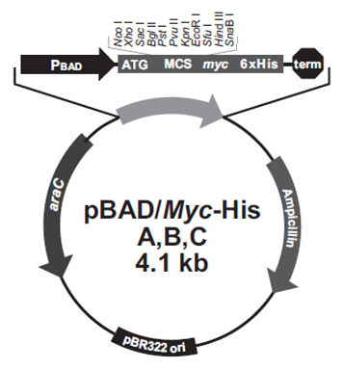
Although there are a few studies regarding the sRNA SraL, its first biological role on the protein chaperone Trigger Factor was only very recently discovered (Silva et al., 2013). The SraL sRNA, also known as RyjA, is composed by 140 nucleotides and was firstly reported in 2001 by two independent extensive genetic studies in E. coli, in which a combination of comparative genomics and microarrays allowed the identification of novel sRNAs (Argaman et al., 2001; Wassarman et al., 2001). More recently, it was confirmed that this sRNA is also expressed in S. Typhimurium (Viegas et al. 2007; Ortega et al. 2012). The fact that this sRNA is expressed in several conditions, namely in late stationary phase and also under Salmonella pathogenicity island (SPI)-2-inducing conditions (Viegas et al. 2007), highlights its possible role as a multi-target regulator. In order to identify new targets of this sRNA it was previously performed in the laboratory a microarray-based target screening. The basic strategy of this screening laid in the comparison of transcription profiles from two S. Typhimurium sraL null mutant strains in late exponential phase, one carrying a truncated pBAD plasmid (ΔSraL + pBAD – the truncated plasmid expresses a nonsense transcript derived from the rrnB terminator and it was used as a control), and the other carrying a plasmid overexpressing SraL (ΔSraL + pBAD::SraL), both under the control of an arabinose-inducible promoter. Microarray analysis had already been employed with success, in previous studies, for the discovery of new targets of sRNAs ( Sharma and Vogel, 2009; Wassarman et al., 2001).

Figure 3.1.1 – pBAD vector. Schematic representation of pBAD commercial plasmid, where are indicated all the restriction sites. The araC and ampicillin resistance genes are also represented, as well as the replication origin of pBR322 vector.
In this work, a pBAD vector (Figure 3.1.1) was used to express SraL. This tightly controlled arabinose-inducible promoter was chosen in order to avoid indirect regulatory effects that are usually associated with constitutive expression (Lease et al., 2004). The short pulse-expression provided by the pBAD vector allows a strong overexpression of the sRNA, in this particular case for 10 min, inducing the decay of the direct target mRNAs, but at the same time avoiding significant alterations at the protein level that might arise from possible secondary effects (Sharma and Vogel, 2009). Similar approaches have been used successfully to identify primary targets of several sRNAs (Masse et al., 2005; Papenfort et al., 2006; Tjaden et al., 2006).
From the microarray analysis we selected a few putative target mRNAs affected by the change of SraL levels in the cell, being the majority involved in the biosynthetic pathway of cysteine. A glycosyltransferase and a putative transporter protein were also identified as putative targets (Table 3.1.1).

Table 3.1.1 – List of the putative targets selected by the analysis of the transcriptome (in green: negative regulation; in red: positive regulation).
Selected putative targets | Fold change*,**
Sulfite reductase subunit β (cysI) | -1.86  -2.50  -3.73
Sulfite reductase subunit α (cysJ) | -1.81  -2.51  -4.28
Thiosulfate-binding protein  (cysP) | -2.26  -3.64  -1.55
3'-phosphoadenosine 5'-phosphosulfate  (cysH) | -2.70  -1.63
Cysteine synthase A, O-acetylserine  (cysK) | -2.16  -1.48  -3.07
Glycosyltransferase  (yfdH) | +2.28  +1.90  +2.61
Putative Transporter protein (ydjN) | -2.36  -2.65  -3.96
*comparison between (ΔSraL + pBAD) and (ΔSraL + pBAD::SraL) strains. A positive value (green) indicates that the levels of the mRNA are lower in the presence of SraL (ΔSraL + pBAD::SraL) than in its absence (ΔSraL + pBAD) ; A negative value (red) indicates that the levels of the mRNA are higher in the presence of SraL (ΔSraL + pBAD::SraL) than in its absence (ΔSraL + pBAD).
**for each target at least 2 different probes were used.

Many outcomes can be expected from the interactions of trans-encoded sRNAs with their mRNA target(s). The microarray results revealed that SraL possibly exerts a positive regulation on several genes that act during the biosynthetic pathway of cysteine (cysI, cysJ, cysP, cysH, cysK) and in the putative transporter protein (ydjN) and a negative regulation in the expression of Glycosyltransferase gene (yfdH). The fact that so many genes belonging to the same pathway were being affected by SraL raised our confidence in the results.
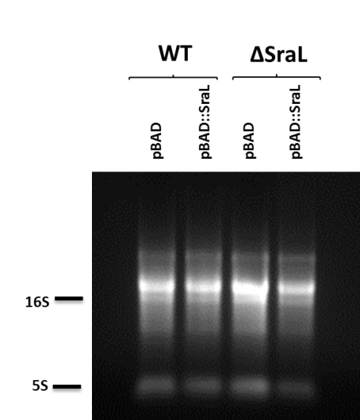
In order to validate the microarray results, we have analyzed by RT-PCR the levels of expression of the putative targets in the absence or in the presence of high levels of the sRNA under study. For that, we have constructed a S. Typhimurium wild type strain carrying the pBAD truncated plasmid (WT + pBAD - used as a control) and also a S. Typhimurium wild type strain carrying the pBAD expressing SraL (WT + pBAD::SraL). Total RNA extraction was performed as described in “Materials and Methods” section and the integrity of the RNA was checked by agarose gel electrophoresis (Figure 3.1.2). The extracted RNA samples exhibited the common rRNA pattern of S. Typhimurium (Mattatall and Sanderson, 1996).
Figure 3.1.2- RNA integrity. Total RNA was analyzed on a 1.5% agarose gel. Samples were ran in TBE 1x buffer and visualized by staining with ethidium-bromide.
All of our analyses were performed in cells in late exponential phase, the condition in which we are able to see the direct effect of the pulse-expression of the sRNA, since at this growth-phase SraL is only barely expressed in wild-type cells (Silva et al., 2013; Viegas et al., 2007; Wassarman et al., 2001). Northern blot is a popular technique used in molecular biology to measure relative amounts of the mRNA present in different samples. As such, the levels of SraL in the four strains were confirmed using this technique (Figure 3.1.3), and they are in agreement with predicted in the strain’s construction. As follows, the WT + pBAD::SraL strain exhibit the highest level of SraL, followed by the ΔSraL + pBAD::SraL strain. In the WT + pBAD starin the level of SraL is barely detected since at this growth phase this sRNA is very low expressed. In the ΔSraL + pBAD the sRNA is not expressed in the cell.

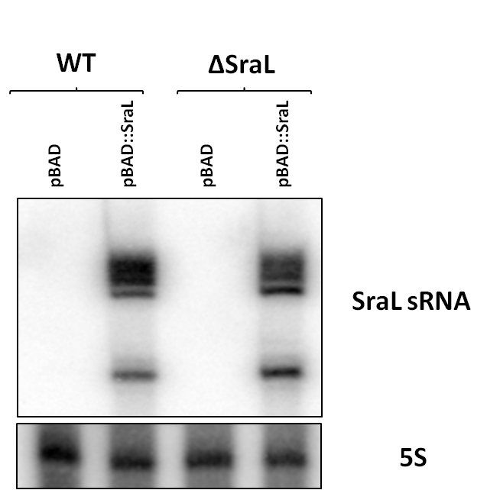
Figure 3.1.3 – Analysis of SraL sRNA expression. Total cellular RNA was extracted from the S. Typhimurium strains grown in LB at 37ºC after 10 min of induction by L-arabinose 0.2% at OD₆₀₀ 1.5. 15 µg of RNA were separated on a 6% PAA / 8.3 M urea gel. The gel was then blotted to a Hybond-N⁺ membrane and hybridized with the corresponding SraL riboprobe. The membrane was stripped and then probed for 5S RNA as loading control. A representative membrane is shown.

We have then compared the mRNA expression levels of the putative targets between the WT + pBAD, the WT + pBAD::SraL, the ΔSraL + pBAD and the ΔSraL + pBAD::SraL, by RT-PCR analysis (Figure 3.1.4), as described in “Materials and Methods” section. RT-PCR is a commonly used technique for measurement and comparison of mRNA levels among different samples. At least two independent RNA extraction procedures were performed for each putative target tested in the RT-PCR screening.
For all the putative targets tested, the results obtained with the RNAs from the first extraction (panel 1 in Fig. 3.1.4) were in good agreement with the microarrays results. In this case (cysI and cysP), an increase in the SraL expression was accompanied by an increase in the levels of these putative targets, which support the hypothesis of positive regulation of these targets by this sRNA.

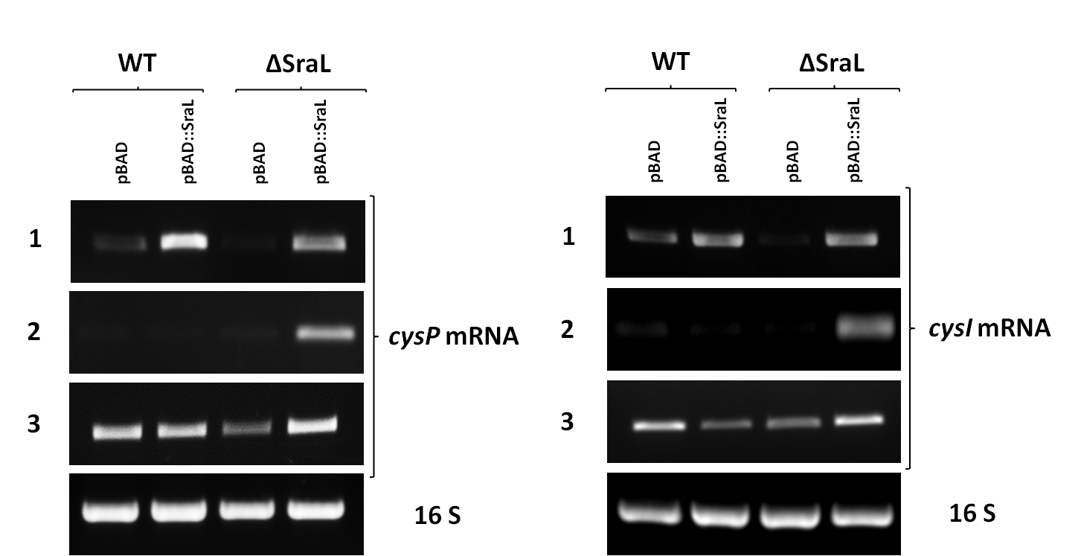
Additionally, since it was described in the literature the existence of a cysJIH operon comprising the putative targets cysJ, cysI and cysH (Loughlin, 1975), we decided to test if the expression pattern would match that previously obtained. Thus, two RT-PCR reactions including forward primers annealed to the upstream genes (cysJ/cysI) and reverse primers to the downstream genes (cysI/cysH) were conducted and once more the target expression pattern was in agreement with the microarray results (Figure 3.1.5), in which the WT + pBAD::SraL exhibited the highest levels of the putative targets, followed by ΔSraL + pBAD::SraL, WT + pBAD and the ΔSraL + pBAD. Together, both data indicated a positive regulation of these genes by SraL.
Figure 3.1.4 - Analysis of SraL putative targets by RT-PCR. RT-PCR experiments were carried out using primers specific for cysP and cysI genes over total RNA extracted from each strain, as indicated in each lane. A representative RT-PCR for 16S rRNA shows that there were not significant variations in the amount of RNA used in each sample. The numbers 1, 2 and 3 on the left correspond to the different RNA extractions performed. Positive regulation of cysI and cysP mRNAs by SraL sRNA;
Surprisingly, when we tried to reproduce these results, with RNAs from two additional independent RNA extractions (panel 2 and 3 in Figure 3.1.4), none of the corresponding results was consistent with the data previously obtained (extraction 1) or even between them (extractions 2 and 3) (Figure 3.1.4.) We have obtained the same discrepancy of results between RNA extractions in the analysis of cysJ, cysH, cysK, ydjN and yfdH mRNA levels (data not shown).

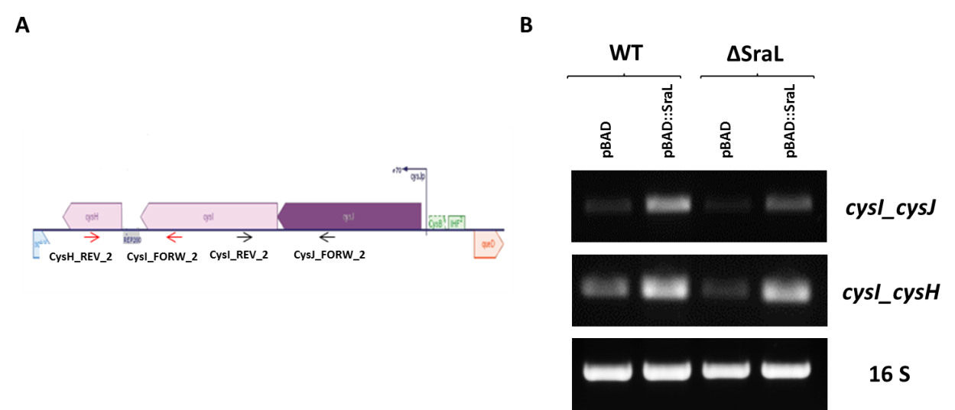
Figure 3.1.5 - Analysis of cysJIH operon by RT-PCR. (A) Schematic representation of the cysJIH transcriptional unit. The arrows indicate the approximate location and orientation (sense/antisense) of the primers used in RT-PCR experiment. (B) Total cellular RNA was extracted from the S. Typhimurium strains grown in LB at 37ºC after 10 min of induction by L-arabinose 0.2% at OD₆₀₀ 1.5. RT-PCR experiments were carried out using forward primers specific to the upstream genes (cysJ/cysI) and specific reverse primers to the downstream genes (cysI/cysH) over total RNA extracted from each strain, as indicated in each lane. RT-PCR for 16S rRNA shows that there were not significant variations in the amount of RNA used in each sample.

According to a previous report, the expression of a gene of interest under the control of the pBAD vector was shown to be narrow early after induction and broader with time (Siegele and Hu, 1997). Since the results that we have obtained for the putative targets were not reproducible between the different RNA extractions, and in an attempt to uniform the number of cells induced, we increase the induction time to 30 min and 1 h.
Besides, we also speculated if this effect could be a reflect of a mixed population of cells induced and uninduced, as was previously referred (Siegele and Hu, 1997). This phenomenon is designated as ‘‘autocatalytic’’ induction mechanism and appears as a consequence of the accumulation of the inducer by active transport, first described for the lac operon (Novick & Weiner, 1957). In the case of the autocatalytic system used here, the ara operon, active transport is linked to the arabinose transporter genes araE and araFGH, which encode the low-affinity and high-affinity uptake system, respectively. These transporters are positively regulated by AraC protein. Any changes in transport efficiency influences intracellular sugar pools and affects pBAD induction. Previous works have indicated that the replacement of the native promoter of the gene encoding the transport protein with a constitutive promoter should effectively decouple the inducer transport-induction loop and eliminate autocatalytic responses (Carrier and Keasling, 1999; A. Khlebnikov et al., 2000). For these reasons, one possible solution for this problem could arise from the construction of a strain in which the transport gene (araE) is controlled independently of the inducer. Moreover, a mutation in the araA gene was reported to make cells unable to metabolize L-arabinose, ruling out any interference of metabolism in the role of L-arabinose as an inducer signal. As so, we constructed the S. Typhimurium ΔsraL ΔaraA pLtetO araE mutant and the S. Typhimurium ΔaraA pLtetO araE mutants by P22 transduction, as described in the section “Materials and Methods”. In these strains the araE gene (that encodes the arabinose transporter) is under the control of the pLtetO promoter which is a constitutive promoter in the absence of TetR. The mutations were confirmed by colony PCR.
For both hypothesis we performed the RT-PCR and/or Northern Blot screening (Figure 3.1.6 and 3.1.7). Using this new approach we still could not correlate the results with any of the previously obtained pattern expressions. As can be observed in the figures, the expected direct proportion between the SraL sRNA levels and the putative positive regulated targets tested could not be demonstrated.
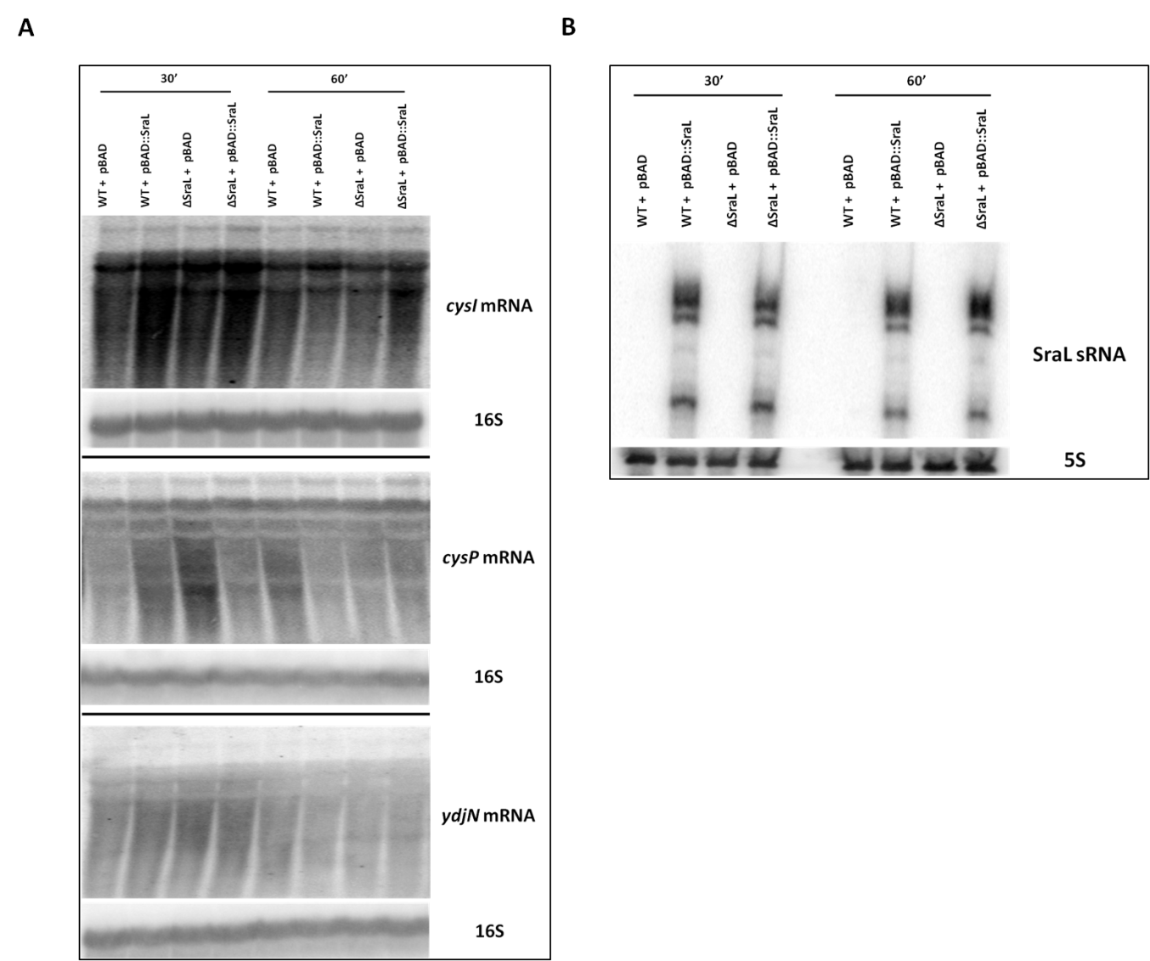

Figure 3.1.6 – Analysis of SraL putative targets by Northern blot. (A) - 20µg of total RNA were separated on a 1.3% formaldehyde / agarose gel. The gel was blotted to a Hybond - N⁺ membrane and hybridized with the corresponding cysI, cysP and ydjN riboprobe. The membrane was stripped and then probed for 16S rRNA as loading control. (B) 15µg of RNA were separated on a 6% PAA / 8.3 M urea gel. The gel was then blotted to a Hybond-N⁺ membrane and hybridized with the corresponding SraL riboprobe. The membrane was stripped and then probed for 5S rRNA.

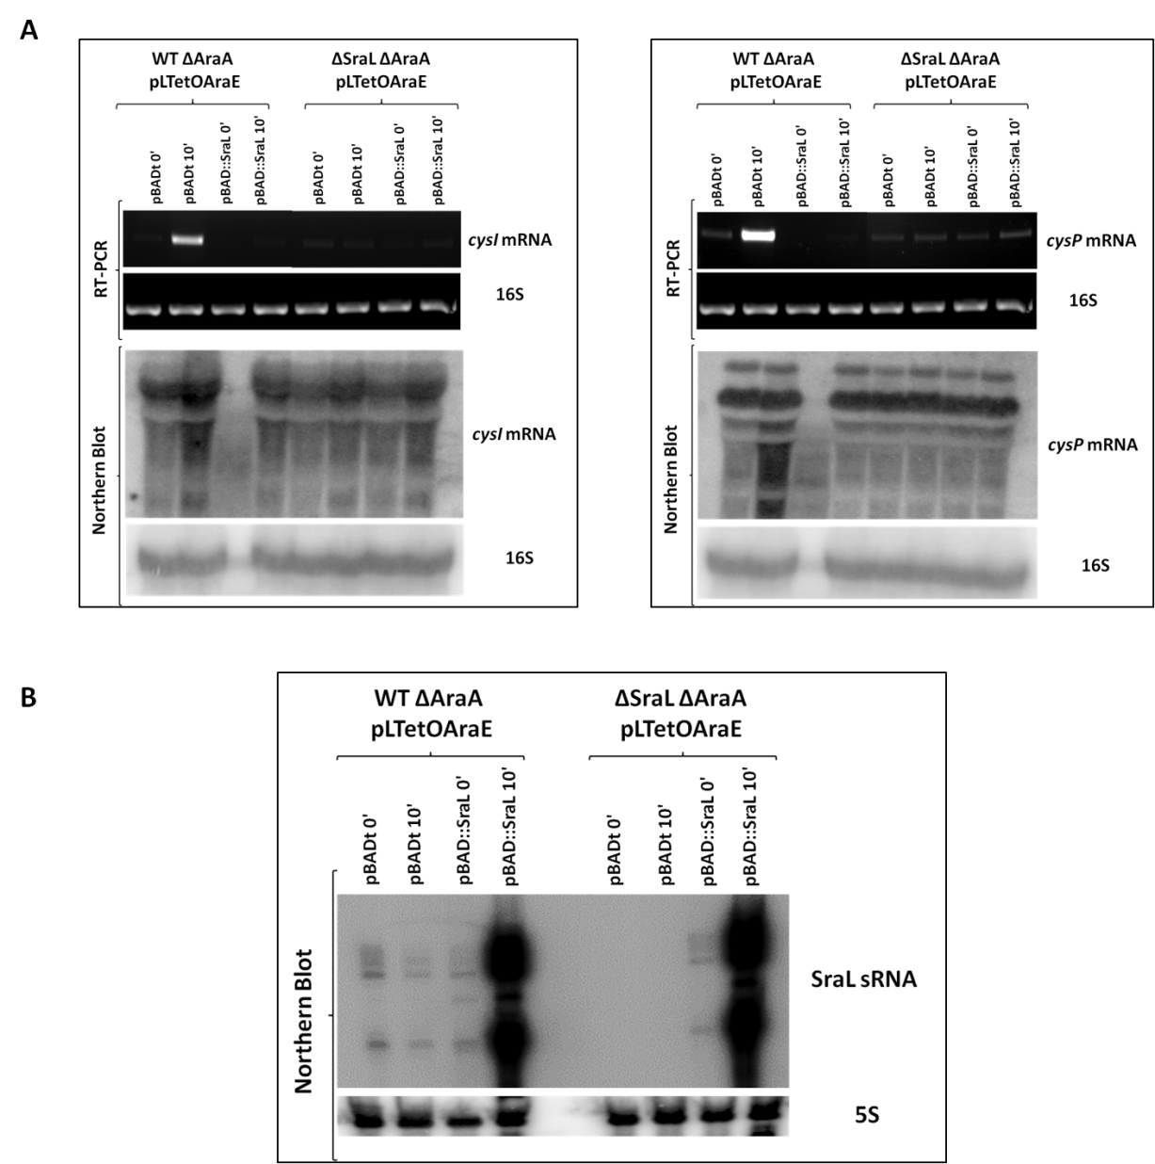
Figure 3.1.7 – Analysis of SraL putative targets by RT-PCR and Northern blot. Total cellular RNA was extracted from the S. Typhimurium strains grown in LB at 37ºC before (0’) and after 10 min (10’) of induction by L-arabinose 0.2% at OD₆₀₀ 1.5. (A) Upper panel - RT-PCR experiments were carried out using primers specific for cysI and cysP genes over total RNA extracted from each strain, as indicated in each lane. RT-PCR for 16S rRNA shows that there were not significant variations in the amount of RNA used in each sample. Lower panel - 20µg of total RNA were separated on a 1.3% formaldehyde / agarose gel. The gel was blotted to a Hybond-N⁺ membrane and hybridized with the corresponding cysI and cysP riboprobe.The membrane was stripped and then probed for 16S rRNA as loading control. (B) 15µg of RNA were separated on a 6% PAA / 8.3 M urea gel. The gel was then blotted to a Hybond-N⁺ membrane and hybridized with the corresponding SraL riboprobe.

3.2. Quantifying elements context effects

There are several factors at the transcriptional, post-transcriptional or post-translational level that are responsible for variations in the expression level of a protein. Understanding these global effects is fundamental for a quantitative interpretation of gene regulation and for a powerful design of synthetic genetic circuits.
In this work, we have generated a collection of constructs to monitor variations of genetic activities of the sequence elements combined. Expression output signals, here measured, were assumed to be a function of the combinatorial library of sequence elements, the transcription rates through the use of different promoters and the translation efficiency and/or mRNA stability through the use of different RBSs and 5’UTRs.
Five constructs were designed based on previously described sequence elements (Berthoumieux et al., 2013; Davis et al., 2011; Mutalik et al., 2013a; Mutalik et al., 2013b; Vimberg et al., 2007) and the gene encoding the Superfolder GFP protein (sfGFP) was used as reporter, (Pédelacq et al., 2006), (Figure 3.2.1). The reporter’s choice was based on its distinctive properties as a robust reporter protein with the highest fluorescence yields and increased folding efficiency (Pédelacq et al., 2006).
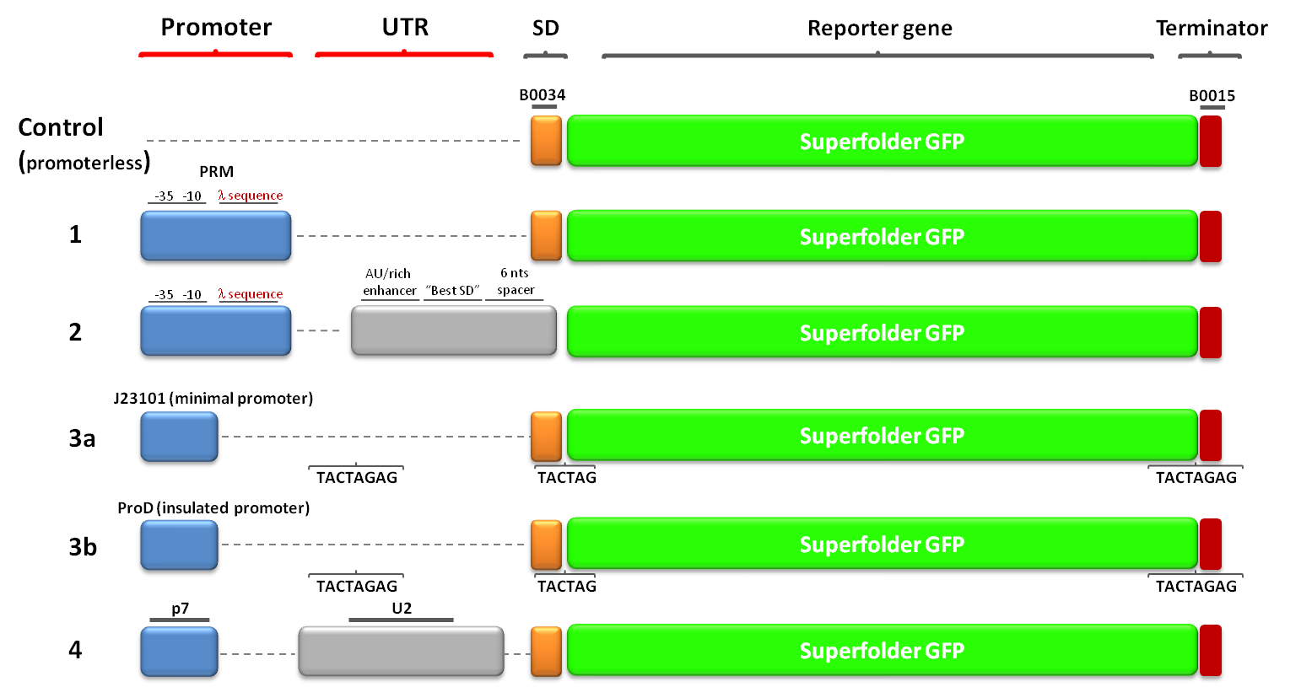
Figure 3.2.1 – Composition of the different constructs. Schematic representation of each sequence element incorporated in the constructs obtained. Blue: Promoters; Grey: 5’UTRs; Orange: SD; Green: Reporter gene; Red: Transcriptional terminator. Sequences TACTAGAG and TACTAG indicated in the constructs 3a and 3b correspond to sequences generated by standard BioBrick assemblies.

Each construct contained a variant of promoter and 5’UTR. Construct 1 contains the pRM promoter. The activity of this promoter is not controlled by any particular transcription factor, which allows to monitor in real time the physiological state of the cell (Berthoumieux et al., 2013). This construct also contains the RBS B0034 (http://parts.igem.org/Part:BBa_B0034:Design). Construct 2 contains the same promoter as the previous but, in an attempt to increase the efficiency of translation, this construct possesses an AU/rich enhancer, the “Best SD” and a 6 nucleotide spacer, as described in (Vimberg et al., 2007).
Since the strength of any promoter is likely to vary depending on neighboring sequences, we have selected a minimal length promoter and an insulated promoter (promoter flanked by sequence elements extending beyond the transcriptional start site) to test their effect on gene expression. As such, constructs 3a and 3b have the minimal length promoter and the ProD promoter, respectively, described in (Davis et al., 2011), followed by the RBS B0034. Finally, construct 4 comprises the p7 promotor and the u2 5’UTR, whose combination was demonstrated to produced high levels of GFP fluorescence, (Mutalik et al., 2013a).
We placed each expression construct in a low-copy number plasmid, pSEVA121 from the Standard European Vector Architecture (SEVA) database, as described in “Materials and Methods” section. The plasmids were transformed into E. coli MG1655 cells and the level of protein synthesis along growth was monitored by fluorescence levels measurement, using both, a fluorescence microplate reader and a fluorescence microscope. Bacterial growth was followed by optical density (OD) measurement.
After transformation, a quick screening of the strains bearing the different constructs was performed to ensure that the sfGFP was being expressed. In Figure 3.2.2, E. coli MG1655 bearing the combinatorial sequence elements were placed in a 96-well plate and GFP fluorescence emission visualized using a FUJI TLA-5100. As control we have used a strain bearing the pSEVA121 plasmid with construction 1 without a promoter sign (c in the figure). As expected, the different constructs do not exhibit same level of fluorescence which is in agreement with the variable impact on expression conferred by the multiple elements combinations. Therefore, we went further in the evaluation of protein synthesis levels of these constructs, by spectrofluorometry and a fluorescence microscopy, to explain the differences observed.

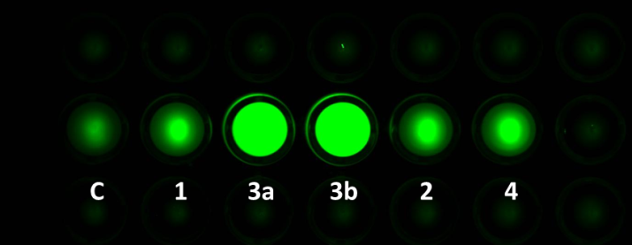

Figure 3.2.2 - Culture fluorescence of strains bearing the different constructs. E. coli strain harboring control plasmid (C) or the combinatorial elements (as indicated) were grown on minimal media supplemented with 0.2% of casaminoacids, 37ºC. 96-well plates were photographed in a FUJI TLA-5100 using a CCD camera (473nm excitation, LBP emission filter).

Since the concentration of cellular components (e.g – ribosomes, tRNAs) is growth rate dependent (Klumpp et al., 2009), this might influence the cells sequence preference patterns. Therefore, we tested the effect of the growth media on protein expression using two different growth media, LB media and M9 minimal media supplemented with 0.2% of casaminoacids (data not shown). Variations on fluorescence intensity measured for LB and M9 media were not significant. However, the undefined nature of LB makes it difficult to analyze and monitor product yields during bacterial growth. Moreover, the use of a poor nutrient media has been reported as resulting in a depletion of some nucleolytic and proteolytic activities in the cell (Le Derout et al., 2002; Viegas et al., 2005). As a consequence, we chose to proceed with the experiments only with M9 minimal media supplemented with 0.2% of casaminoacids and we have compared the growth profile of the strains bearing the different constructs in this media. Growth curves show that there are no significative differences between growth profiles of the strains, discarding any side effects of the constructions (Figure 3.2.3).
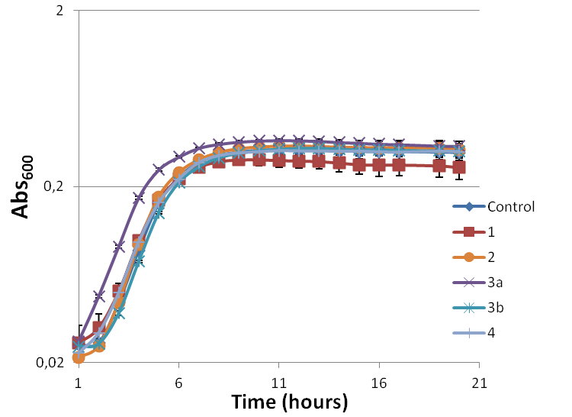

Figure 3.2.3 – Growth curves of the different constructs (as indicated). L.B o/n cultures of E. coli MG1655 bearing the different constructs were diluted to an initial OD₆₀₀ of 0.05 and grown at 37ºC in M9 minimal media supplemented with 0.2% of casaminoacids. Absorbance was measured every hour.

For fluorescence intensity measurements, overnight cultures of cells harboring the five different plasmids were diluted into fresh M9 media and aliquots were removed to determine the overall culture fluorescence at four different growth stages, corresponding to a cell density of OD₆₀₀ of 0.05, 0.5, 1.5 and 2. Although fluorescence differed markedly between the different combinatorial plasmids, an almost linear correlation of cell number and fluorescence was observed throughout growth (Figure 3.2.4 and 3.2.6). The total fluorescence intensity was calculated by dividing the fluorescence signal by the corresponding OD₆₀₀ value, then subtracting the background signal, given by the control construct (also corrected per the respective OD), and multiplying that final value by the OD at each point (total fluorescence).
Our first goal was to determine whether we could directly observe subtle or considerable fluorescence variation arising from the sequence elements used in each construct. By comparing relative fluorescence levels of the different constructs, we determined the relative effectiveness of each combinatorial library. Introduction of insulation elements flanking the promoter region (construct 3b) lead to highest amounts of sfGFP, probably as a consequence of high transcription rates. The introduction of an enhancer and a nucleotide spacer did not change the cell preference for the SD present in each construct, as can be seen by comparison of the fluorescence levels of constructs 1 and 2. Additionally, we can observe some fluorescence variation with specific combinations of promoters and 5’UTRs, with the construct 4 producing the lowest amounts (Figure 3.2.4).
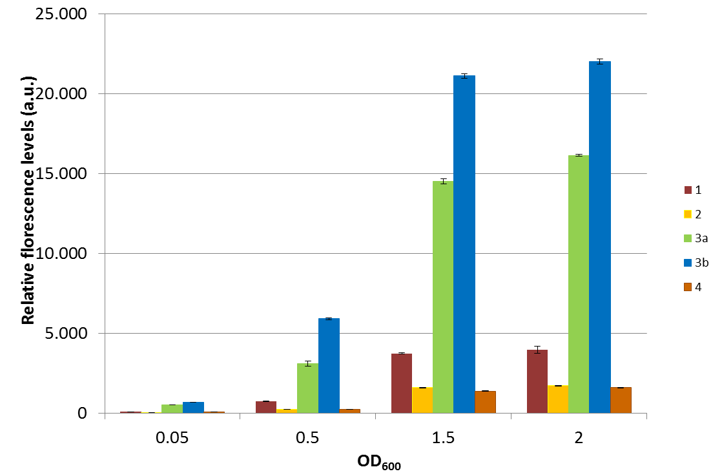

Figure 3.2.4 – Total fluorescence levels of the different constructs tested (as indicated). E. coli MG1655 strains harboring the indicated constructs were grown in liquid culture and fluorescence was measured at the indicated cell density (OD₆₀₀). Fluorescence values are given in arbitrary units (a.u) and were corrected for the basal fluorescence of the control construct.

The same result was observed when it came to the estimation of bacterial fluorescence/OD₆₀₀ (Figure 3.2.5) or the microscopy fluorescence results, although, in this last one, the difference between the weakest constructs seemed to be less profound (Figure 3.2.6).

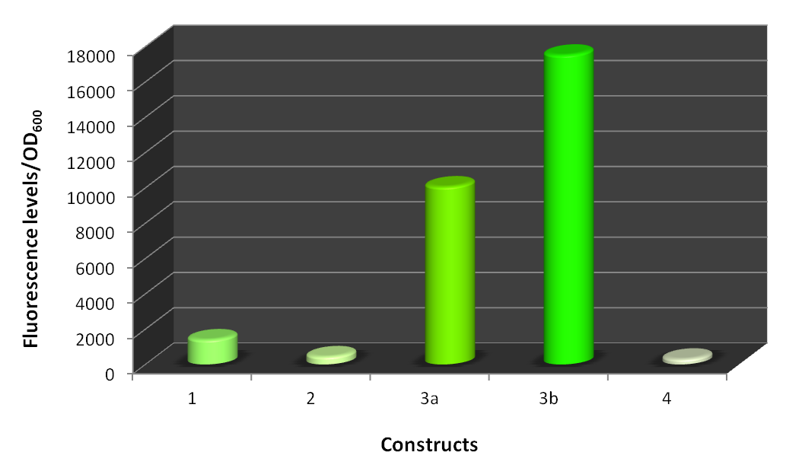

Figure 3.2.5 – Estimation of bacterial fluorescence/OD₆₀₀ of the combinatorial library. L.B o/n cultures of E. coli MG1655 bearing the different constructs were diluted to an initial OD₆₀₀ of 0.05 and grown at 37ºC in M9 minimal media supplemented with 0.2% of casaminoacids. Fluorescence was measured at cell density (OD₆₀₀) of 0.3.
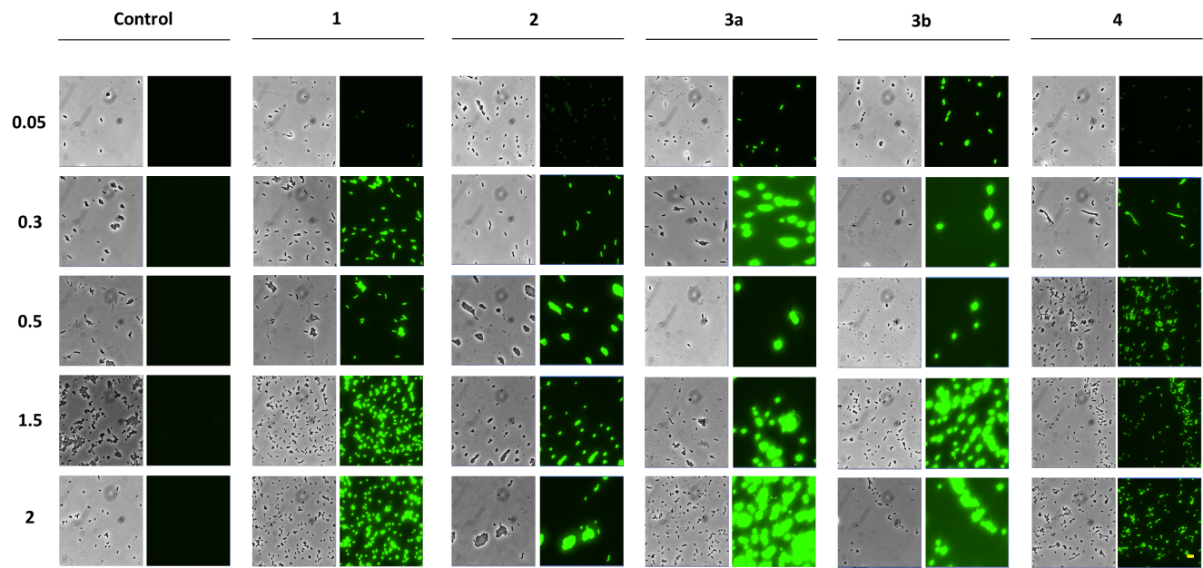

It was reported in the literature that the presence of a stem-loop structure no more than 2-4 nucleotides from the extreme 5’ terminus of an mRNA was able to protect the transcript from the attack by important cellular ribonucleases involved in the mRNA degradation (Emory et al., 1992). Therefore, in an attempt to see if we could stabilize some mRNAs of our constructs, we decided to add this structure, designated hp, to the constructs that previously had produced the lowest amounts of sfGFP. Since the introduction of the 5’ stem-loop would lead to the removal of the 5’UTR of each construct, construct 1 and 2 would lead to the production of the same message. So, we chose the constructs 1 and 4 to test the stabilizing capacity of this structure (Figure 3.2.7). The new constructs obtained contained, the same promoter as their original construct, e.g. construct 1hp harbors pRM promoter followed by a λ sequence and construct 4hp, the p7 promotor. In both the stem-loop structure, hp, follows the promoter region.
Figure 3.2.6 – Fluorescence monitorization of the different constructs. L.B o/n cultures of E. coli MG1655 bearing the different constructs were diluted to an initial OD₆₀₀ of 0.05 and grown at 37ºC in minimal M9 media supplemented with 0.2% of casaminoacids. Fluorescence microscopy images were acquired using a Leica DM6000B microscope and the results were treated in MetaMorph software. Images were taken at different cell densities OD₆₀₀ (indicated on the left).

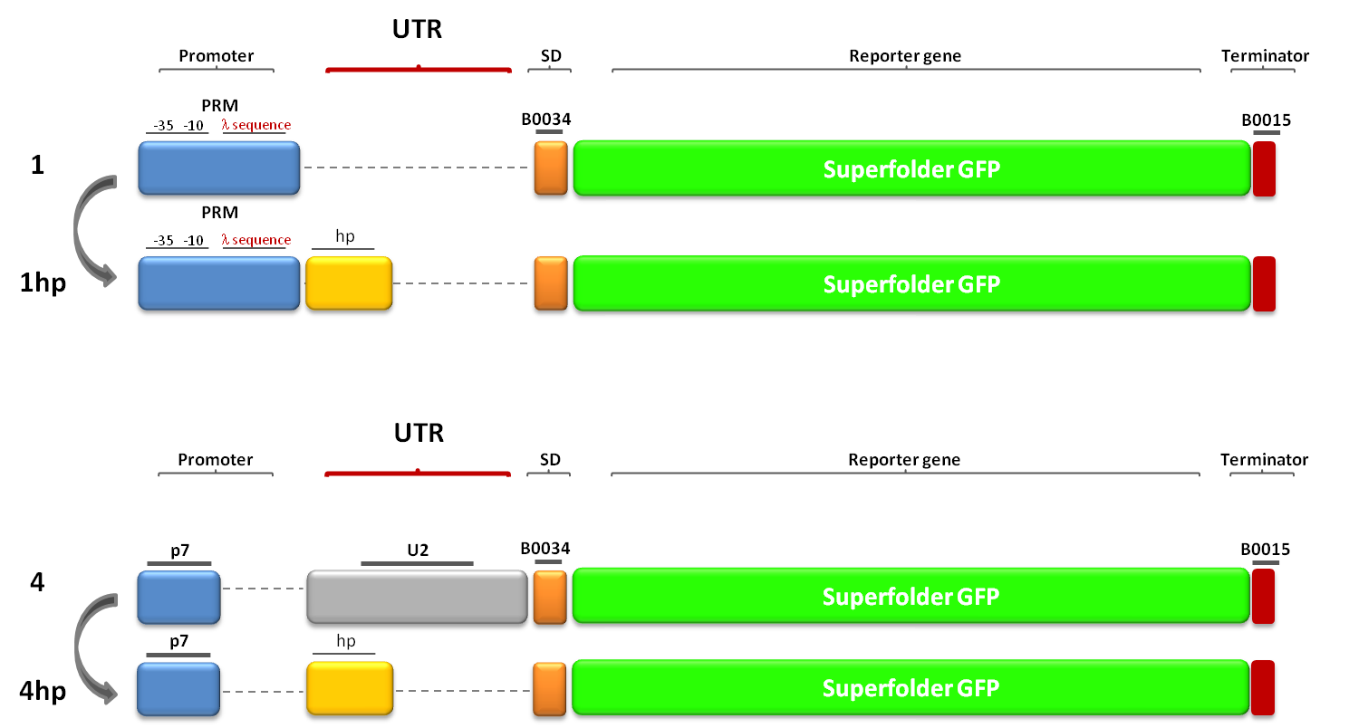
Figure 3.2.7 - Composition of the different constructs bearing the 5’ stem-loop. Schematic representation of each sequence element incorporated in the constructs obtained. Blue: Promoters; Grey: 5’UTRs; Yellow: stem-loop structure, hp; Orange: SD; Green: Reporter gene; Red: Transcriptional terminator.
Growth curves show that there are no differences between growth profiles of these strains, discarding any side effects of the constructions (Figure 3.2.8).
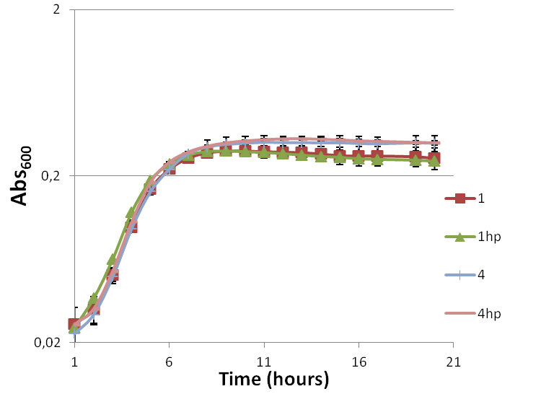

Figure 3.2.8 - Growth curves of the different constructs (as indicated). An L.B o/n culture was diluted to an initial OD₆₀₀ of 0.05 and grown at 37ºC in M9 minimal media supplemented with 0.2% of casaminoacids. Absorbance was measured every hour.

Another quick screening of the strains bearing the different constructs was performed to ensure that the sfGFP was being expressed (Figure 3.2.9). All E. coli MG1655 bearing the combinatorial sequence elements were streaked next to each other on the same M9 agar plate and visualized using a FUJI TLA-5100. And again, the different constructs show the variable impact on expression conferred by the multiple part combinations.

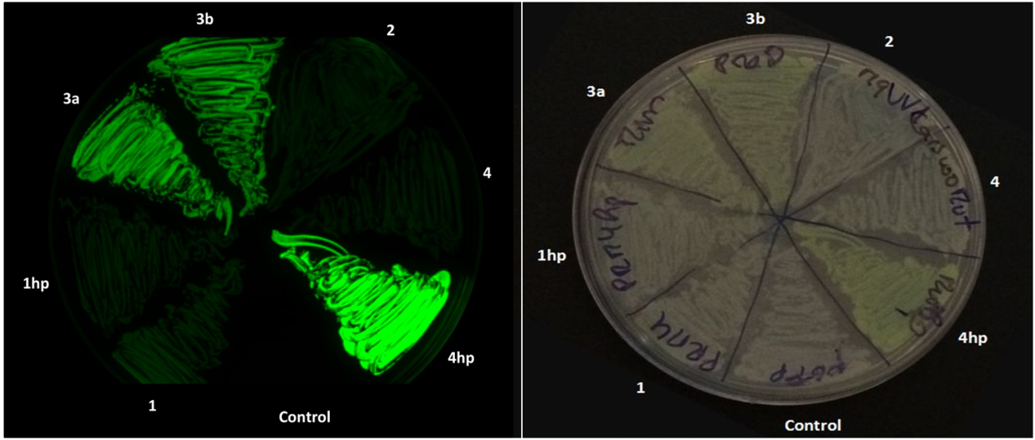
Comparing the fluorescence intensity data of the resulting constructions bearing the 5’ structure with their respective initial construct, we were able to improve the protein levels in the construct 4hp, as it can be seen in Figures 3.2.9 and 3.2.10. It is interesting to mention that the fluorescence of constructs 3a, 3b and 4 hp is so intense that is directly visible in the agar plate since they produce bright green colonies (the respective liquid culture shows an intense green color).
Figure 3.2.9 - Colony fluorescence of strains bearing the different constructions. E. coli MG1655 strains harboring control plasmid (Control) or the combinatorial elements (as indicated) were grown on M9 agar. Growth colonies were photographed in a FUJI TLA-5100 using a CCD camera (473nm excitation, LBP emission filter).The left image was obtained in the fluorescence mode. The right image shows the same plate in the visible light mode and shows the colony morphology of these strains.
In construct 1hp the levels decreased comparatively with the 5’ structureless construct, probably as a consequence of instability in the message conferred by the introduction of this structure through unpredicted secondary structure alterations.
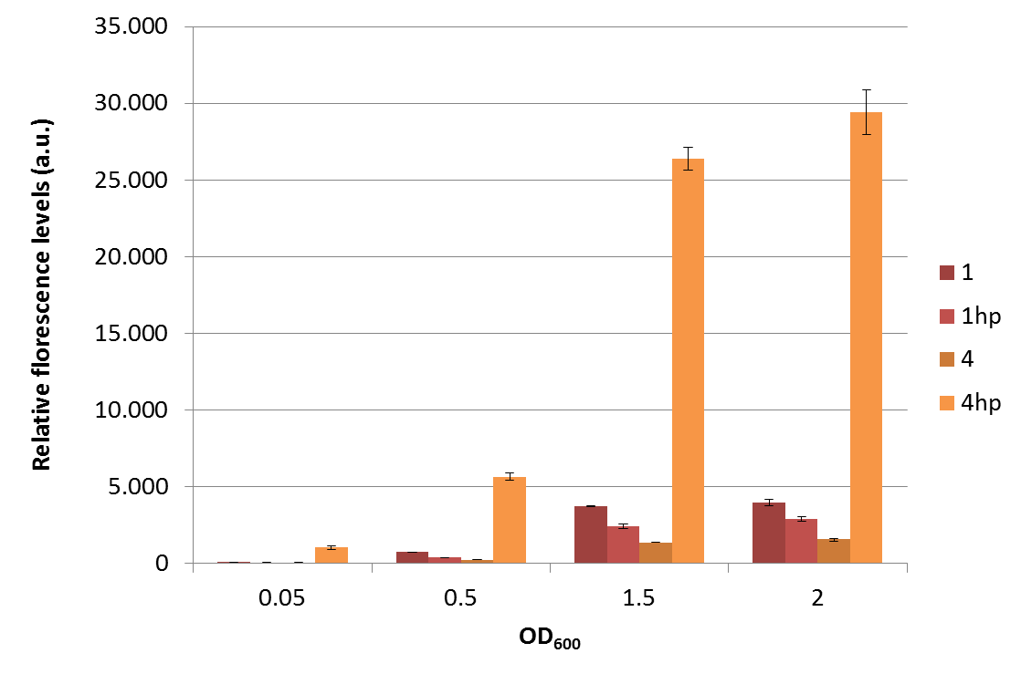

Figure 3.2.10 - Total fluorescence levels of the indicated constructions. E. coli MG1655 strains harboring the indicated constructs were grown in liquid culture and fluorescence was measured at the indicated cell density (OD₆₀₀). Fluorescence values are given in arbitrary units (a.u) and were corrected for the basal fluorescence of the control construct.

Collecting all fluorescence data from all the constructs obtained (Figure 3.2.11), we can see that higher levels of protein production were achieved in the constructs bearing the insulation sequence elements (construct 3b), and the 5’ stem-loop structure (construct 4hp), while the lowest levels were associated with the combinatorial elements used in constructs 2 and 4 and probably with an unpredicted message instability, in construct 1hp.
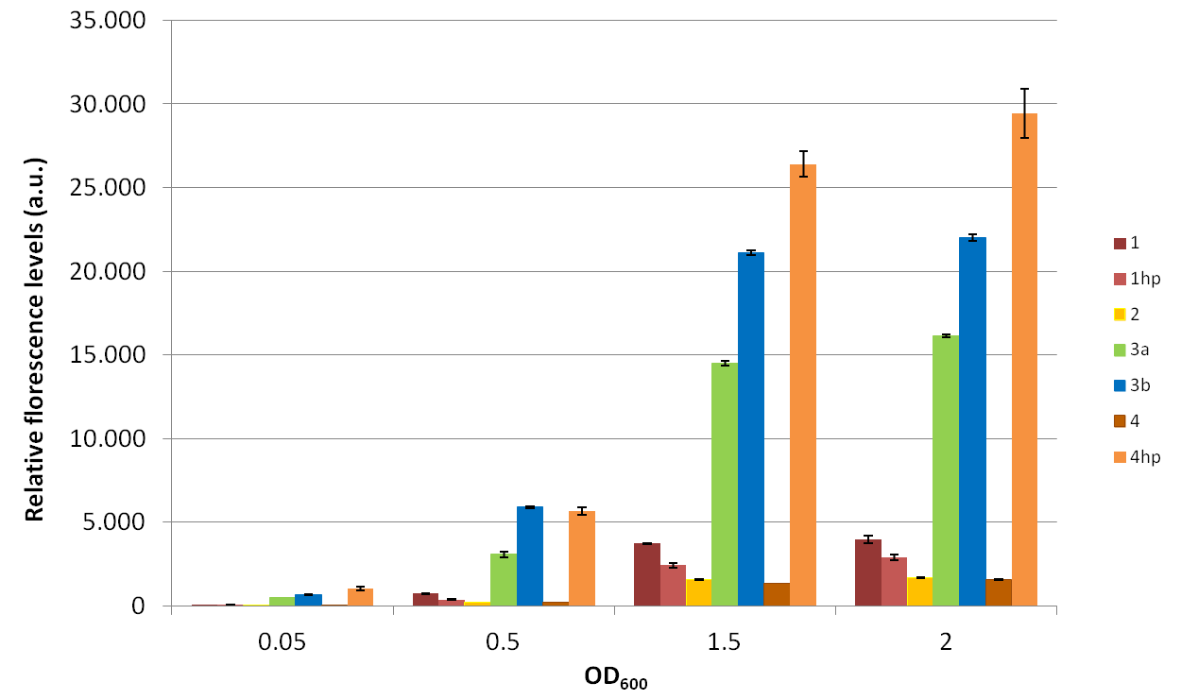
Figure 3.2.11 - Total fluorescence levels of all the constructions. E. coli MG1655 strains harboring the indicated constructs were grown in liquid culture and fluorescence was measured at the indicated cell density (OD₆₀₀). Fluorescence values are given in arbitrary units (a.u) and were corrected for the basal fluorescence of the control construct.

4. Discussion and conclusions

4. Discussion and conclusions

4.1. Exploring the role of SraL sRNA

In recent years small RNAs have gained importance as ubiquitous regulators in all forms of life. New sRNAs are being constantly discovered and characterized in a wide range of bacterial species. An usual and quite successful method for identification of these molecules and their targets uses genome wide search techniques, like microarrays, RNA-Seq or proteomics. Subsequently to their identification, methods that allow analyses at the single gene level, such as RT-PCR and Northern Blot hybridization are then used for its validation and further characterization.
In this work we focus in the study of SraL sRNA. This sRNA is a promising multi-target regulator considering its high levels in late stationary phase and in SPI-2 conditions (Viegas et al., 2007). It is directly regulated by the major stationary phase regulator Sigma S (RpoS) (Silva et al., 2013), and is encoded between genes involved in the oxidative stress (Amábile-Cuevas and Demple, 1991; Argaman et al., 2001; Wassarman et al., 2001).
Proteomic analyses was already successfully applied in the discovery of the first target of this sRNA (Silva et al., 2013). However, if we consider the low number of proteins affected by SraL (Silva et al., 2013) and also the fact that the protein synthesis is not always correlated with the mRNA levels, a transcriptional approach was considered appropriate for the identification of new targets . As such, the experimental procedure used for exploring SraL putative targets was based on a microarray analysis approach, followed by RT-PCR and/or Northern Blot validation. Because global, large-scale analyses tend to be blind with respect to primary targets versus secondary targets distinction, the microarray strategy here adopted uses a short pulse-expression of the sRNA, provided by a tightly controlled arabinose-inducible promoter. Despite our efforts, we were not able to validate the microarray results with the RT-PCR and Northern Blot data. However, it is important to mention that we were not able to draw clear conclusions if SraL was regulating the putative candidate targets under investigation, since the results were variable depending on the RNA extraction under analysis which seems to be related with secondary effects associated with the use of arabinose for the induction of gene expression. In the multiple sets of RNAs analysed we did not obtain in the end any clear positive or negative answer to our hypothesis.
The transcriptomic results that were firstly obtained were very promising considering that the genes whose mRNA profiles were most affected upon SraL induction in the cell belong to the same biosynthetic pathway, and even some of them are codified in the same operon. Furthermore, in the literature it was reported the induction of the genes of the cys regulon, which belong to the biosynthetic pathway of cysteine, during oxidative stress, the genetic context in which SraL is inserted (Turnbull and Surette, 2010), making even more peculiar the results here presented. Since the microarray results had pointed out SraL as a possible regulator of several of the genes involved in the biosynthetic pathway of cysteine, it seemed likely the expression of SraL under a oxidative stress condition. Efforts were made to test this possibility, as such the expression of SraL was studied in the presence of the redox cycling agent, paraquat, that was previously described as an inducer of the genes soxR and soxS , encoded in the vicinity of sraL gene (Blanchard et al., 2007; Liochev, 1999). The levels of this sRNA were then analysed by Northern Blot (Data not shown), but we were not able to connect SraL expression with this type of stress.

4.1.2. Future perspectives

Considering the vast problems reported with arabinose induction (Khlebnikov et al., 2000; Siegele and Hu, 1997) and despite our efforts to overcome them, an advantageous future approach would be the use of an expression vector harboring a different inducible-promoter, for instance, the pLtetO promoter, that is induced by tetracycline in the presence of TetR (Lutz and Bujard, 1997). After the construction of new SraL expression-plasmids, it would be of particular interest to test the same putative targets, in order to clarify if they are truly regulated by SraL sRNA.
SraL is significantly expressed in conditions stimulating the expression of genes of the pathogenicity island 2 (SPI-2), central for the ability of S. enteric to cause systemic infections and for intracellular pathogenesis, which constitutes a strong indication of an involvement of this sRNA in Salmonella virulence. Further investigation under this growth condition might be a suitable choice to unveil other SraL sRNA targets, providing more information about the biological role of this possible multi-regulator sRNA.

4.2. Synthetic Biology

4.2.1. Improving mRNA stability

In general, the levels of expression of a gene can depend on three factors: the efficiency of its transcription, the intracellular concentration and stability of its mRNA and its capability to be translated into proteins, and the post-translational regulation of protein yield (Viegas et al., 2005).
In this Thesis we have investigated the influence of different promoters and 5’UTRs on the efficiency of transcription and translation, respectively. Variants of the sequence elements used were tested with the help of a reporter gene coding for sfGFP. The use of fluorescent proteins is advantageous since they allow ﬂuorescence measurements directly in living bacterial cells.
Our results revealed a great variability on protein synthesis arising from the sequence elements combined in the different constructs (Figure 3.2.4 and 3.2.6).
Multiple studies concerning the influence of elements present in the translation initiation region have been published (Chen et al., 1994; Komarova et al., 2002; Stenström and Isaksson, 2002; Vimberg et al., 2007). For example, start codons in prokaryotic mRNAs are distinguished by an upstream, A/U rich sequence that pairs with a complementary sequence in the 16S rRNA component of the small ribosomal unit, the Shine-Dalgarno (SD) sequence (Shine and Dalgarno, 1974). In the work developed by Vimberg et al., they tested variants of SD sequences with the help of a GFP reporter gene and proved that SD sequences shorter or longer than 6 nucleotides have low efficiency. They hypothesized that shorter SD sequences may be less efficient because binding to the ribosome is weaker and that for very long SDs, the interaction of the 30S ribosomal subunit with the mRNA is too strong, increasing the time required for the ribosome to leave the translation initiation site and proceed with protein elongation (Vimberg et al., 2007). On the other hand, in order to increase the probability of 30S ribosomal subunit attachment and the initiation of translation, bacterial mRNAs contain standby sites that are used for the primary binding of the small ribosomal subunits in the vicinity of the SD and start codon, called enhancers. These sequences are A/U rich, located upstream of the SD and strongly increase protein synthesis (Qing et al., 2003). Vimberg et al. have demonstrated that for an efficient initiation of translation both the presence of a strong SD and the enhancer sequences are important. The SD sequences should determine the maximal rate of initiation while the enhancer may increase the local concentration of the initiation complexes allowing the strong SD sequences to work most efficiently (Vimberg et al., 2007). To test the effect of those sequence elements in protein synthesis, we used the pRM promoter directing the transcription of two mRNA molecules with different 5’UTR, constructs 1 and 2 (Figure 3.2.1). The sequences incorporated in the 5’UTR of construct 2 were the most efficient sequences reported in (Vimberg et al., 2007). However, when the fluorescence levels of these two constructs were compared (Figure 3.2.4 and 3.2.5) it could be concluded that this 5’ alteration did not change the qualitatively SD preference of construct 1. This represents a clear example that despite the presence of an enhancer and an optimal spacing between these 5’UTR elements, this cannot “hide” the efficiency of translation initiation conferred by the SD itself.
One of the major problems in reutilizing sequence elements is their context dependency. This context dependency issue has been the main focus in many biological studies (Cardinale and Arkin, 2012; Cho and Yanofsky, 1988; Ellinger et al., 1994; Telesnitsky and Chamberlin, 1989; Yarchuk, et al., 1992). For instance, the activity of one promoter often shows a great variability associated with the genetic locus or gene transcribed (Davis et al., 2011) or even a RBS element that initiates translation for one coding sequence might not function with another coding sequence (Salis et al., 2010). The identity of the region downstream of the transcription start-site strongly influences the efficiency with which a bacterial polymerase escapes from the promoter and continues elongation. To decrease the possibility that the initially transcribed sequence alters promoter activity, insulation elements have been included extending beyond the transcriptional start site (Davis et al., 2011; Mutalik et al., 2013a; Mutalik et al., 2013b). Genetic insulators work such that the functioning of one element might not corrupt a neighbouring element. Thus, in an attempt to improve our sfGFP synthesis we used the same promoters reported by Davis et al. (Davis et al., 2011) in our constructs 3a and 3b. In fact, these two promoters lead to the highest levels of fluorescence between our constructs (Figure 3.2.4), being the insulated the most active. This results are in agreement with the previously obtained by Davis et al. (Davis et al., 2011).
In the literature it was also reported a combinatorial library of different promoters and 5’UTR’s (Mutalik et al., 2013a.); we chose one of those combinations to see if we could obtain higher protein levels - construct 4. However, when we compared construct 4 with the other constructs, we observed that this construct produced very low fluorescence levels (Figure 3.2.4, 3.2.5 and 3.2.6). The influence of the strain used in our study and the plasmid copy number might be behind of the relative low fluorescence levels here obtained, in comparison with ones previously reported (Mutalik et al., 2013a.).
Degradation of mRNA has a major role in post-transcriptional control gene expression (Arraiano et al., 2010). The ability of the cells to respond to the environmental needs, by altering the pattern of protein synthesis, requires the capacity to degrade mRNA. Nevertheless, the steady-state level of a continuously synthesized message is directly proportional to its half-life. 5’ and 3’ sequence elements have been involved in mRNA stabilization (Belasco et al., 1985; Belasco et al., 1986;Chen et al., 1988; Gorski et al., 1985; Mott et al., 1985; Newbury et al., 1987; Yamamoto and Imamoto, 1975). This is specially the case of a small number of 5’-terminal mRNAs segments that can stabilize heterologous messages to which they are fused. An example of this kind of stabilizers comprises the 5’UTR of the ompA transcript of E. coli. This protection seems to be related with the incapability of ribonuclease cleavage when this 5’ structure is present. In other words, it appears that this 5’UTR protects many E. coli mRNAs to be degraded by a common pathway. Emory et al. revealed that the presence of a stem-loop at or near the 5’-terminus of the ompA 5’UTR was essential for its function as a powerful mRNA stabilizer and that was independent of the stem-loop sequence (Emory et al., 1992). Consequently, in our study we also investigated the effect of this stabilizing 5’UTR element in our constructs (Figure 3.2.7). Considering that we wanted to improve the levels of sfGFP synthesis we have selected the least productive of our previous sfGFP constructions, 1 and 4. Notice that despite construct 2 lead to lowest amounts of sfGFP synthesis than construct 1, the insertion of the 5’UTR element would lead to the same final mRNA transcript. When incorporated in our constructs the 5’ stabilizing sequence was able to increase protein synthesis in the construct 4hp, whose protein levels were in fact the highest from all the constructs tested (Figure 3.2.10 and 3.2.11). The decrease in the sfGFP expression in construct 1hp might be a consequence of an unpredicted alteration in the mRNA secondary structure created by the insertion of this 5’ stem loop which probably changed the translational efficiency in the initiation region, by influencing the ribosome binding site or translation initiation, as referred in (de Smit and van Duin, 1994; Mutalik et al., 2013a).
In summary, here we show that for optimization of protein production multiple factors need to be considered, not only the combinatorial sequence elements but also the secondary structure of the final message, the strain used, the temperature of bacterial growth that ultimately will affect the sequence “preferences” of the cell machinery available for transcription and translation processes or even the plasmid copy number.

4.2.2. Future perspectives

RNases can rapidly modulate the levels of the mRNA. Deactivation of single or multiple RNases affects the longevity of the bulk intracellular mRNA and this approach has been crucial in understanding the mechanisms of mRNA decay (Arraiano et al., 2010). Additionally the inherent instability of prokaryotic mRNAs has been a major obstacle to the profitable industrial production of proteins in microorganisms. Altering the rate of the mRNA decay by the depletion of the function of participating nucleases could be an efficient step in increasing the mRNA longevity and therefore its translational availability (Viegas et al., 2005). A great impact on protein production was reported to an RNase E mutant strain and to an RNase II mutant strain (Viegas et al., 2005). So in future work it would be of utmost importance to study RNases depleted backgrounds, in order to evaluate the impact of different ribonucleases on protein translation.
Another future goal to additionally investigate is the transcriptional noise through flow cytometry - single-cell fluorescence expression. Flow cytometry not only proved useful to investigate gene regulatory networks in individual cells but also to enrich cells with a particular property out of complex populations by fluorescence activated cell sorting (Galbraith et al., 1999), constituting an advantageous approach.
We can also try to improve the stability of our mRNA transcripts by modulating their 3’UTR region, since this region was also reported to improve transcripts stability.
Furthermore, additional complementary studies through quantitative Real Time-PCR or Northern Blot analysis of each construct might contribute to the elucidation of the variations in protein synthesis, if these variations are a result of transcriptional or post-transcriptional alterations at the level of the mRNA.

References

References
Alberts, B., Johnson, A., Lewis, J., Raff M., Roberts K., and Walter, P.. 2002. “Molecular Biology of the Cell.”
Alper, Hal, Curt Fischer, Elke Nevoigt, and Gregory Stephanopoulos. 2005. “Tuning Genetic Control through Promoter Engineering.” Proceedings of the National Academy of Sciences of the United States of America 102(36): 12678–83.
Amábile-Cuevas, C F, and B Demple. 1991. “Molecular Characterization of the soxRS Genes of Escherichia coli: Two Genes Control a Superoxide Stress Regulon.” Nucleic acids research 19(16): 4479–84.
Andrianantoandro, Ernesto, Subhayu Basu, David K Karig, and Ron Weiss. 2006. “Synthetic Biology: New Engineering Rules for an Emerging Discipline.” Molecular systems biology 2: 2006.0028.
Apirion, D, and A B Lassar. 1978. “A Conditional Lethal Mutant of Escherichia coli Which Affects the Processing of Ribosomal RNA.” J. Biol. Chem (253): 1738–42.
Argaman, L, R Hershberg, J Vogel, G Bejerano, E G Wagner, H Margalit, and S Altuvia. 2001. “Novel Small RNA-Encoding Genes in the Intergenic Regions of Escherichia coli.” Current biology : CB 11(12): 941–50.
Arkin, Adam. 2008. “Setting the Standard in Synthetic Biology.” Nature biotechnology 26(7): 771–74.
Arraiano, Cecília M, José M Andrade, Susana Domingues, Inês B Guinote, Michal Malecki, Rute G Matos, Ricardo N Moreira, Vânia Pobre, Filipa P Reis, Margarida Saramago, Inês J Silva, and Sandra C Viegas. 2010. “The Critical Role of RNA Processing and Degradation in the Control of Gene Expression.” FEMS microbiology reviews 34(5): 883–923.
Arraiano, Cecília Maria, Fabienne Mauxion, Sandra Cristina Viegas, Rute Gonçalves Matos, and Bertrand Séraphin. 2013. “Intracellular Ribonucleases Involved in Transcript Processing and Decay: Precision Tools for RNA.” Biochimica et biophysica acta 1829(6-7): 491–513.
Awano, Naoki, Vaishnavi Rajagopal, Mark Arbing, Smita Patel, John Hunt, Masayori Inouye, and Sangita Phadtare. 2010. “Escherichia coli RNase R Has Dual Activities, Helicase and RNase.” Journal of bacteriology 192(5): 1344–52.
Babitzke, P, L Granger, J Olszewski, and S R Kushner. 1993. “Analysis of mRNA Decay and rRNA Processing in Escherichia coli Multiple Mutants Carrying a Deletion in RNase III.” Journal of bacteriology 175(1): 229–39.
Babitzke, Paul, and Tony Romeo. 2007. “CsrB sRNA Family: Sequestration of RNA-Binding Regulatory Proteins.” Current opinion in microbiology 10(2): 156–63.
Bandyra, Katarzyna J, Nelly Said, Verena Pfeiffer, Maria W Górna, Jörg Vogel, and Ben F Luisi. 2012. “The Seed Region of a Small RNA Drives the Controlled Destruction of the Target mRNA by the Endoribonuclease RNase E.” Molecular cell 47(6): 943–53.
Belasco, Joel G., J.Thomas Beatty, Camellia W. Adams, Alexander von Gabain, and Stanley N. Cohen. 1985. “Differential Expression of Photosynthesis Genes in R. capsulata results from Segmental Differences in Stability within the Polycistronic rxcA Transcript.” Cell 40(1): 171–81.
Belasco, Joel G., Gisela Nilsson, Alexander von Gabain, and Stanley N. Cohen. 1986. “The Stability of E. coli Gene Transcripts Is Dependent on Determinants Localized to Specific mRNA Segments.” Cell 46(2): 245–51.
Bernstein, Jonathan a, Arkady B Khodursky, Pei-Hsun Lin, Sue Lin-Chao, and Stanley N Cohen. 2002. “Global Analysis of mRNA Decay and Abundance in Escherichia coli at Single-Gene Resolution Using Two-Color Fluorescent DNA Microarrays.” Proceedings of the National Academy of Sciences of the United States of America 99(15): 9697–9702.
Berthoumieux, Sara, Hidde de Jong, Guillaume Baptist, Corinne Pinel, Caroline Ranquet, Delphine Ropers, and Johannes Geiselmann. 2013. “Shared Control of Gene Expression in Bacteria by Transcription Factors and Global Physiology of the Cell.” Molecular systems biology 9: 634.
Blanchard, Jeffrey L, Wei-Yun Wholey, Erin M Conlon, and Pablo J Pomposiello. 2007. “Rapid Changes in Gene Expression Dynamics in Response to Superoxide Reveal SoxRS-Dependent and Independent Transcriptional Networks.” PloS one 2(11): e1186.
Brantl, Sabine. 2007. “Regulatory Mechanisms Employed by Cis-Encoded Antisense RNAs.” Current opinion in microbiology 10(2): 102–9.
Browning, Douglas F, and Stephen J Busby. 2004. “The Regulation of Bacterial Transcription Initiation.” Nature reviews. Microbiology 2(1): 57–65.
Caldelari, Isabelle, Yanjie Chao, Pascale Romby, and Jörg Vogel. 2013. “RNA-Mediated Regulation in Pathogenic Bacteria.” Cold Spring Harbor perspectives in medicine 3(9).
Cannistraro, V J, and D Kennell. 1999. “The Reaction Mechanism of Ribonuclease II and Its Interaction with Nucleic Acid Secondary Structures.” Biochimica et biophysica acta 1433(1-2): 170–87.
Cardinale, Stefano, and Adam Paul Arkin. 2012. “Contextualizing Context for Synthetic Biology--Identifying Causes of Failure of Synthetic Biological Systems.” Biotechnology journal 7(7): 856–66.
Carpousis, a J, G Van Houwe, C Ehretsmann, and H M Krisch. 1994. “Copurification of E. coli RNAase E and PNPase: Evidence for a Specific Association between Two Enzymes Important in RNA Processing and Degradation.” Cell 76(5): 889–900.
Carpousis, Agamemnon J, Ben F Luisi, and Kenneth J McDowall. 2009. “Endonucleolytic Initiation of mRNA Decay in Escherichia coli.” Progress in molecular biology and translational science 85: 91–135.
Carrier, T A, and J D Keasling. 1999. “Investigating Autocatalytic Gene Expression Systems through Mechanistic Modeling.” Journal of theoretical biology 201(1): 25–36.
Celesnik, Helena, Atilio Deana, and Joel G Belasco. 2007. “Initiation of RNA Decay in Escherichia coli by 5’ Pyrophosphate Removal.” Molecular cell 27(1): 79–90.
Chen, Chyi-Ying A., J.Thomas Beatty, Stanley N. Cohen, and Joel G. Belasco. 1988. “An Intercistronic Stem-Loop Structure Functions as an mRNA Decay Terminator Necessary but Insufficient for Puf mRNA Stability.” Cell 52(4): 609–19.
Chen, H, M Bjerknes, R Kumar, and E Jay. 1994a. “Determination of the Optimal Aligned Spacing between the Shine-Dalgarno Sequence and the Translation Initiation Codon of Escherichia coli mRNAs.” Nucleic acids research 22(23): 4953–57.
Cheng, Zhuan-Fen, and Murray P Deutscher. 2002. “Purification and Characterization of the Escherichia coli Exoribonuclease RNase R. Comparison with RNase II.” The Journal of biological chemistry 277(24): 21624–29.
Cheng, Zhuan-Fen, and Murray P Deutscher. 2003. “Quality Control of Ribosomal RNA Mediated by Polynucleotide Phosphorylase and RNase R.” Proceedings of the National Academy of Sciences of the United States of America 100(11): 6388–93.
Cho, Kyung-Ok, and Charles Yanofsky. 1988. “Sequence Changes Preceding a Shine-Dalgarno Region Influence trpE mRNA Translation and Decay.” Journal of Molecular Biology 204(1): 51–60.
Coburn, G A, and G A Mackie. 1996. “Overexpression, Purification, and Properties of Escherichia coli Ribonuclease II.” The Journal of biological chemistry 271(2): 1048–53.
Condon, Ciarán, and Harald Putzer. 2002. “The Phylogenetic Distribution of Bacterial Ribonucleases.” Nucleic acids research 30(24): 5339–46.
Datta, A K, and K Niyogi. 1975. “A Novel Oligoribonuclease of Escherichia coli. II. Mechanism of Action.” The Journal of biological chemistry 250(18): 7313–19.
Davis, Joseph H, Adam J Rubin, and Robert T Sauer. 2011. “Design, Construction and Characterization of a Set of Insulated Bacterial Promoters.” Nucleic acids research 39(3): 1131–41.
Deana, Atilio, Helena Celesnik, and Joel G Belasco. 2008. “The Bacterial Enzyme RppH Triggers Messenger RNA Degradation by 5’ Pyrophosphate Removal.” Nature 451(7176): 355–58.
Le Derout, J, P Régnier, and E Hajnsdorf. 2002. “Both Temperature and Medium Composition Regulate RNase E Processing Efficiency of the rpsO mRNA Coding for Ribosomal Protein S15 of Escherichia coli.” Journal of molecular biology 319(2): 341–49.
Ellinger, T, D Behnke, R Knaus, H Bujard, and J D Gralla. 1994. “Context-Dependent Effects of Upstream A-Tracts. Stimulation or Inhibition of Escherichia coli Promoter Function.” Journal of molecular biology 239(4): 466–75.
Emory, S a, P Bouvet, and J G Belasco. 1992. “A 5’-Terminal Stem-Loop Structure Can Stabilize mRNA in Escherichia coli.” Genes & Development 6(1): 135–48.
Evguenieva-Hackenberg, E, and G Klug. 2000. “RNase III Processing of Intervening Sequences Found in Helix 9 of 23S rRNA in the Alpha Subclass of Proteobacteria.” Journal of bacteriology 182(17): 4719–29.
Evguenieva-Hackenberg, Elena, and Gabriele Klug. 2011. “New Aspects of RNA Processing in Prokaryotes.” Current opinion in microbiology 14(5): 587–92.
Folichon, Marc, Paulo E Marujo, Véronique Arluison, Jacques Le Derout, Olivier Pellegrini, Eliane Hajnsdorf, and Philippe Régnier. 2005. “Fate of mRNA Extremities Generated by Intrinsic Termination: Detailed Analysis of Reactions Catalyzed by Ribonuclease II and poly(A) Polymerase.” Biochimie 87(9-10): 819–26.
Fozo, Elizabeth M, Matthew R Hemm, and Gisela Storz. 2008. “Small Toxic Proteins and the Antisense RNAs That Repress Them.” Microbiology and molecular biology reviews : MMBR 72(4): 579–89, Table of Contents.
Galán, J E, and R Curtiss. 1989. “Cloning and Molecular Characterization of Genes Whose Products Allow Salmonella Typhimurium to Penetrate Tissue Culture Cells.” Proceedings of the National Academy of Sciences of the United States of America 86(16): 6383–87.
Galbraith, D W, M T Anderson, and L A Herzenberg. 1999. “Flow Cytometric Analysis and FACS Sorting of Cells Based on GFP Accumulation.” Methods in cell biology 58: 315–41.
Gao, Junjun, Kangseok Lee, Meng Zhao, Ji Qiu, Xiaoming Zhan, Ankur Saxena, Christopher J Moore, Stanley N Cohen, and George Georgiou. 2006. “Differential Modulation of E. coli mRNA Abundance by Inhibitory Proteins That Alter the Composition of the Degradosome.” Molecular microbiology 61(2): 394–406.
Gerdes, Kenn, and E Gerhart H Wagner. 2007. “RNA Antitoxins.” Current opinion in microbiology 10(2): 117–24.
Givskov, M, and S Molin. 1984. “Copy Mutants of Plasmid R1: Effects of Base Pair Substitutions in the copA Gene on the Replication Control System.” Molecular & general genetics : MGG 194(1-2): 286–92.
Görke, Boris, and Jörg Vogel. 2008. “Noncoding RNA Control of the Making and Breaking of Sugars.” Genes & development 22(21): 2914–25.
Gorski, K., J.-M. Roch, P. Prentki, and H.M. Krisch. 1985. “The Stability of Bacteriophage T4 Gene 32 mRNA: A 5′ Leader Sequence That Can Stabilize mRNA Transcripts.” Cell 43(2): 461–69.
Gottesman, Susan. 2005. “Micros for Microbes: Non-Coding Regulatory RNAs in Bacteria.” Trends in genetics : TIG 21(7): 399–404. http://www.ncbi.nlm.nih.gov/pubmed/15913835 (October 18, 2013).
Gottesman, Susan, and Gisela Storz. 2010. “Bacterial Small RNA Regulators: Versatile Roles and Rapidly Evolving Variations.” Cold Spring Harbor perspectives in biology 3(12): 1–16.
Guyer, M S, R R Reed, J A Steitz, and K B Low. 1981. “Identification of a Sex-Factor-Affinity Site in E. coli as Gamma Delta.” Cold Spring Harbor symposia on quantitative biology 45 Pt 1: 135–40.
Hajnsdorf, E, O Steier, L Coscoy, L Teysset, and P Régnier. 1994. “Roles of RNase E, RNase II and PNPase in the Degradation of the rpsO Transcripts of Escherichia coli: Stabilizing Function of RNase II and Evidence for Efficient Degradation in an Ams Pnp Rnb Mutant.” The EMBO journal 13(14): 3368–77.
He, L, F Söderbom, E G Wagner, U Binnie, N Binns, and M Masters. 1993. “PcnB Is Required for the Rapid Degradation of RNAI, the Antisense RNA That Controls the Copy Number of ColE1-Related Plasmids.” Molecular microbiology 9(6): 1131–42.
Kaberdin, Vladimir R, Dharam Singh, and Sue Lin-Chao. 2011. “Composition and Conservation of the mRNA-Degrading Machinery in Bacteria.” Journal of biomedical science 18(1): 23.
Kelly, Jason R, Adam J Rubin, Joseph H Davis, Caroline M Ajo-Franklin, John Cumbers, Michael J Czar, Kim de Mora, Aaron L Glieberman, Dileep D Monie, and Drew Endy. 2009. “Measuring the Activity of BioBrick Promoters Using an in Vivo Reference Standard.” Journal of biological engineering 3: 4.
Khalil, Ahmad S, and James J Collins. 2010. “Synthetic Biology : Applications Come of Age.” 11(5): 367–79.
Khlebnikov, a, O Risa, T Skaug, T a Carrier, and J D Keasling. 2000. “Regulatable Arabinose-Inducible Gene Expression System with Consistent Control in All Cells of a Culture.” Journal of bacteriology 182(24): 7029–34.
Klumpp, Stefan, Zhongge Zhang, and Terence Hwa. 2009. “Growth Rate-Dependent Global Effects on Gene Expression in Bacteria.” Cell 139(7): 1366–75.
Knight, Tom. 2003. “Idempotent Vector Design for Standard Assembly of Biobricks Idempotent Vector Design for Standard Assembly of Biobricks.” MIT Artificial Intelligence Laboratory.
Komarova, Anastassia V, Ludmila S Tchufistova, Elena V Supina, and Irina V Boni. 2002. “Protein S1 Counteracts the Inhibitory Effect of the Extended Shine-Dalgarno Sequence on Translation.” RNA (New York, N.Y.) 8(9): 1137–47.
Krol, Alexander R Van Der, Leon A Mur, Marcel Beld, Joseph N M Moi, and Antoine R Stuitje. 1990. “Number of Gene Copies May Lead to a Suppression of.” 2(April): 291–99.
Lease, Richard A, Dorie Smith, Kathleen McDonough, and Marlene Belfort. 2004. “The Small Noncoding DsrA RNA Is an Acid Resistance Regulator in Escherichia coli.” Journal of bacteriology 186(18): 6179–85.
Lee, Kangseok, Jonathan A Bernstein, and Stanley N Cohen. 2002. “RNase G Complementation of Rne Null Mutation Identifies Functional Interrelationships with RNase E in Escherichia coli.” Molecular microbiology 43(6): 1445–56.
Li, Z, S Pandit, and M P Deutscher. 1999. “RNase G (CafA Protein) and RNase E Are Both Required for the 5’ Maturation of 16S Ribosomal RNA.” The EMBO journal 18(10): 2878–85.
Lin-Chao, S, C L Wei, and Y T Lin. 1999. “RNase E Is Required for the Maturation of ssrA RNA and Normal ssrA RNA Peptide-Tagging Activity.” Proceedings of the National Academy of Sciences of the United States of America 96(22): 12406–11.
Liochev, S. I. 1999. “Induction of the soxRS Regulon of Escherichia coli by Superoxide.” Journal of Biological Chemistry 274(14): 9479–81.
De Lorenzo, Víctor, and Antoine Danchin. 2008. “Synthetic Biology: Discovering New Worlds and New Words.” EMBO reports 9(9): 822–27.
Loughlin, R. E. 1975. “Polarity of the cysJIH Operon of Salmonella Typhimurium.” Journal of General Microbiology (86): 275–82.
Luttinger, a, J Hahn, and D Dubnau. 1996. “Polynucleotide Phosphorylase Is Necessary for Competence Development in Bacillus Subtilis.” Molecular microbiology 19(2): 343–56.
Lutz, R, and H Bujard. 1997. “Independent and Tight Regulation of Transcriptional Units in Escherichia coli via the LacR/O, the TetR/O and AraC/I1-I2 Regulatory Elements.” Nucleic acids research 25(6): 1203–10.
Marujo, P E, E Hajnsdorf, J Le Derout, R Andrade, C M Arraiano, and P Régnier. 2000. “RNase II Removes the oligo(A) Tails That Destabilize the rpsO mRNA of Escherichia coli.” RNA (New York, N.Y.) 6(8): 1185–93.
Masse, Eric, Carin K Vanderpool, and Susan Gottesman. 2005. “Effect of RyhB Small RNA on Global Iron Use in Escherichia coli.” 187(20): 6962–71.
Mattatall, N R, and K E Sanderson. 1996. “Salmonella Typhimurium LT2 Possesses Three Distinct 23S rRNA Intervening Sequences.” Journal of bacteriology 178(8): 2272–78.
Misra, T K, and D Apirion. 1979. “RNase E , an RNA Processing Enzyme from Escherichia coli.” J. Biol. Chem (254): 11154–59.
Mohanty, B K, and S R Kushner. 1999. “Analysis of the Function of Escherichia coli poly(A) Polymerase I in RNA Metabolism.” Molecular microbiology 34(5): 1094–1108.
Mohanty, B K, and S R Kushner. 2000a. “Polynucleotide Phosphorylase Functions Both as a 3’ Right-Arrow 5' Exonuclease and a poly(A) Polymerase in Escherichia Coli.” Proceedings of the National Academy of Sciences of the United States of America 97(22): 11966–71.
Mohanty, B K, and S R Kushner. 2000b. “Polynucleotide Phosphorylase, RNase II and RNase E Play Different Roles in the in Vivo Modulation of Polyadenylation in Escherichia coli.” Molecular microbiology 36(4): 982–94.
Mott, J E, J L Galloway, and T Platt. 1985. “Maturation of Escherichia coli Tryptophan Operon mRNA: Evidence for 3’ Exonucleolytic Processing after Rho-Dependent Termination.” The EMBO journal 4(7): 1887–91.
Mutalik, Vivek K, Joao C Guimaraes, Guillaume Cambray, Quynh-Anh Mai, Marc Juul Christoffersen, Lance Martin, Ayumi Yu, Colin Lam, Cesar Rodriguez, Gaymon Bennett, Jay D Keasling, Drew Endy, and Adam P Arkin. 2013a. “Quantitative Estimation of Activity and Quality for Collections of Functional Genetic Elements.” Nature methods 10(4): 347–53.
Mutalik, Vivek K, Joao C Guimaraes, Guillaume Cambray, Colin Lam, Marc Juul Christoffersen, Quynh-Anh Mai, Andrew B Tran, Morgan Paull, Jay D Keasling, Adam P Arkin, and Drew Endy. 2013b. “Precise and Reliable Gene Expression via Standard Transcription and Translation Initiation Elements.” Nature methods 10(4): 354–60.
Napoli, C., C. Lemieux, and R. Jorgensen. 1990. “Introduction of a Chimeric Chalcone Synthase Gene into Petunia Results in Reversible Co-Suppression of Homologous Genes in Trans.” The Plant cell 2(4): 279–89.
Newbury, Sarah F., Noel H. Smith, E.Clare Robinson, Ian D. Hiles, and Christopher F. Higgins. 1987. “Stabilization of Translationally Active mRNA by Prokaryotic REP Sequences.” Cell 48(2): 297–310.
Nicholson, A W. 1999. “Function, Mechanism and Regulation of Bacterial Ribonucleases.” FEMS microbiology reviews 23(3): 371–90.
Niyogi, S K, and A K Datta. 1975. “A Novel Oligoribonuclease of Escherichia coli. I. Isolation and Properties.” The Journal of biological chemistry 250(18): 7307–12. http://www.ncbi.nlm.nih.gov/pubmed/240824 (February 20, 2014).
Novick, Aaron, and Milton Weiner. 1957. “Enzyme induction as an all-or-none phenomenon.” 553–66.
O’Hara, E B, J A Chekanova, C A Ingle, Z R Kushner, E Peters, and S R Kushner. 1995. “Polyadenylylation Helps Regulate mRNA Decay in Escherichia coli.” Proceedings of the National Academy of Sciences of the United States of America 92(6): 1807–11.
Ochman, Howard, Fernando C Soncinit, Felix Solomont, and Eduardo A Groismantt. 1996. “Of a Pathogenicity Island Required for Salmonella Survival in Host Cells.” 93(July): 7800–7804.
Opdyke, Jason A, Ju-gyeong Kang, and Gisela Storz. 2004. “GadY , a Small-RNA Regulator of Acid Response Genes in Escherichia coli.” 186(20): 6698–6705.
Ortega, Álvaro D., Jesús Gonzalo-Asensio, and Francisco García-del Portillo. 2012. “Dynamics of Salmonella Small RNA Expression in Non-Growing Bacteria Located inside Eukaryotic Cells.” RNA Biology 9:4, 469-488.
Otaka, Hironori, Hirokazu Ishikawa, Teppei Morita, and Hiroji Aiba. 2011. “PolyU Tail of Rho-Independent Terminator of Bacterial Small RNAs Is Essential for Hfq Action.” Proceedings of the National Academy of Sciences of the United States of America 108(32): 13059–64.
Ow, Maria C, and Sidney R Kushner. 2002. “Initiation of tRNA Maturation by RNase E Is Essential for Cell Viability in E . coli.” 1102–15.
Papenfort, Kai, Verena Pfeiffer, Franziska Mika, Sacha Lucchini, Jay C. D. Hinton, and Jörg Vogel. 2006. “Sigma E -Dependent Small RNAs of Salmonella Respond to Membrane Stress by Accelerating Global Omp mRNA Decay.” Molecular Microbiology 62(6): 1674–88.
Papenfort, Kai, and Jörg Vogel. 2009. “Multiple Target Regulation by Small Noncoding RNAs Rewires Gene Expression at the Post-Transcriptional Level.” Research in microbiology 160(4): 278–87.
Pédelacq, Jean-Denis, Stéphanie Cabantous, Timothy Tran, Thomas C Terwilliger, and Geoffrey S Waldo. 2006. “Engineering and Characterization of a Superfolder Green Fluorescent Protein.” Nature biotechnology 24(1): 79–88.
Pepe, C M, S Maslesa-Galić, and R W Simons. 1994. “Decay of the IS10 Antisense RNA by 3’ Exoribonucleases: Evidence That RNase II Stabilizes RNA-OUT against PNPase Attack.” Molecular microbiology 13(6): 1133–42.
Pfeiffer, Verena, Kai Papenfort, Sacha Lucchini, Jay C D Hinton, and Jörg Vogel. 2009. “Coding Sequence Targeting by MicC RNA Reveals Bacterial mRNA Silencing Downstream of Translational Initiation.” Nature structural & molecular biology 16(8): 840–46.
Piazza, F, M Zappone, M Sana, F Briani, and G Dehò. 1996. “Polynucleotide Phosphorylase of Escherichia coli Is Required for the Establishment of Bacteriophage P4 Immunity.” Journal of bacteriology 178(18): 5513–21.
Py, B, C F Higgins, H M Krisch, and A J Carpousis. 1996. “A DEAD-Box RNA Helicase in the Escherichia coli RNA Degradosome.” Nature 381(6578): 169–72.
Qing, Guoliang, Bing Xia, and Masayori Inouye. 2003. “Enhancement of Translation Initiation by A/T-Rich Sequences Downstream of the Initiation Codon in Escherichia coli.” Journal of molecular microbiology and biotechnology 6(3-4): 133–44.
Ross, W, K K Gosink, J Salomon, K Igarashi, C Zou, A Ishihama, K Severinov, and R L Gourse. 1993. “A Third Recognition Element in Bacterial Promoters: DNA Binding by the Alpha Subunit of RNA Polymerase.” Science (New York, N.Y.) 262(5138): 1407–13.
Sakai, Taro, Naoko Nakamura, Genryou Umitsuki, Kazuo Nagai, and Masaaki Wachi. 2007. “Increased Production of Pyruvic Acid by Escherichia coli RNase G Mutants in Combination with Cra Mutations.” Applied microbiology and biotechnology 76(1): 183–92.
Salis, Howard M., Ethan A. Mirsky, and Christopher A. Voigt. 2010. “Automated Design of Synthetic Ribosome Binding Sites to Precisely Control Protein Expression.” 27(10): 946–50.
Sauer, Evelyn, and Oliver Weichenrieder. 2011. “Structural Basis for RNA 3’-End Recognition by Hfq.” Proceedings of the National Academy of Sciences of the United States of America 108(32): 13065–70.
Selinger, Douglas W, Rini Mukherjee Saxena, Kevin J Cheung, George M Church, and Carsten Rosenow. 2003. “Global RNA Half-Life Analysis in Escherichia coli Reveals Positional Patterns of Transcript Degradation.” Genome Research (January): 216–23.
Sharma, Cynthia Mira. 2005. “How to Find Small Non-Coding RNAs in Bacteria.” Biol. Chem. 386(December): 1219–38.
Sharma, Cynthia Mira and Vogel, J. 2009. “Experimental Approaches for the Discovery and Characterization of Regulatory Small RNA.” Genomics: 536–46.
Shea, J E, M Hensel, C Gleeson, and D W Holden. 1996. “Identification of a Virulence Locus Encoding a Second Type III Secretion System in Salmonella Typhimurium.” Proceedings of the National Academy of Sciences of the United States of America 93(6): 2593–97.
Shine, J., and L. Dalgarno. 1974. “The 3’-Terminal Sequence of Escherichia coli 16S Ribosomal RNA: Complementarity to Nonsense Triplets and Ribosome Binding Sites.” 71(4): 1342–46.
Siegele, D a, and J C Hu. 1997. “Gene Expression from Plasmids Containing the araBAD Promoter at Subsaturating Inducer Concentrations Represents Mixed Populations.” Proceedings of the National Academy of Sciences of the United States of America 94(15): 8168–72.
Silva, Inês Jesus, Álvaro Darío Ortega, Sandra Cristina Viegas, Francisco García-del, and Cecília Maria Arraiano. 2013. “An RpoS-Dependent sRNA Regulates the Expression of a Chaperone Involved in Protein Folding An RpoS-Dependent sRNA Regulates the Expression of a Chaperone Involved in Protein Folding.” RNA (19): 1–13.
Silva, Inês Jesus, Margarida Saramago, Clémentine Dressaire, Susana Domingues, Sandra Cristina Viegas, and Cecília Maria Arraiano. 2011. “Importance and Key Events of Prokaryotic RNA Decay: The Ultimate Fate of an RNA Molecule.” Wiley interdisciplinary reviews RNA 2(6): 818–36.
Silva-Rocha, Rafael, Esteban Martínez-García, Belén Calles, Max Chavarría, Alejandro Arce-Rodríguez, Aitor de Las Heras, a David Páez-Espino, Gonzalo Durante-Rodríguez, Juhyun Kim, Pablo I Nikel, Raúl Platero, and Víctor de Lorenzo. 2013. “The Standard European Vector Architecture (SEVA): A Coherent Platform for the Analysis and Deployment of Complex Prokaryotic Phenotypes.” Nucleic acids research 41(Database issue): D666–75.
De Smit, M H, and J van Duin. 1994. “Control of Translation by mRNA Secondary Structure in Escherichia coli. A Quantitative Analysis of Literature Data.” Journal of molecular biology 244(2): 144–50.
Spickler, C, and G A Mackie. 2000. “Action of RNase II and Polynucleotide Phosphorylase against RNAs Containing Stem-Loops of Defined Structure.” Journal of bacteriology 182(9): 2422–27.
Stenström, C Magnus, and Leif a Isaksson. 2002. “Influences on Translation Initiation and Early Elongation by the Messenger RNA Region Flanking the Initiation Codon at the 3’ Side.” Gene 288(1-2): 1–8.
Stevens, A, and S K Niyogi. 1967. “Hydrolysis of Oligoribonucleotides by an Enzyme Fraction from Escherichia coli.” Biochemical and biophysical research communications 29(4): 550–55.
Storz, Gisela, Jason A Opdyke, and Aixia Zhang. 2004. “Controlling mRNA Stability and Translation with Small, Noncoding RNAs.” Current opinion in microbiology 7(2): 140–44.
Storz, Gisela, Jörg Vogel, and Karen M Wassarman. 2011. “Regulation by Small RNAs in Bacteria: Expanding Frontiers.” Molecular Cell 43(6): 880–91.
Stougaard, P, S Molin, and K Nordström. 1981. “RNAs Involved in Copy-Number Control and Incompatibility of Plasmid R1.” Proceedings of the National Academy of Sciences of the United States of America 78(10): 6008–12.
Telesnitsky, Alice P.W., and Michael J. Chamberlin. 1989. “Sequences Linked to Prokaryotic Promoters Can Affect the Efficiency of Downstream Termination Sites.” Journal of Molecular Biology 205(2): 315–30.
Thomason, Maureen Kiley, and Gisela Storz. 2011. “Bacterial Antisense RNAs: How Many Are There and What Are They Doing?” Annu Rev Genet 44: 167–88.
Tjaden, Brian, Sarah S Goodwin, Jason a Opdyke, Maude Guillier, Daniel X Fu, Susan Gottesman, and Gisela Storz. 2006. “Target Prediction for Small, Noncoding RNAs in Bacteria.” Nucleic acids research 34(9): 2791–2802.
Tomizawa, J, T Itoh, G Selzer, and T Som. 1981. “Inhibition of ColE1 RNA Primer Formation by a Plasmid-Specified Small RNA.” Proceedings of the National Academy of Sciences of the United States of America 78(3): 1421–25.
Turnbull, Amy L, and Michael G Surette. 2010. “Cysteine Biosynthesis, Oxidative Stress and Antibiotic Resistance in Salmonella Typhimurium.” Research in microbiology 161(8): 643–50.
Vanzo, N. F., Y. S. Li, B. Py, E. Blum, C. F. Higgins, L. C. Raynal, H. M. Krisch, and A. J. Carpousis. 1998. “Ribonuclease E Organizes the Protein Interactions in the Escherichia coli RNA Degradosome.” Genes & Development 12(17): 2770–81.
Viegas, Sandra C, Verena Pfeiffer, Alexandra Sittka, Inês J Silva, Jörg Vogel, and Cecília M Arraiano. 2007. “Characterization of the Role of Ribonucleases in Salmonella Small RNA Decay.” Nucleic Acids Research 35(22): 7651–64.
Viegas, Sandra C, Dorothea Schmidt, Volker Kasche, Cecília M Arraiano, and Zoya Ignatova. 2005. “Effect of the Increased Stability of the Penicillin Amidase mRNA on the Protein Expression Levels.” FEBS letters 579(22): 5069–73.
Viegas, Sandra Cristina, and Cecília Maria Arraiano. 2008. “Regulating the Regulators: How Ribonucleases Dictate the Rules in the Control of Small Non-Coding RNAs.” 5(4): 230–43.
Vimberg, Vladimir, Age Tats, Maido Remm, and Tanel Tenson. 2007. “Translation Initiation Region Sequence Preferences in Escherichia coli.” BMC molecular biology 8: 100.
Vogel, Jörg. 2009. “A Rough Guide to the Non-Coding RNA World of Salmonella.” Molecular microbiology 71(1): 1–11.
Wachi, M, G Umitsuki, M Shimizu, a Takada, and K Nagai. 1999. “Escherichia coli cafA Gene Encodes a Novel RNase, Designated as RNase G, Involved in Processing of the 5’ End of 16S rRNA.” Biochemical and biophysical research communications 259(2): 483–88.
Wassarman, Karen M. 2007. “6S RNA: A Small RNA Regulator of Transcription.” Current opinion in microbiology 10(2): 164–68.
Wassarman, Karen M, Francis Repoila, Carsten Rosenow, Gisela Storz, and Susan Gottesman. 2001. “Identification of Novel Small RNAs Using Comparative Genomics and Microarrays.” Genes & Development: 1637–51.
Waters, Lauren S, and Gisela Storz. 2009. “Regulatory RNAs in Bacteria.” Cell 136(4): 615–28.
Wong, Wilson W, Tony Y Tsai, and James C Liao. 2007. “Single-Cell Zeroth-Order Protein Degradation Enhances the Robustness of Synthetic Oscillator.” Molecular systems biology 3(130): 130.
Xu, F, and S N Cohen. 1995. “RNA Degradation in Escherichia coli Regulated by 3’ Adenylation and 5' Phosphorylation.” Nature 374(6518): 180–83.
Xu, F, S Lin-Chao, and S N Cohen. 1993. “The Escherichia coli pcnB Gene Promotes Adenylylation of Antisense RNAI of ColE1-Type Plasmids in Vivo and Degradation of RNAI Decay Intermediates.” Proceedings of the National Academy of Sciences of the United States of America 90(14): 6756–60.
Yamamoto, Tadashi, and Fumio Imamoto. 1975. “Differential Stability of Trp Messenger RNA Synthesized Originating at the Trp Promoter and pL Promoter of Lambda Trp Phage.” Journal of Molecular Biology 92(2): 289–304.
Yarchuk, Oleg, Nathalie Jacques, Jean Guillerez, and Marc Dreyfus. 1992. “Interdependence of Translation, Transcription and mRNA Degradation in the lacZ Gene.” Journal of Molecular Biology 226(3): 581–96.
Zangrossi, S, F Briani, D Ghisotti, M E Regonesi, P Tortora, and G Dehò. 2000. “Transcriptional and Post-Transcriptional Control of Polynucleotide Phosphorylase during Cold Acclimation in Escherichia coli.” Molecular microbiology 36(6): 1470–80.

