A Work Project, presented as part of the requirements for the Award of a master’s degree in Management from the Nova School of Business and Economics.

HOW PEOPLE PERCEIVE THE THEATRE IN PORTUGAL AND ITS DECLINING SITUATION:
Unpacking consumer psychology, perceptual mapping and their application and relevance to the study of consumer behaviour within the Portuguese Theatre
Vasco Durão

Work project carried out under the supervision of:
Daniela Schmitt
15-12-2022
Abstract
Nowadays everyone is aware of Portugal's Theatre declining situation. "The Portuguese don't go to the theatre" is a commonly heard sentence. The main goal of this study is to analyse the Portuguese preferences and associations towards theatre and then point to some recommendations that might be put in practice to change the present situation. The proposed suggestions will be based on findings from a perceptual map.
Keywords: Theatre in Portugal, Market Research, Perceptual Maps, Consumer perceptions.

This work used infrastructure and resources funded by Fundação para a Ciência e a Tecnologia (UID/ECO/00124/2013, UID/ECO/00124/2019 and Social Sciences DataLab, Project 22209), POR Lisboa (LISBOA-01-0145-FEDER-007722 and Social Sciences DataLab, Project 22209) and POR Norte (Social Sciences DataLab, Project 22209).

Table of Contents
1. Introduction 3
2. Literature Review 5
2.1. Market Research 5
2.1.1. Situation of the Theatres in the EU 5
2.1.2. Situation of the Theatres in Portugal 7
2.2. Consumer Psychology 11
2.2.1. The Keller Model 11
2.2.2. Brand Personality Dimensions 14
2.3. Marketing Analysis Method 16
2.3.1. Perceptual Maps 17
2.3.1.1. Choice of Attributes – Perceptual Map 19
3. Analysis 25
3.1. Perceptual Map 25
3.1.1. Methodology 25
3.1.2. Results 29
4. Discussion 49
4.1. Results 49
4.2. Managerial Implications 51
4.3. Limitations and Outlook for Future Research 53
Appendices 55
Bibliography 67

1. Introduction
As the world and society evolve, the arising of new forms of communication and entertainment is inevitable, leading to an increase of potential for digital interaction and a fundamental modification in the way the public connects and assimilates live performances.
The emergence of new pieces of media, such as cinema or television, threaten to oust what is considered the oldest and most influential medium of mass communication: theatre. As such, the audience demands more power of choice, different contents, appealing incentives, and competitive prices within the alternatives for leisure activities and entertainment services.
Consequently, the innovation and development of new marketing and communication strategies, as a reflection of society’s new values and interests, is imperative, in order to regain and retain theatre performances’ position in the market.
On the other hand, there is an intensifying market pressure on the overall cultural institutions, stemming from a lack of financial budgeting options and investments from governments, necessary to the success of theatre arts. In addition to this, attendance of theatre performances seems to be decreasing at a worrying pace, demanding further research on what might be causing this effect on consumers.
This thesis seeks to research and analyse the reasons for this trend. The key question which this project aims to answer is:
‘Why is the demand for Portuguese Theatre stagnated and possibly declining?’

To be able to further understand the proposed question, it is first necessary to understand what ‘theatre’ means and what it refers to when mentioned throughout this work project.
The word ‘theatre’ is referent to the term that originated from the Greek word ‘theatron’ which means ‘place where something is seen’. The word was first used in English in its current form in 1576 by James Burbage when originally naming his playhouse. In the course of time, the word started being applied to both the building or structure, and the genre itself. Additionally, ‘drama’ derives from the Greek word ‘action’ or ‘to act’. The principal dramatic modes are comedy and tragedy, from which other forms emerged, like farce and melodrama respectively (Brockett e Hildy 2007). Dramatic arts and theatre arts refer to the same, and so are used interchangeably.
Finally, a theatrical production consists in converting one form of art, a text, to another, a visual display of performance, which can rely on a combination of speech, gesture, music and sound.

An overview of this study will now be presented. This thesis is organized in the following way: first it will present an overall look at the performing arts and theatre market, narrowing then on the Portuguese theatre landscape. Secondly, relevant literature on the subject of theatre, relevant theories and frameworks will be introduced; afterwards, in order to collect and analyse perceptions by consumers on the Portuguese theatre, the methodology of the perceptual map was employed as well as the results of its analysis; finally, a discussion of the most relevant findings and some recommendations will be identified.
A summary of the results obtained will now be introduced.
The Perceptual Map analysis indicated that consumers think of customer service, quality of service and ticket price the most when reflecting on Portuguese theatre, and the 3 aspects are deeply correlated and tend to be thought of as reasonable. On the other hand, channels of communication and variety of offers are the least correlated features and are presented as a source of unsatisfaction, which could suggest that a root of the main issue can be found on the lack and unsuitable usage of channels of communication utilised to advertise the current variety of offers. Additionally, Portuguese theatre is perceived as sincere, competent, and sophisticated.

2. Literature Review

2.1. Market Research
To further understand the theme of this thesis it is necessary to analyse the overall market of the performing arts and, more specifically, theatre. As such, the focus will be on the European Union market landscape, and later, on the Portuguese theatre’s position within the cultural sphere.

2.1.1. Situation of the Theatres in the EU
The subsector of performing arts has had a growth of value added of 8.6% between 2013 and 2017 regarding its compound annual growth rate. Reaching 44.7 billion euros in 2017, the performing arts subsector contributed an average of 0.6% towards the EU Member State’s overall value added, according to the European Investment Fund (2022).
When looking at the Theatre sector, European theatre is highly diverse in its composition, as it encompasses both public and private organizations, funded by public or private entities, or commercially oriented venues that rely mainly on in-house revenues.
Limitations when researching the European theatre stem mainly from the lack of reliable available sources of data. This issue is aggravated by the fact that data has not been orderly compiled both nationally and in the EU, in most cases not singling out theatre from the rest of performing arts (such as concerts, operas, festivals, circus, dance and other interdisciplinary forms of performance arts). This is the reason why figures relevant to this study depict a superficial outlook of the theatre sector in the EU.
Theatre institutions in the EU Member States can range from very few, 7 in Latvia, to a significant 4,252 in Spain. However, these institutions might spectrum from official venues and unofficial companies diverging in each country. The number of staged performances between the season of 2018 and 2019 varies between 3,021 in Bulgaria and 65,995 in Germany. On the other hand, attendance to these performances fluctuated from 371,000 audience members to more than 18.5 million, respectively, which reflects the sector’s promising ability to engage a considerable portion of each country’s population, as per the study prepared by PPMI, KEA European Affairs (PPMI, KEA European Affairs 2022). The greatest amount of revenues produced by theatres were in Germany (586 757 000€) and Austria (174 586 000€) in 2018 season.
Theatre, as many of the other sectors in performing arts, is responsible for a wide range of employment in the form of artists, administrators, and technicians. According to the data found in Eurostat (2018), performing arts has had a strong growth in value-added regarding employment between 2013 and 2017, when 2 million people represented approximately 25% of the work force in the European Cultural and Creative Sector (which includes theatre and music), in a total of 814,530 companies (an average of 3.2% of companies per Member State), amounting to 9.4% compound annual growth rate.
Public support has commonly taken the main role regarding the subsistence of the theatre industry, which is reputed to experience a ‘cost disease’ (Bowen, Baumol e G. 1968) in productivity levels, characterized by the fact that there are high fixed production costs (such as location, equipment, costumes, etc) additional to the marginal costs, which are associated to each individual play and performance, and cannot be charged to the consumer in its entirety, since it would drive the ticket price up significantly.
However, a trend of decreasing in budgetary financing has risen in the last years in Europe. This might be caused by financial crisis resulting from unmanageable circumstances. As the main form of public theatres funding, this has affected the industry in general. Great Britain and France decreased their financing by 20%, Italy and Spain by around 30% and 40% in the Netherlands, between 2012 and 2013 (Mikuličin 2013).

2.1.2. Situation of the Theatres in Portugal
Shifting focus to the Portuguese theatre scene, the picture is quite different. According to some research conducted a priori, it is noteworthy that education is frequently mentioned as being a determining factor to why the Portuguese don’t have theatre habits and are less interested in going to the theatre. A problem that comes from a long time ago.
Starting in the 80s, culture began to be a recurring topic in the politic discourse, and cultural concerns started taking space in Parliament. In 1985, a law was passed which declared the cultural Portuguese patrimony as crucial to its cultural identity. Such law stated the preservation of cultural patrimony as well as the creation of cultural intellectual property (Bandeira 2020). Although this was seen as a major leap for Portuguese culture, especially for theatre and dance, little to nothing was done regarding legislation to guarantee the fulfilment of the new law.
In fact, Portugal has since been witnessing a decrease on the country’s budget allocated to culture, with its public funding dropping 75% between 2002 and 2012. (J. Lourenço 2012). This decision started to express itself in 2006, the first year since 1997 when there was a decrease on revenues with a downturn of 11.5 million in 2005, to less than 9 million in 2015, a decline of 22.3% (PORDATA 2022). When compared to the 0.56% European average in terms of culture as a percentage of GDP, Portugal comes below at 0.42%, only ranking higher than Greece, Germany, and Ireland (Garcia, et al. 2016).
However, contrary to what happened in previous years, in 2016, the sector saw an increase of 30 million euros in the proposed State budget when compared to the year before. (Dinis e Coelho 2016). More recently, Portugal’s 2023 State budget augmented its funding to the theatre sector alone with a whopping increase of 106%. This is in line with the Government’s firm commitment with Culture, with the goal of finishing this legislation with a 2.5% discretionary spending destined to Culture alone (Direção-Geral das Artes 2022).
The added public investment made towards theatre saw a rise on the number of sessions: in 2019, 13,516 sessions took place, an increase of more than 280% when compared to the year 2000. The number of spectators also rouse quite significantly, almost quadrupling in 20 years, finishing 2019 with a total of 2.19 million. This translates to 212.9 in every 1,000 citizens that went to the theatre, with an average number of spectators per theatre showing of 162 in the year before the pandemic hit (PORDATA 2022).
Box office revenues hit a record number of 125.3 million in 2019 as well. However, when comparing the theatre with other live exhibitions, the numbers don’t look as promising. In 2019, of the 37,049 total live exhibitions, which also include concerts and other live cultural events, 36.5% were from theatre sessions alone but only 13% of total spectators were from theatre shows (PORDATA 2022). In fact, going to the cinema was the most practiced cultural activity by the Portuguese, with 41% saying they go to the cinema, while theatre ranked the lowest with only 13% (Lusa/TSF 2022).
It is safe to assume that the theatre sector is highly dependent on public funding. Only when public funding is higher, is it possible to see more theatre shows and sessions, and subsequently more spectators. But when looking at the average number of spectators per session, the number hasn’t changed substantially. When in 1990, the average was of 144.6, in 2019, the number had only increased to 162. Profit margins are also quite low. When examining D. Maria II National Theatre, one of Portugal’s most emblematic and one of the oldest theatres still in operation, the expected profit margin for 2018 was a mere 2.5% (Teatro Nacional D. Maria II 2018).
For the purposes of this thesis study, the years of COVID-19 pandemic were excluded, namely 2020 and 2021, as they were abnormal times and don’t reflect the evolution of the theatre sector. In fact, in 2020, the number of theatre spectators dropped 69.3% and revenues fell in 56.4% when compared to 2019. The number of sessions also suffered a drop of 54.4%. However, theatre was one of the cultural sectors where the decrease in spectators was less drastic. The cinema and music sectors dropped 75.5% and 86.5% in the first year of the pandemic, respectively (Observatório Português das Atividades Culturais 2022).
The government’s restrictions to fight the spread of coronavirus also played a big role on these numbers. Whilst cinema and music almost fully ceased their operations, theatres in Portugal were allowed to open in a revised schedule to comply with regulations and the imposed curfew (DN/Lusa 2020).
Based on the market research, it is safe to assume that the theatre sector is problematic in Portugal. A standalone analysis of theatre might give off a wrong impression and it’s only when compared with other similar industries, that its weak nature is realised. As mentioned above, not only is it highly dependent on public funding, but it also operates on significantly low margins for the type of sector. It is, therefore, relevant to further dissect the defects and reasons behind it being such a frail industry.

2.2. Consumer Psychology
In this section, the Keller model and the brand personality dimensions, which will be used during this study, will be introduced. It will be possible to find an explanation and description of both, the reason why it is being used and where it will be present throughout this thesis. The block related to performance on the Keller model will be used as a guidance to recognise the important factors associated with a brand or, in this case, a service performance and will help create the survey for the perceptual maps. The brand personality dimensions have the objective to facilitate and better comprehend the associations that a customer makes between a particular brand or product category and certain personality traits.

2.2.1. The Keller Model
The Keller model, also known as the Customer-Based Brand Equity (CBBE) tries to guide the brand on maximizing in the best way possible “how it should best be built, measured, and managed”. (Keller 2001). “The basic premise of the model is that the power of a brand lies in what customers have learnt, felt, seen, and heard about the brand over time”, and its main goal is to create “active loyalty relationships” with their customers (Keller 2001).
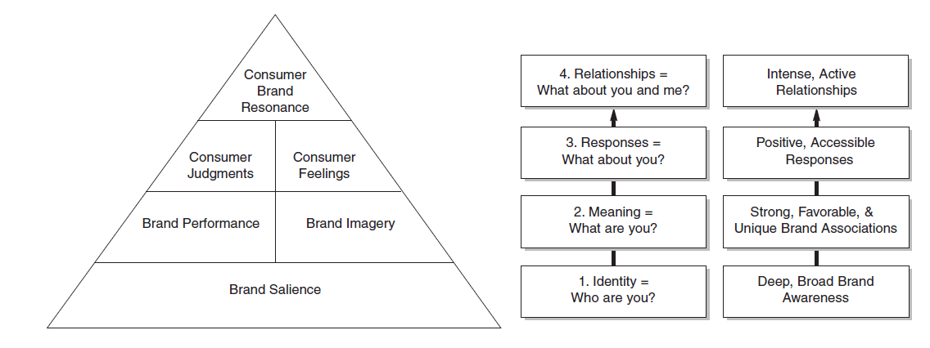
Figure 1- Customer-Based Brand Equity Pyramid

The model is made from different blocks: Salience, Performance, Imagery, Judgement, Feelings and Resonance (Figure 1). For this thesis, the focus will be on exploring and adapting two blocks believed to be the most relevant for the presented theme, specifically the Performance and Imagery. By using this model, it is possible to take into consideration different aspects that are a part of each block and relate it with theatre. The performance block will be present mainly in the section of the perceptual map in order to help create the survey around important multiple attributes and factors. And one component of the imagery will be a framework also used in the perceptual map to easily analyse and observe the types of connection and perceptions that the consumers have relatively to the different cultural events using the survey.
Looking at the block of Performance, it “relates to the ways in which the product or service attempts to meet customers’ more functional needs” (Keller 2001). Keller refers to brand performance as “the intrinsic properties of the brand in terms of inherent product or service characteristics” (Keller 2001). The product is very commonly the first point of contact between the brand and customers; therefore, it is important that consumer interactions with the product match expectations at the very least or exceed them in order to foster brand loyalty and resonance. There are five types of attributes and benefits that are a part of brand performance: Primary characteristics and secondary features – “Customers often hold beliefs about the levels at which the primary characteristics of a product operate (e.g., low, medium, high, or very high)” (Keller 2001). And they might also have about secondary elements that supplement the primary characteristics; Product reliability, durability, and serviceability – “Reliability refers to the consistency of performance over time and from purchase to purchase. Durability refers to the expected economic life of the product. Serviceability refers to the ease of servicing the product if it needs repair” (Keller 2001). The perceptions of product performance are very important to be analysed since it can be influenced by different factors that can impact delivery and installation, customer service, quality of the solutions, etc.; Service effectiveness, efficiency, and empathy – “Service effectiveness refers to how completely the brand satisfies customers’ service requirements. Efficiency refers to the manner in which these services are delivered in terms of speed, responsiveness, and so forth. Finally, service empathy refers to the extent to which service providers are seen as trusting, caring, and having the customer’s interests in mind.” (Keller 2001); Style and design – “Performance may also depend on sensory aspects —how a product looks and feels and perhaps even what it sounds or smells like.” (Keller 2001). This type of association is more focused on the aesthetic attributes that contribute for the associations people have with the product; Price – “The pricing strategy adopted for a brand can dictate how consumers categorize the price of the brand (e.g., low, medium, or high) and how firm or flexible that price is perceived to be (e.g., as frequently or infrequently discounted).” (Keller 2001). All these factors are important to analyse the performance of a brand and to understand if it is fulfilling the customers’ needs and how and where it can differentiate.
Another block present in the Keller model is the brand imagery. This block “deals with the extrinsic properties of the product or service, including the ways in which the brand attempts to meet customers’ psychological or social needs.” (Keller 2001). In order to analyse the different intangible aspects of the brand, the model presents four main categories: User profiles; Purchase and Usage Situations; Personality and Values; and History, heritage, and experiences. (Keller 2001). For this particular case only one of the categories will be explained since is the one that needs to be highlighted, which is the “Personality and Values”. This category tries to directly compare personality features and values similar to people with the brands. The goal is to understand the connection that people have with each brand. It consists of five dimensions of brand personality: “sincerity (e.g., down-to-earth, honest, wholesome, and cheerful); excitement (e.g., daring, spirited, imaginative, and up-to-date); competence (e.g., reliable, intelligent, and successful); sophistication (e.g., upper-class and charming); and ruggedness (e.g., outdoorsy and tough).” (Keller 2001). This category is based on a commonly used model in marketing- Brand Personality Dimensions. Such model was developed by Jennifer Aaker in 1997 and it will be explained in more detail in the next section (Aaker 1997).

2.2.2. Brand Personality Dimensions
Looking closely at the Brand Personality Dimensions introduced by Aaker, it had the goal of addressing the limitations associated with brand personality and come up with “a reliable, valid, and generalizable scale that measures these dimensions.” (Aaker 1997).
Brand Personality is a concept that generated a lot of interest and discussion since it was presented. It is a dynamic concept that allows a brand to create value and find a way to understand the consumer and how they feel. Moreover, it is a way for the brand to “appear more attractive and engage with the audience”, therefore it should not be underestimated, and its strategy should be carefully planned (Mercadal 2021). “A firm’s brand personality directly creates an emotional association in the mind of an ideal consumer group.” (Tarver 2021).
According to Aaker, Brand Personality is “to establish content validity, the development of a comprehensive and representative set of personality traits and the process of identifying a set of stimuli are described.” (Aaker 1997). A more recent approach refers to brand personality as “a set of human characteristics that are attributed to a brand name. An effective brand increases its brand equity by having a consistent set of traits that a specific consumer segment enjoys. (…) is something to which the consumer can relate.” (Tarver 2021).
To define the 5 brand personality dimensions, a study was conducted using the 5-point Likert Scale (1 being “not at all descriptive” and 5 being “extremely descriptive”). People would use this scale to “rate the extent to which the 114 personality traits describe a specific brand”. Once the data was analysed, they determined that the best five dimensions were Sincerity, Excitement, Competence, Sophistication and Ruggedness (Aaker 1997).
After, they came up with the brand personality framework (Appendix 1 – figure 2) as an attempt to finally have a measurement scale where you can clearly see the different dimensions and their representative sample of subjects (Aaker 1997). A study made in 2011 by Maehle, Otnes and Supphellen has reached a list of the general characteristics of brands associated to each one of the dimensions that will be presented next. Firstly, Sincerity, which main subject are “down-to-earth”, “honest”, “wholesome”, and “cheerful”. This dimension is usually associated to brands with the following characteristics: positive service experience, strongly associated with family, fulfilling the customers’ needs and expectation in a degree of high quality or associated with high moral values. Excitement is a dimension associated with brands which incentivise consumers to express their true self’s, create a creative and appealing image, are present on special occasions and “used by exciting people or produce exciting ads”. Looking at the Competence dimension, it relates to brands that are associated with: having high quality or are part of distinguished companies. Sophistication is a dimension that can be associated with brands with the following characteristics: differentiated by their uniqueness, used by celebrities, and associated with beauty and the feminine side. And last but not least, Ruggedness, a dimension that can be associated to a brand with a masculine nature (Maehle, Otnes e Supphellen 2011).
It has already been proved and studied that the brand personality concept can be applied to brands because people relate to brands in a personal and close way. The use of this model has the purpose to also understand if customers can relate in the same way to products. In a study from 2011, it has been found that not only brands but also product categories are strongly associated with certain brand personality dimensions. Although they recommend further research and investigation, they discovered some indications that products categories can also have distinct personality traits (Maehle, Otnes e Supphellen 2011)
It is important to mention that even though these models are related and associated with brands, the objective here is to take advantage of their formats and adapt them to this study. The goal is to understand and observe how the customers see theatre and to what characteristics they associate it with. Moreover, in the perceptual maps section some attributes and variables will be compared between what was considered the 4 main cultural events (Theatre, Cinema, Museums and Concerts). One of the comparisons is related to what brand personality dimensions do the respondents mostly associate each cultural event to. This model will also be important to generate conclusions, in the section of the perceptual map, about how the perceived personality of such events can positively or negatively influence the respondents’ engagement with the different cultural events.

2.3. Marketing Analysis Method
In the course of this thesis, the technique that will be implemented is perceptual mapping. The following chapter will characterize the method and explore its relevance to the work project.

2.3.1. Perceptual Maps
Perception is defined as the process by which a person chooses, arranges, and analyses information inputs to produce a relevant and significant picture of the world (Kotler and Keller 2016).
On the other hand, positioning is an activity carried out by managers which employs a range of marketing tools to impact and affect the customer’s perception and establish a sustainable long-term place in the target audience’s mind. A product’s position is the place it already occupies in the consumer’s mind, within its industry’s competitive environment (Schweiger e Schrattenecker 2009); (Helm 2009); (Rekettye e J. 2001). Depending on branding, consumers might perceive identical products differently. Additionally, positioning is an essential concept when it comes to the service industry, as it is a method that can lead to competitive advantages as a result of the consumers perception of the attributes tied to the quality of the service (Dash 2015). As a consequence of using this method, retaining and gaining new clients is the main variable in the development of the brand or institution.
Perceptual mapping is a marketing method regarded as one of the most significant and ideally suited for analysing brand equity’s origins and research (Chadha and Kapoor 2008). The perceptual map is a visual representation of the consumer’s perceptions of the selected attributes on two or more dimensions (Hair, et al. 1992).
When discussing attribute-based perceptual mapping, Chadha and Kapoor (2008) identify three different approaches: factor analysis (FA), correspondence analysis (CA), and discriminant analysis (DA). Each technique refers to the number of ‘plots’ obtained, and each requires specific criteria for producing the corresponding map and interpretation (Gower, et al. 2010). These methods allow the identification of the number of dimensions consumers engage in to distinguish the object, determine the satisfactory location of each object within each dimension, and present relevant information on the nature and properties of each dimension (Chadha e Kapoor 2008).
The aim of the map is to graphically illustrate different brands, in this specific case, the different cultural activities. The distances between them can be used to highlight similarity, and dissimilarity which is measured by the specific variables (Gigauri 2019). The perceptual map should construct a straightforward illustration of the targeted consumer’s perceptions on the aforementioned attributes and the relation between them (Chadha e Kapoor 2008). To be able to understand where the Portuguese theatre ranks regarding people’s perceptions as compared to other cultural events, such as cinema, museums, and concerts, the using of this method is crucial, and it will serve as a primary source of data to identify probable causes of lack of attendance in Portuguese theatre.
In the case of theatre, if the perceptual map reveals unsatisfactory results, the need to relocate its achieved position to alter consumer’s perception is named repositioning. This process can be accomplished through marketing communication or other promotional tools (Rekettye e J. 2001) and can set the direction on other marketing activities, mobilized by the service company, in order to guarantee better service quality based on the beliefs of the customers (Dash 2015).
As a second step it is necessary to structure a positioning strategy. This strategy should focus on three main factors: target customers; target competitors (in the case of theatre other cultural events will be considered, such as going to concerts or attending museums); and competitive advantage. Perceptual maps will, then, assist in revealing how the targeted consumer feels about both the company’s and its competitor’s products, at the same time (Najafizadeh, et al. 2012).
The finality of this process is to establish the brand value with an effective product positioning, and consequently maintain its lead in a competitive business environment and enable profit generation (Chiang, Lin e Wang 2008), (Gigauri 2019).
Theatre shows are undeniably a business which depends on attracting and retaining interested consumers. Without an audience, the theatrical performances have no way of continuing, which means that audience perception of the overall institution of theatre is critical in determining its success. Perceptual mapping is an easily conducted and low-cost technique which is consumer based and presents both diagnostic and strategic applications, especially regarding the identification of the threat posed by a substitute cultural event. Additionally, this tool would help answer one of the sub-questions proposed in this thesis, of what consumer have in mind when thinking about Portuguese theatre.

2.3.1.1. Choice of Attributes – Perceptual Map
Price
Price is usually one of the most important attributes to analyse. When it comes to theatre, researchers have named it “a typical example of an inelastic and luxury good” (Heilbrun e Gray 2001) (Lévy-Garboua e Montmarquette 2002). They also added that consumers show little sensitivity to price (Bourdieu 1984). This insensitivity is grounded in the social context that theatre has historically been associated with, typically a high-class form of entertainment.
A study was conducted in the 12 months prior to the pandemic where it was concluded that 9 out of 10 Portuguese people had a low cultural consumption (Lusa/TSF 2022). The salaries of the interviewees were considered an important factor when it comes to how often the Portuguese go to the theatre. 29% of the people with monthly salaries of over 2,700€ and only 7% of people with salaries between 800€ and 500€ affirmed they go to the theatre once or twice a year. At an average ticket price of 17.8€ (INE, 2021) when compared to the most consumed cultural event, cinema, which average ticket prices are of only 6.6€, theatre is far more expensive (Maia 2019).
Due to these findings, price seemed like quite an important and determining factor, hence a decision was made to include it in the assessed attributes in the perceptual analysis.

Service Quality
Service quality is directly linked to an organization’s profits and reputation. Measuring service quality can help a company or organization better satisfy customer needs whilst remaining competitive. Service quality is measured in 5 dimensions: reliability, tangibility, empathy responsiveness and assurance. Reliability is an organization’s ability to consistently deliver a product or service that meets the consumer’s expectations. Tangibility is how an organization portrays service quality to its customers. In the theatre context, this would translate to the appearance of the theatres - their maintenance, equipment, technology, as well as their communication materials. Empathy and responsiveness relate to how empathetic a consumer believes the company to be and how promptly a company can address and dedicate to the consumers, respectively. Finally, assurance is the confidence that customers have in an organization to fulfil tasks that are usually above their ability to understand. Most people go to the theatre for the belief they will be entertained by competent people whose job it is to entertain (Indeed Editorial Team 2022). Assessing service quality is essential for a company’s survival and success. Managing service quality also means better managing service delivery and better meeting the ever-changing customer expectations (N. 2019).
In the theatre industry, service quality is measured from the moment the customer buys a ticket to the moment he/she leaves the theatre. As mentioned before, service quality is vital for an industry and it’s no less the case for the theatre sector. Measuring service quality and the perception consumers have on the theatre experience can not only help explain the declining state of the industry, but also help with coming up with solutions to battle it.

Promotions
Promotions, typically discount sets in the theatre industry, are ways of enticing and retaining costumers. Senior and student discounts are probably the most common form of promotions in the performing arts sector. But, in Portugal, cinema focuses its promotions on partnerships with other companies. For example, the famous cartão NOS which a customer can get from a TV subscription with NOS, grants the user with 2 for 1 in cinema tickets or a discount on popcorn (NOS 2022). This is the case of a promotion that Thaler (1985) describes as a gain as opposed to merely a reduction of the purchase price. He defends that a “mental account” might be formed which will make the customer passively loyal to a brand and instantly associate it to a product, service, or industry.
Essentially, these partnerships could be described as passive loyalty programmes. And, although, the recent rise in the rate of promotions has been turning customers more sensitive to price, less loyal and more opportunistic, that impact hasn’t been felt in the cinema sector as much (Kapferer 2012). As cinema and theatre share many of the same characteristics and being this type of promotion quite a big success in Portugal, it is quite relevant to further analyse its relevance to customers.

Variety of Offers
Variety of offers tends to be an important aspect of any business or industry. In the arts sector, the customers perceived quality of a theatre can be linked to its high variety of offers. In fact, customers’ cultural preferences are typically influenced by the variety an industry offers since it frequently acts as a quality cue (Berger, Draganska e Simonson 2006).
In 2020, there were 6,161 theatre showings and 5,368 concerts in Portugal, while cinema had 276,982 sessions spanning across the 1,037 films showed that year (INE 2021). Given the nature of what it takes to organise a cinema session, it is logical that it would have more sessions than other, more organisational heavy sectors. Nonetheless, it is therefore important to understand the impact of such variety on a customer’s choice of one cultural activity over another and the impact the lack of variety has on adhesion.

Location & Facilities
Theatre is probably one of the oldest forms of entertainment, dating back to as early as the beginning of the 5th century. A big perception of the theatre as an experience revolved around the venues, that a few decades ago, offered entertainment outside the show itself. One big example is Parque Mayer, a complex of four theatres with daily showings of several shows. The complex had multiple stands that served food and drinks (P. Lourenço 2022).
One of the consequences is that as cities grow, historical centres where theatres are usually located, become further away from most citizens (Agustí, Guilera e Lladós 2022). As such, willingness to commute to the theatre venues plays a big a role on the decision to go to the theatre rather than going to the cinema, for example. Although cinema and theatre can be seen as great substitute activities, the practical degree of such substitutability may be reduced by the wider accessibility of cinema across a nation as opposed to the more concentrated position of theatre (Seaman 2005). By not being so present outside city centres, theatre then becomes more segregationist and less competitive and appealing.
Another aspect is the condition of such facilities. While sports stadiums are typically new, well-maintained spaces, theatres are usually old venues in sometimes questionable conditions and accessibility. Seaman (2005) mentions that the direct link between the quality and availability of art facilities is not to be disregarded. Its importance may well be quite high to consumers and deserves deeper analysis.

Channels of communication
In this case, the channels of communication relate to how the different cultural events are advertised, either by social media ads, posters or TV spots.
The channels of communication can be a great determinant of how an industry appeals to a consumer. Everyone is quite familiar with a film trailer but however present, they are far from being widely adopted forms of promotion in the theatre sector (Johnston, Vollans e Greene 2016). For example, in Portugal, it is far more common to see TV spots for new films coming out or announcements for music festivals than it is to see ads for museums or theatre. In contrast, museums and theatre are mostly advertise through posters scattered around the cities they are in.
However, channels of communication are not just limited to how an event is advertised but also how it reaches people. Fort (2004) stated that when people watch football matches on TV, the broadcasting of the event itself results in significant revenues but also in higher diffusion, reaching more people. That’s also why football has an added and growing popularity as well. In fact, streaming of theatre plays is what helped theatre survive the pandemic (David 2022).
Given the importance of channels of communication in interest generation for the consumers and being responsible for the reach that these events might have, by optimizing its communication strategy, the Portuguese theatre industry could benefit from higher levels of engagement, generating more interest and possibly attracting more costumers.

3. Analysis

3.1. Perceptual Map
By building a perceptual map it is possible to understand, graphically, how theatre is positioned when compared to other cultural events (Cinema, Museums and Concerts), gain insights on the different perceptions that customers have regarding each event, and be able to identify if there are any possible gaps that theatre can take advantage of to improve its presence.
Firstly, a description of the composition of the survey will be presented, and how the sample was collected. Secondly, it will be presented an in-depth analysis of the results obtained in the survey related with the demographic characteristics, and, afterwards, some observations regarding in which category the respondents include each cultural event in. This is followed by different multidimensional perceptual maps, in which it is possible to gather insights on the perceptions that customers have on this variety of events and their attributes, and ultimately help answering this thesis’ main question: Why is the demand for Portuguese Theatre stagnated and possibly declining?

3.1.1. Methodology
In order to gather data to analyse the consumer’s perceptions, it was created a survey on Microsoft Teams that was accessible for 5 days. The survey had a total of 17 questions, there was a Portuguese and English version, and all the answers were anonymous (Appendix 3 – table 6). Due to the research being focused on the Portuguese market, the biggest target of the study were people familiarized with the different cultural events in Portugal. Therefore, a Portuguese version of the survey was created to be easier to reach the Portuguese population. It is important to add that the perceptions collected are not only from the customers of each of these cultural events, but some are also from non-customers (of cinema, concerts and museums activities) that shared their perception relatively to the one event they have never been.
At the beginning of the survey a small introduction was written identifying the study, the subject, the university and the goal of the survey. The first three questions consisted of demographic information: the respondent’s age group, gender, and nationality. The age group had different options to characterize the different personas: under 18, 18-25, 26-35, 36-45, 46-58, +59 (Appendix 3 – table 6). The number of age groups options were reduced relatively to the preliminary survey to make it more concise and meaningful. As for the gender it had three options: women, men and other. In the question related with nationality it was added three nationalities that were considered the more common, Portuguese, French and German, and an “other” option.
In the next section of the survey, the main focus of examination was to compare 4 different common cultural events in Portugal, namely, Theatre, Cinema, Museums and Concerts. These 3 cultural events were chosen since they are perceived as being the closest substitutes of the Theatre. Through this analysis it will be possible to take conclusions on what may be failing or working with each one of them, taking into consideration the customers perceptions. At the beginning of this section of the survey, two key questions were taken into account: one to understand the frequency of attendance of the respondents, and other to observe which category (Fun, Formal, Educational, and Boring) they would insert each one of the cultural events in (Appendix 3 – table 6). The rest of the questions on the survey were the questions more critical and relevant to develop the perceptual analysis. It consisted of 12 questions structured according to the 4-points Likert scale. The 4-point Likert scale does not offer a neutral option, but it has multiple advantages, it is “desirable for young respondents and for respondents with low motivation to complete the questionnaire” and also “easy to understand and they require less effort to answer”. (Nemoto e Beglar 2014) The Likert scale allowed to collect the consumer’s perceptions about each cultural event (Theatre, Cinema, Museums and Concerts) according to the attribute being questioned in an intuitive way. The 4-points Likert scale was used in order to force the respondents to have an opinion about each attribute and avoid the results to stagnate in an inconclusive answer (for example, if people would frequently choose the option “neither agree nor disagree” so they would finish the survey faster). When analysing the preliminary survey, it also helped conclude that the Likert scale could be more intuitive and an easier method for the respondents to interpret. The scale was adapted to each question, therefore the first 7 questions consisted on an interval from 1 to 4, being 1- Not Satisfied and 4-Highly Satisfied, followed by the “Never been” option. The characteristics analysed in those first 7 questions were: Price, Service Quality, Promotions, Channels of Communication, Variety of Offers, Customer Service and Location and Conditions of the Facilities. The other 5 questions were based on the 5 different brand personality dimensions with the scale adapted to which one of them, followed by the “Never been” option: Rugged (1-Very Frail to 4-Very Sturdy.), Sincere (1-Very Unreliable to 4-Very Sincere), Enthusiastic (1-Very Dull to 4-Very Enthusiastic), Competent (1-Very Incompetent to 4-Very Competent) and Sophisticated (1-Very Basic to 4-Very Sophisticated), as can be seen in Appendix 3 – table 6.
Before the survey was officially launched, the group double checked each question, its translation and asked to friends to fill the survey in order to understand if it was intuitive and confirm if there were no mistakes. With these tests it was necessary to make some adjustments to the survey. Some questions needed to be rewritten in order to make more sense and to be easier to understand what was asked. Moreover, examples were added to the different attributes to help the respondents imagine the characteristics and components present in each cultural event.
In order to collect all the answers necessary, it was used different platforms: Facebook, Instagram and WhatsApp. These platforms allowed to take advantage of personal social media accounts and share the survey with friends and families (Instagram, Facebook and WhatsApp) but also share the survey in groups from university or related with theatre and cultural events. (WhatsApp and Facebook)
The survey resulted in 214 observations with an average time to completion of 16 minutes and 35 seconds. In order to have a good sample to analyse, some respondents had to be excluded since they were inserted in certain conditions. People that never been to theatre or did not answer some of the questions in the attributes and left it blank had to be excluded. Moreover, respondents that answered that they have been to one of the cultural events (Theatre, Cinema, Museums or Concerts) but in the following questions answered “never been” also had to be excluded. This could mean that they did not understand the question or were not following the instructions given. This were unreliable and inconsistent answers; therefore, it was better to exclude in order to obtain more accurate observations and analysis. Consequently, only 146 out of the 214 respondents were taken into consideration for this study, whose answers will help build the perceptual maps and analyse customer’s perceptions.
The program used to compute the analysis relative to the different variables was the IBM SPSS software platform.
In the next section it will be possible to analyse the aggregated results obtained by the 146 respondents in the survey for the perceptual map and highlight some observations relatively to the different parameters.

3.1.2. Results
Sample characteristics
As mentioned before, after filtering the results, 146 respondents' answers were considered and based on those perceptual maps were built. It is important to mention that some of the questions- age, gender, nationality, category and frequency - were in nominal values that had to be converted into a numerical scale, connecting the different options to a number. In the next sections, it will be specified to each number corresponded each option.
Age
As said before the survey contained 6 different age groups (under 18, 18-25, 26-35, 36-45, 46-58 and +59) but once the data started being analysed some of the groups had a low number of answers. Therefore, some of the age groups were merged in order to make the interpretations easier and more concentrated, resulting in 4 different age groups: under 18; 18-25; 26-45 and +46. The numbers present in the histogram correspond to different age groups, 1 corresponds to the age group of under 18, 2 refers to the age group that include ages from 18 to 25, 3 is for the age group between 26 and 45 and finally, number 4 for the respondents that were 46 or older. As observed in the figure 23, the age group between 18 and 25 years old is the majority and represents almost 49% of the respondents (Appendix 3 – table 7).

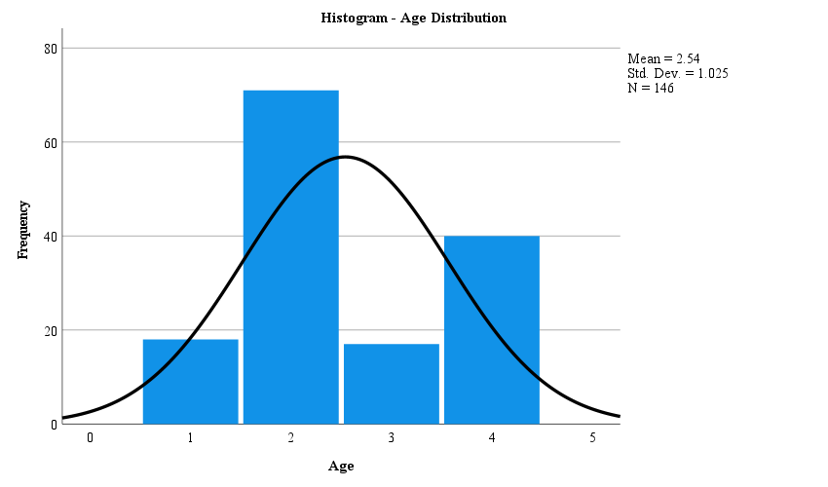
Figure 23: Frequency distribution of the age histogram
1= Under 18
2= 18-25
3= 26-45
4= 46+

Looking into the under 18 age group, they account for around 12%. As for the last two groups, the third age group represents 11.6% and the fourth age group represents 27.4% (Appendix 3 – table 7). These percentages seem to show that younger respondents are the ones more familiarized with these cultural events. Although, this conclusion can be influenced by the fact that the survey was shared on multiple social media platforms, which have a tendency to be used by younger ages. It would be beneficial if it was possible to have a larger and unbiased sample of the population in order to make this interpretation.

Gender
The numbers present in the Appendix 3 – figure 24 correspond to different genders, 1 corresponds to women, 2 refers to men and 3 is for the respondents that answered other. Moreover, as visible in Appendix 3 – figure 24, the gender distribution is skewed towards women and it is possible to observe that they constitute the majority of respondents, corresponding to a percentage of 61.6%. As for the remaining respondents, 37.7% were men and 0.7% felt into the category of others (Appendix 3 – table 8).

Nationality
Observing the data relative to nationality, in table 9 from appendix 3, the reason why is skewed to the right it is because 98,6% of the respondents answered they were Portuguese, except for 2 people (1.4%) that did not answered the question (Appendix 3 – figure 25). These statistics can be understandable since it makes sense that most of the people that are familiarized with these cultural events in Portugal to be Portuguese respondents.

Frequency of Attendance
Continuing with the analysis, it was collected the frequencies of attendance of each respondent according to each of the compared cultural events (theatre, cinema, museums and concerts). The numbers present in the histogram correspond to different types of attendance, 1 corresponds to once a year, 2 refers to an attendance from 2 to 3 times a year and 3 is for the respondents that have an attendance equal or superior to 4 times a year. As mentioned above, the reason why it is not presented the frequency relatively to “never been” is related to the fact that when filtering the results of the survey the respondents that have never been to theatre had to be excluded. Those answers could have become too vague and unsupported, and it was necessary a real and practical perspective of the consumers, leaving us with the 146 respondents that have been to theatre at least once.
In figure 26 relative to theatre, the normal curve is skewed to the left, towards an attendance of once a year, accounting for a percentage of 57.5% (Appendix 3 – table 10). It is possible to also analyse through the Appendix 3 – table 10 that the attendance of 2 to 3 times a year corresponded to a percentage of 30.1% and only 18 people would go 4 or more times a year (12.3%).

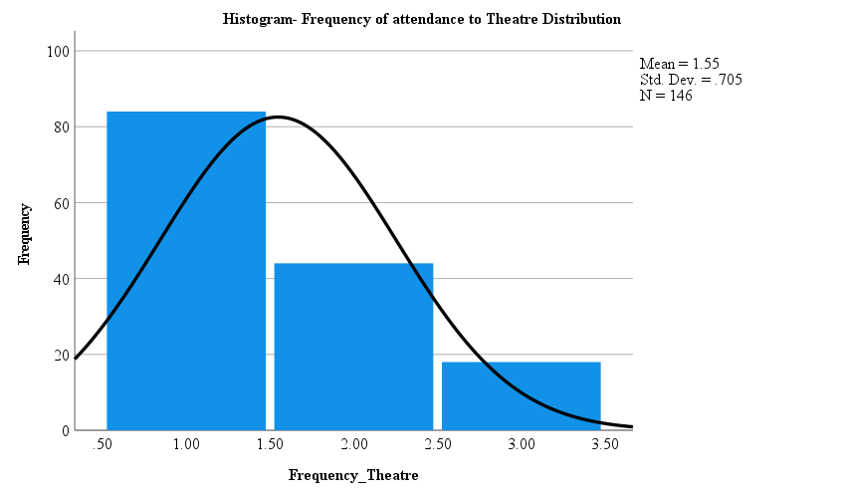
Figure 26: Frequency of attendance to theatre histogram histogram
1= Once a year
2= 2-3 times a year
3= 4 or more times a year

As for cinema, it is possible to observe through figure 27 that it is skewed towards the right side, with an attendance more frequent throughout the year. Looking at the Appendix 3 – table 11, the attendance of once a year accounted for 20.5%, 2 to 3 times a year corresponded to 35.6% and more than 4 times a year represented the highest percentage of 42.5%. Only 2 people (1.4%) have never been to the cinema. In case of this cultural event, there was 3.4 more respondents that would go more than 4 times a year to the cinema (a total of 62 people) than to theatre (a total of 18 people). This is an interesting insight to have and possibly retrieve some observations when comparing the different cultural events.

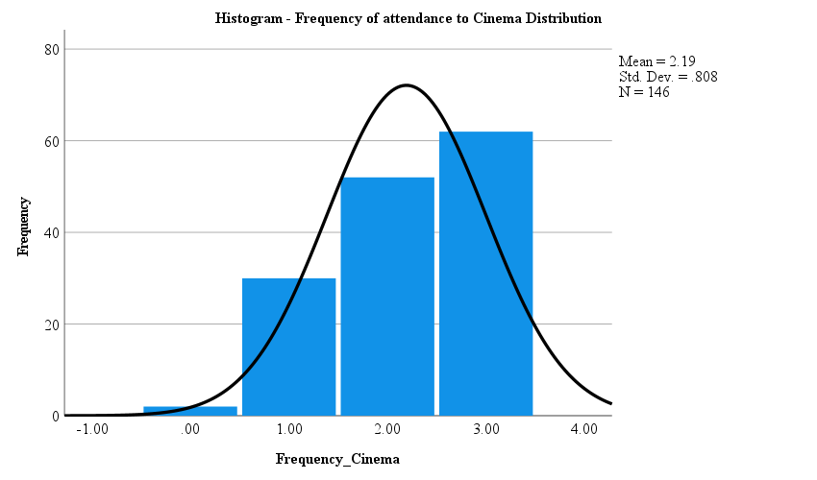
Figure 27: Frequency of attendance to cinema histogram
0=Never been
1= Once a year
2= 2-3 times a year
3= 4 or more times a year

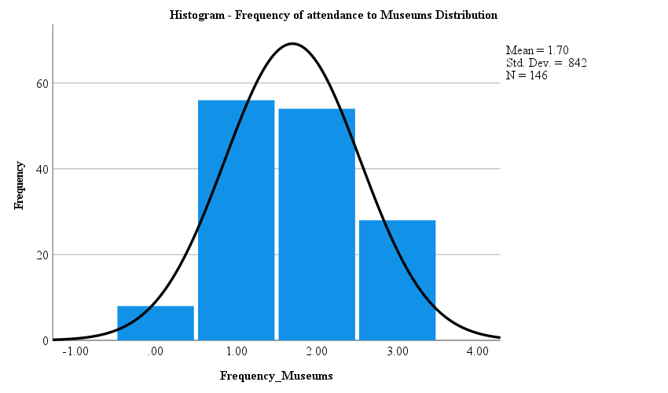
By observing figure 28, it is noticeable that the attendance to museums has a more disperse distribution. 5.5% of the respondents (8 people) have never attended a museum, once a year represented the highest percentage of 38.4%, 2 to 3 times a year corresponded to 37% and more than 4 times a year represented 19.2% (Appendix 3 – table 12). The amount of people that attended museums more than one time in a year (82 people) was 1.3 higher when compared to theatre (62 people). Leading to believe that it was more common for people to repeat the experience of going to a museum than to a theatre. But still an attendance to museums not as high and repetitive as the frequency of attendance to cinema.
Figure 28: Frequency of attendance to museums histogram
0=Never been
1= Once a year
2= 2-3 times a year
3= 4 or more times a year

As for concerts, its frequencies can be observed to be similarly dispersed in figure 29 as in figure 28, the frequencies of the museums. From the respondents, 6.8% never been to concerts, 34.2% have been once throughout the year, 42.5% have been between 2 and 3 times a year and more than 4 times a year accounted for a percentage of 16.4% (Appendix 3 – table 13). Concerts were the cultural event with more people that never went to one (10 people) when compared to cinema and museums (2 and 8 people, respectively). Moreover, for this cultural event the respondents have also showed to have an attendance more frequent when compared to theatre. The survey showed that approximately 1.4 times more people went to concerts more than once in a year (86 people) when compared to theatre (62 people). Even though concerts did not represent the highest percentage for the frequency of more than 4 times a year, it represented the highest frequency for an attendance between 2 to 3 times a year (42.5%) when compared to the other three cultural events.
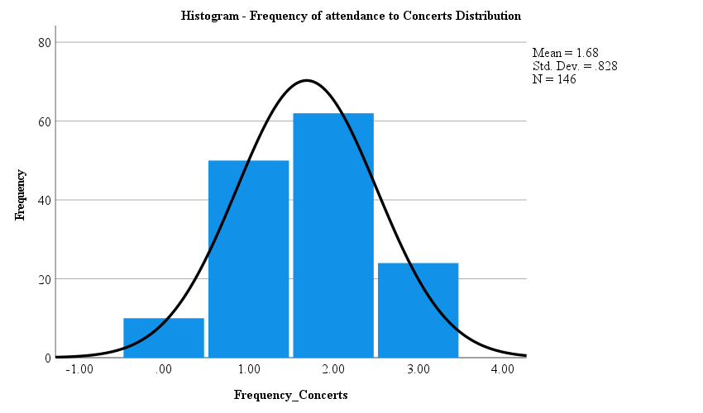
Figure 29: Frequency of attendance to concerts histogram
0=Never been
1= Once a year
2= 2-3 times a year
3= 4 or more times a year

Category
In order to understand the respondent’s perception and feelings towards the different cultural events, a question regarding the categorization of each cultural event was created into the following options: fun, formal, educational and boring. When converting the nominal into numerical data the correspondence was: 1 to fun, 2 to formal, 3 to educational and 4 to boring.
In figure 30 relative to theatre, the normal curve is skewed to the left, towards the fun and formal categories. Most of the respondents, 47.3%, considered theatre a fun cultural event and 26.7% associated it with formal. Moreover, 22,6% answered that theatre is related with the category educational and only 5 people (3.4%) considered theatre to be boring (Appendix 3 – table 14). When comparing this data to the one from the preliminary survey the most common category associated to theatre was also fun with a percentage of 55%. Although, when looking for the second more common category in the preliminary survey it differentiated from the one above, being presented the educational category with a percentage of 29% (Appendix 3 – table 14).
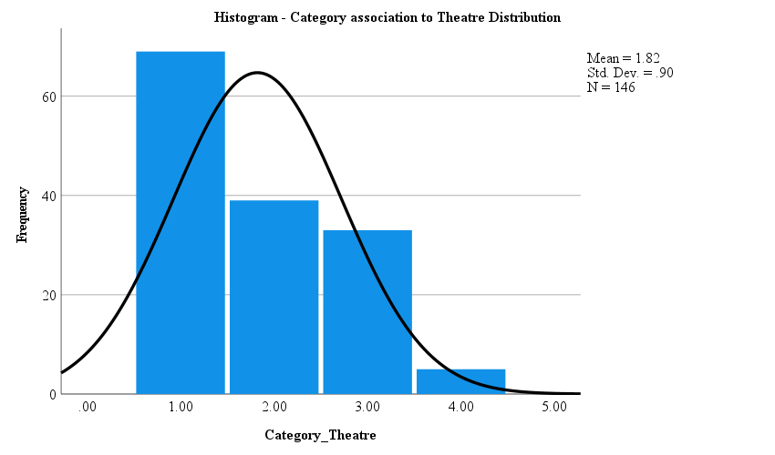
Figure 30: Frequency of category association to theatre histogram
1= Fun
2= Formal
3= Educational
4= Boring

As for cinema, through figure 31 can be observed that is skewed to the left, towards the fun category. For this cultural event, it showed a huge consensus between the respondents to allocate cinema to the fun category with a percentage of 95.2%. Besides that, 5 people (3.4%) considered it to be formal, 2 (1.4%) educational and 0 people considered it boring (Appendix 3 – table 15).
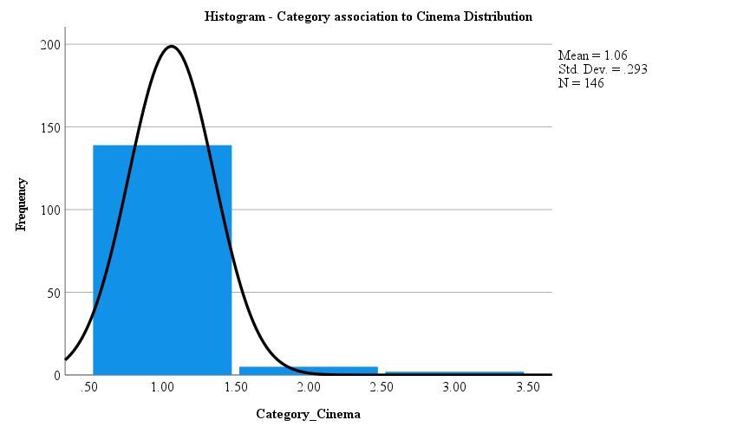
Approximately, the double of people considered cinema to be inserted in the category of fun when compared to theatre.
Figure 31: Frequency of category association to cinema histogram
1= Fun
2= Formal
3= Educational
4= Boring

When looking at museums, the normal curve is slightly skewed to the right, towards the educational category. By observing figure 32, is visible a high consensus between the respondents to allocate museums to the category of educational with a percentage of 80.1%. Moreover, 6 people (4.1%) considered museums fun, 14 (9.6%) formal and 9 (6.2%) boring (Appendix 3 – table 16). The category educational seems to be the one more strongly connected to this cultural event.
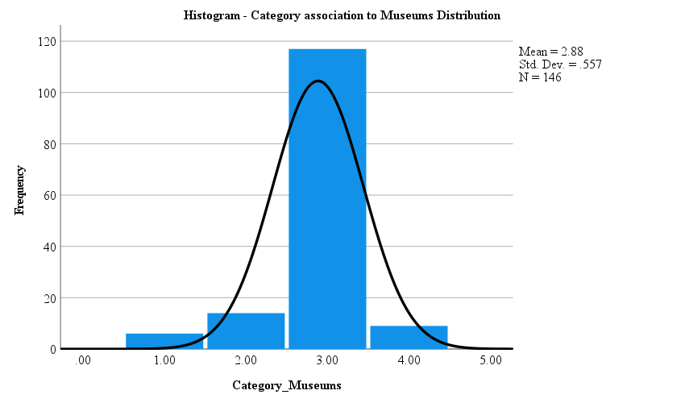
Figure 32: Frequency of category association to museums histogram
1= Fun
2= Formal
3= Educational
4= Boring

Lastly, for the concerts, its graphic is skewed to the left towards the fun category. (figure 33) In this cultural event there is also a big consensus towards the category associated with concerts, being considered fun with a percentage of 94.5%. Besides that, 2.1% considered concerts educational and 3.4% considered it boring. No respondents considered concerts educational. In this case, concerts have a similar percentage (94.5%) to the cinema with 95.2% associated with the category of fun (Appendix 3 – table 17). This allows to analyse that the respondents have a similar perspective and idea of both of these cultural events. Besides it opens the possibility of considering cinema and concerts the closest alternatives when taking into consideration all four of the cultural events but it will be possible to observe that in the next section.
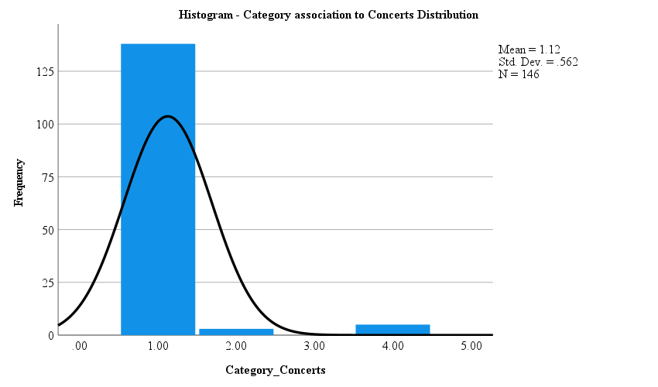
Figure 33: Frequency of category association to concerts histogram
1= Fun
2= Formal
3= Educational
4= Boring

To summarize this section, it was observed that most of the respondents belonged to the age group between 18 and 25 years old, were women and all of them had Portuguese nationality.
Looking at the frequency of attendance, theatre revealed to be the cultural event with the highest number of people that just attended once in a year (84 people) and with the lower number of people that would go 2 to 3 times a year or more (with a total of 62 people). This opens the possibility to believe that people prefer to go more frequently to cinema, which represented the higher numbers of frequency of attendance. The same for museums or concerts that had similar numbers between each other and higher frequencies of attendance than theatre. The reasons for these results can have different possibilities: people do not like the yearly experience they have in theatre and avoid going. It will be possible to also analyse these factors in the next section and compare between all the attributes and cultural events studied to retrieve some observations from the perceptual maps originated.
As for the category section, theatre was the only cultural event that did not have a consensus answer between the categories presented, the percentages were mainly distributed by the first three categories (fun, formal and educational). The more common categories used for theatre was fun with a percentage of 47.3% (lower than the cinema and concerts percentage relatively to the category of fun) and formal with a percentage of 26.7%, which contradicted the results obtained in the preliminary survey which contained fun and educational as the two main categories chosen. In this case it might translate into a lack of good positioning of theatre, incorrect communication, or inaccurate perception of the respondents relatively to theatre and it will be possible to analyse that aspect in the following parts of the paper. Relatively to the other cultural events, cinema and concerts have a similar percentage representing the number of people that associated these events to the category of fun. This might indicate that both of these cultural events are possible alternatives to satisfy the same wants or needs since people perceive them with an identical category. Moreover, looking at museums, it was the only event that the category of educational was strongly associated with a high percentage of answers, when compared to the others 3 cultural events.
In the next section the data collected in the survey will be gathered in order to build the perceptual maps and to be possible to analyse some of the aspects mentioned before and withdraw new insights relatively to theatre.

Multidimensional Perceptual Map
To further analyse how people perceive the theatre a perceptual map was generated through SPSS (an online statistical software). This tool facilitates the discovery of variables that are very correlated, or incredibly negatively correlated and then it collapses those into smaller dimensions, which at the end helps to make better sense of the data. The chosen method to compress information was factor analysis. With this method it is possible to find variables which are latent and can be good descriptors of the data set.
Throughout this assessment two-dimensional solutions were generated, as presented in table 18 and 19. The reason behind the quantity of dimensions produced lies on the method chosen, and according to the picked one (factor analysis), a dimension is only accepted if the different values related with the linear system of equation (eigenvalues) are higher than 1, as proposed by Kaiser in 1960 (Cliff 1988). Therefore, a cumulative variance of 97.72% and 92.86% can be seen in table 18, just leaving a small portion of the variance not being explained by the selected dimensions. When looking into more detail, to the different parts of the cumulative variance, it becomes clear that the first dimension explains 56.27% of the variance while the second one explains 41.45%, as can be seen in the table below.
Table 18: Total variance explained – attributes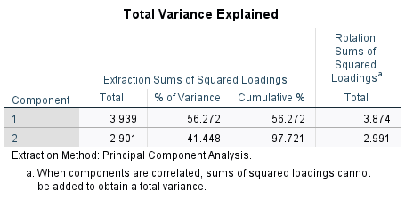
For the second factor analysis conducted, alike the first one, the first dimension justifies 78.51% of the variance, while the remaining 14.36% was allocated to the second dimension.
Table 19: Total variance explained - personality
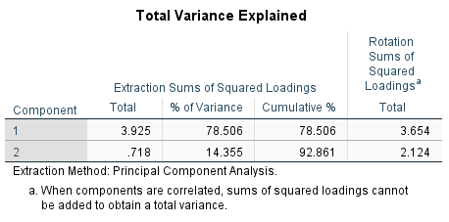
To better represent the dimensions mentioned above, two scatter graphs were originated, where in both the X-axis represents dimension 1 and the Y-axis concerns dimension 2, as shown in Appendix 3 – figure 34 and 35.
To describe both dimensions and the correlations between the several variables and factors it is necessary to interpret the factor loadings to have a deeper understanding of how each variable relates with a given factor. Loadings can go from -1 to 1 and the closer they are to these two values the more the factor impacts the variables. The opposite can be observed when the loadings are closer to 0 (Sarstedt 2010). Another way of analysing the factor loadings can be by looking at the closeness of the vectors to the different axis. If a vector is very close to a specific axis this means that that vector contributes more to the interpretation of such dimension than another one. By looking at the following table and analysing the factor loadings, one can identify 2-dimension groups.

Table 20: Rotated Component Attributes Matrix | Varimax with Kaiser Normalization
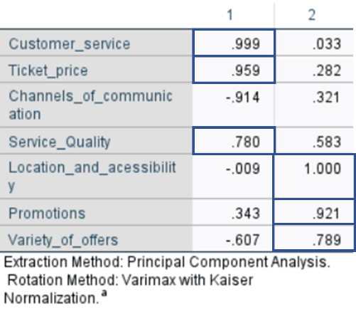
The first comprises the ticket price, the customer service, and the service quality. The second one is mainly related to the location and accessibility, the variety of offers and promotion. Thus, dimension 1 can be understood as the main/primary impactful service attributes since it is mostly related with the quality of the offering, price, and customer support, while dimension 2 can be seen as the additional, and secondary most important attributes that can impact the service (table 20).
Still related with consumers perceptions of the Theatre personality, as can be seen in the table below, the first dimension shows a strong aggregate on competent, sophisticated, and sincere, whereas the second dimension comprises ruggedness (table 21). Therefore, the first one can be associated with adjectives with positive denotation while the second one as the opposite.

Table 21: Rotated Component Personality Traits Matrix | Oblimin with Kaiser Normalization
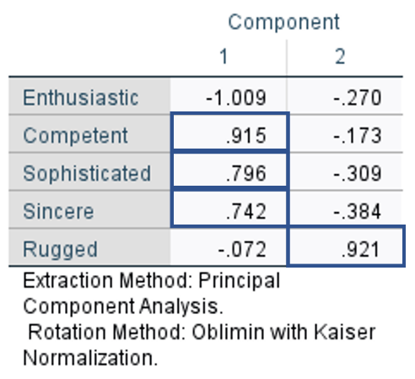
Other activities (museums, cinema, and concerts) were included on the perceptual map analysis. Hence, by adding them in the study conclusions can be made about people’s perceptions of each activity (which can then present information to support the idea mentioned above) and spot the similarities among the Theatre and the other events, which can be further explored to potentially revert the present situation of the Theatre.

Figure 36: Perceptual Map cultural activities positioning - attributes analysis
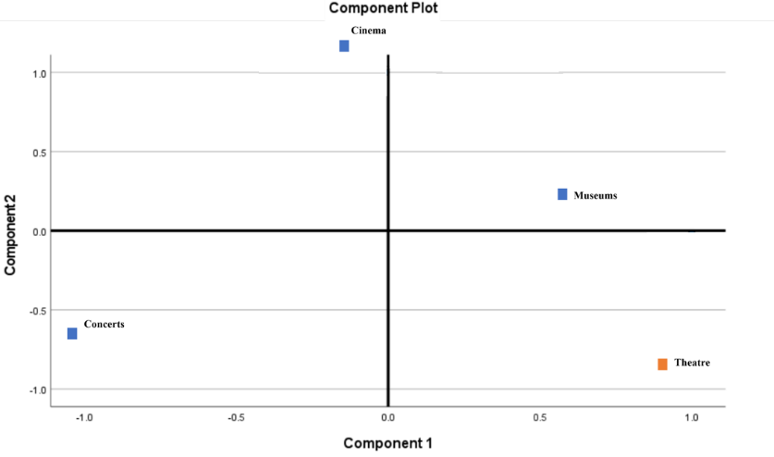
Moving onto figure 36, the position of the various categories of cultural activities, while bearing in mind the ranking of the different attributes, the main takeaway is that these events can be divided into 4 different groups: the Museums in the 1st quadrant, the Cinema in the 2nd one, the Concerts in the 3rd quadrant and lastly, the Theatre in the quadrant number 4 (if the cartesian plane is divided into 4 different section, starting from the top right quadrant and moving counter clockwise). According to people’s perceptions, all these activities are different. They do not share similarities and that can be concluded due to their peculiar location on the graph. Also, that may be the case since each one of them focus on offering a different experience and thus, have specific characteristics that cannot be comparable to the other activities (e.g.: theatre and concerts showtimes - very specific, do not happen every day at every hour like the expositions and movie sessions). Therefore, it suggests that an individual’s perception of the Theatre has little to do with the other activities.
A similar conclusion can be applied to people’s perception of the Theatre’s personality (figure 37) when compared to the rest of the activities, since none of them are in the same quadrant as the Theatre, as can be seen in the figure below.

Figure 37: Perceptual Map cultural activities positioning – personality traits analysis
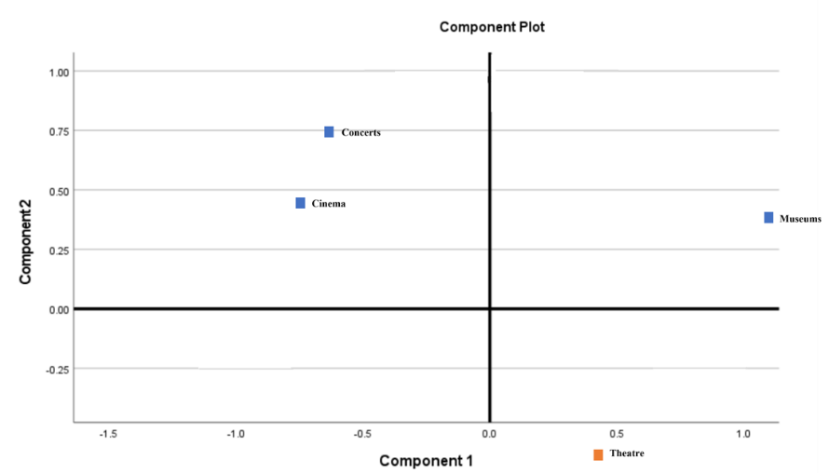
When merging the position of the several cultural events with the positions associated with the 7 defined attributes (Customer service, Ticket price, Service quality, Promotions, Location and accessibility, Variety of offers and Channels of communication), using its coordinates (Appendix 3 – table 22) while considering the length and direction of the vectors the following interpretations can be made (figure 38, below):

Figure 38: Perceptual map – activities and attributes position
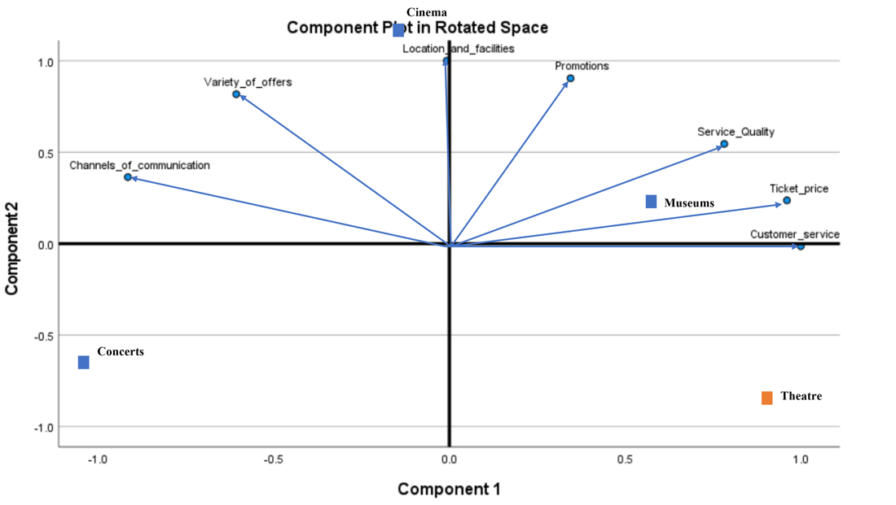
1) There are attributes with similar directions, which implies that if one of them is rated high then other ones in the group can expect a similar score. In this case, there is only one group that indicates a clear positive correlation among the several attributes (ticket price and customer service). Hence, if ticket price rates high then this will implicitly cause a high ranking rate in customer service as well, and vice versa. There is also a positive correlation between this previous group and the service quality attribute, although not that clear through the graph. Consequently, when the ticket price or the customer service rates high the service quality scores the same and vice-versa, which makes sense since usually people expect that a higher price will come with a better output (service quality) and better treatment (customer service).
2) There are attributes that are negatively correlated with the others (vectors with opposite directions): channels of communication, variety of offers, location and accessibility and finally, promotions. This suggests that a high rank in one attribute will be negatively associated with the opposing attribute and vice versa.
3) There are attributes perpendicular to one another, which reveals that they are extremely uncorrelated, as it is the case of the location & facilities and customer service, which is logical since one thing does not relate to the other whatsoever.
To analyse the perceptual map properly, several associations between the attributes and the activities were performed and the main conclusions were the following: individuals perceive every activity as different, since each one of them is in a different quadrant, as explained before. On the one hand, according to figure 38 the activity that was perceived as having the highest quality service, customer service and better price was the Museums. On the other hand, the Cinema is highly associated with having a great location and accessibility conditions. The Theatre is also positively associated with the customer service, ticket price and service quality, although less obvious than the Museums. Lastly, the Concerts occupy a unique position on the maps, which leads to negative associations with all the attributes (figure 38).
Another interpretation can be made based on the ranking of the 7 attributes per type of cultural activity, with special focus on the Theatre. The process involved creating an imaginary perpendicular line along each attribute line. Then the movement of the line started from the point contrary to the origin and would go to the centre of the map. This way it was possible to ensure which attributes were influencing the activities position, more specifically the theatre position, that can also be verified by observing the perceptual map in figure 38. The higher the rank, the higher the level of individual’s correlation between an attribute and the activity in question.
Regarding the Theatre, it is perceived by consumers as having great customer service, high service quality and good prices. It ranks moderately in promotions and, location and facilities. The opposite is visible with the channels of communication and variety of offers. Respondents were not so sure about a possible strong association between the theatre and these two attributes, and they aren’t clearly satisfied with the current used channels of communication and variety of plays available. These results confirmed the original beliefs: people are pleased with the overall service quality that is provided by the theatre and its prices, so the issue must fall on the communication channels and the variety of plays offered, since these are the 2 attributes that ranked the lowest score.
Moving onto figure 39, the theatre is also perceived as very competent, sophisticated, and sincere, and not so rugged or enthusiastic as the concerts and the cinema. This conclusion could only be taken after calculating the coordinates of each cultural activity (Appendix 3 – table 23) and positioned each one of those into the perceptual map containing the different dimensions of a brand’s personality.

Figure 39: Perceptual map – activities and personality position
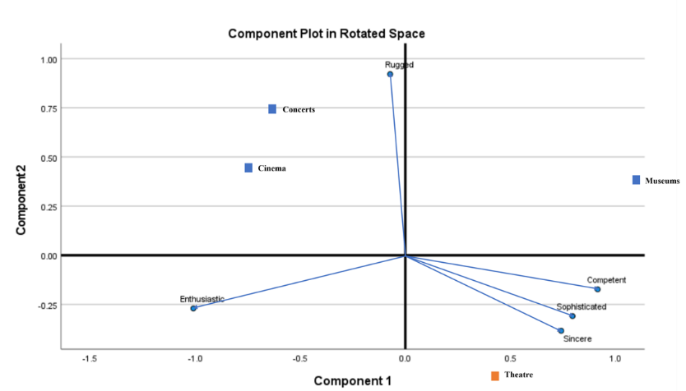
An additional aspect to take into consideration is the vectors length associated with the different attributes, which can produce different types of interpretations. The attributes with the longest vectors are the customer service, ticket price, channels of communication, variety of offers and service quality, while the shortest are the promotions and location and facilities.
Furthermore, the higher the attributes length, the better that attribute differentiates among the various activities. Thus, it is simpler for consumers to differentiate the cultural events in terms of customer service, ticket price, channels of communication, variety of offers, service quality (figure 38) ruggedness and enthusiasm (figure 39). Besides that, vectors can explain the associations people make with the corresponding attributes. Hence, when the attribute is located closer to the direction of the vector (further away from the origin), the highest the association people make between that attribute and the activity, which is the case with the theatre and the service quality, customer service, price, sophistication, sincerity, and competence as previously mentioned.
Finally, it is essential to emphasize that the angles between the vectors, in figure 38, can also convey important information, such as similarities in consumer perceptions. For example, regarding the attribute’s perceptions, the vectors related with ticket price and customer service have a smaller angle between them, which can be interpreted as having higher similarity among them, meaning when people think about the theatre having a great customer service, they also think about having a great price. The same logic can be applied to people’s perceptions of the location & facilities and promotions and then, to the variety of offers with the channels of communication. On the other hand, customer service and channels of communication have a big angle between them which can tell that an activity when associated with having a great customer service usually has few channels of communication and vice versa.
The same rationale can be applied when looking at consumers' perceptions of the Theatre personality (figure 39, above). The angles between sincere, sophisticated, and competent are small, which implies that there are high similarities among them. When the Theatre is perceived as sincere it is also highly associated with being extremely sophisticated as well as incredibly competent. The opposite happens with sincerity and enthusiasm, suggesting that the theatre can be understood as super sincere but not enthusiastic at all.
To sum up and after analysing the perceptual map, the following takeaways can be made:
1) All these activities are perceived differently by the public, not comparable since they have different offerings and operate in distinctive ways. Which makes it difficult to explain why people chose to go to the Cinema instead of the Theatre – idea of prioritisation.
2) The Theatre is more correlated with customer service, quality service and prices than with promotions and localization & accessibility and is even less related with the variety of offers and channels of communication. When confronted with the question about the main problems associated with the Theatre in Portugal, what came to their minds was the price and service provided. None of them mentioned the channels of communication or the variety of plays in the first place. Another aspect that confirms the findings of the preliminary research was that the ticket price, the service quality, and customer service are not an issue for the attendees. In fact, the Theatre is understood as having a great overall quality (in terms of service (e.g.: play) and customer service) and good prices. Additionally, one conclusion that can be taken from this analysis is that the current chosen attributes for this study are not the main drivers for the precarious situation that the Theatre has been living in. Instead, what makes people not go to the Theatre is a genuine lack of interest, driven from absence of cultural education and establishment of priorities, in which the Theatre is not one of them;
3) The Theatre is incredibly perceived as being sincere, competent, and sophisticated and not so much rugged or enthusiastic, probably due to being more associated with an educational activity which is consequently perceived as being less exciting, especially by younger generations (which were the majority of our respondents).

4. Discussion

4.1. Results
The following chapter will summarise the main findings gathered by the study, and present some managerial implications identified, by degree of actionability.
How do people perceive the Portuguese theatre? What do they say about it and what are the associations they have towards it?
An initial objective of this thesis was to compare Portuguese theatre to other activities that pertain to a similar category (e.g., concerts, cinema…). This was done to understand if there were any resemblances that could be studied and/or explored as a mean to obtain relevant insights about theatre. Yet, both initial stages of information gathering ruled out the possibility of such comparison due to the divergence in perception that consumers present on these different activities – the overall understanding was that these activities were too dissimilar to be effectively compared among themselves. To build on these differences, the way in which these activities are significantly different than the theatre, which makes this comparison even more complicated.
In the perceptual map, the understandings that consumers have regarding Portuguese theatre can be allocated to three groups – the concepts they heavily relate to the Portuguese theatre; the ones they relate, but not as heavily; and the ones they do not associate to Portuguese theatre. This last-mentioned group could, hence, be where the main issues concerning Portuguese theatre reside.
Beginning with customer service, quality of service and the ticket price, these are often associated with extremely positive perceptions by the public. Moreover, the three characteristics are correlated – usually, higher prices are associated with higher levels of customer service, and vice versa.
On the other hand, promotions, location & facilities, are matters somewhat present in consumers’ minds when thinking about Portuguese theatre, however, there is potential for improvements, meaning that if some issues are solved with regards to these aspects, people’s perceptions might change. In essence, consumers are not fully pleased with these dimensions, but they also don’t believe that these are the features that will drastically change the level of adhesion to theatre in Portugal.
Regarding attributes that respondents associate with substantial problems in the Portuguese theatre, two main elements were identified - variety of offer and the channels of communication. Consumers seems to hardly associate these characteristics with theatre, reiterates the importance of solving these potential issues, and their effect on the scope of Portuguese theatre.
The responders concur that theatre can be perceived as sincere, competent, and sophisticated. However, a surprising finding was that theatre is not considered an enthusiastic activity. The conclusion that people do not consider theatre as an enthusiastic activity is more in line with the initial expectations of this thesis: regardless of personal opinion, the group believed that the general public considers theatre an outdated and niche cultural activity.

4.2. Managerial Implications
In order to understand the recommendations that arose from the study, and to identify their level of applicability, it is imperative to bear in mind that Portuguese theatre is an extremely government-dependent industry, where theatres’ survival rests in the government’s ability to introduce funds and subsidies so that it can prosper. This way, there is a lot of important and direct recommendations that would simply not be viable given the nature of this industry. To surpass that, the recommendations were divided into what is within the theatre’s manager ability or those who are directly involved in theatre (e.g.: theatre companies, directors, actors, theatre investors…), and what the government could do to help the theatre industry in Portugal. However, to address the issues in the theatre landscape, the recommendations cannot be implemented in isolation – the industry will experience a positive “snow-ball effect”, but it must start somewhere, and in this case, it starts with government intervention.
Given the role of the government in the subsistence of this industry, the continuous application of stimulus is necessary, and the optimal approach would be to increase the level of support given to businesses. This could be a redesign of the distribution of funds, which takes into account the type of institution (i.e.: a small theatre has different economic needs than a big theatre). Moreover, the ore sustainable subsidization of theatre would allow the industry to grow in a healthier manner, and to develop so that it could potentially, at a certain point, sustain itself.
Possible government interventions are presented below:
An increase in the subsidies provided, to allow theatre companies to increase the variety of plays available in Portugal, both smaller and bigger institutions, allowing them to increase the offer and possibly hire more famous actors, providing consumers with what they want.
By creating incentive programs for development of online communication channels for theatres and theatre companies. This would allow them to foster a closer relationship with their target audience, communicate with them in a bilateral manner, and in their preferred digital approach.
Developing education programs would allow for more contact between the people and the theatre, which would help younger people to develop a greater interest in these cultural events and become more enthusiastic about them. These programs could materialize in different ways, but the optimal approach would be a dual approach. On one hand, the school curriculum throughout the country should be updated to contain theatre classes or lessons, with practical and theoretical components, in addition to the creation of theatre clubs in schools, to foster an environment of curiosity surrounding the theatre. On the other hand, the development of a cultural education program in theatre companies and regional theatre groups, which would include theatre classes, open lectures about theatre performances, to stimulate the public and lead to a greater understanding of these shows’ inherent cultural value. If people are informed and truthfully recognize the non-monetary and monetary value of theatre, this could lead to a higher willingness to pay by the consumers.
As for what the Theatre industry can put into action, while backed by government funding, such funds should be invested in channels of communication more fitting to the targeted customer. A strong presence in the digital space would allow for a closer and bilateral relationship with the customers and potential customers, as it would allow the generation of interest and capture potential customers. It would, in addition, create a conversation between the businesses and the consumer, allow for more direct feedback and deeper understanding of their preferences, and would make the consumer feel like the theatre can be a more personal activity than what is perceived as today.

4.3. Limitations and Outlook for Future Research
Small sample size. A large number of respondents was necessary to make the study more credible for all analyses. The presented sample was not large enough. Of the 214 responses only 146 could be used, once again they do not reflect properly the market perceptions. Some of the responses had to be rejected, the ones who selected that they attended the theatre during their lifetime (one of the 1st questions of the survey), but then later in the survey they chose the option ‘never been to the theatre’. It is believed that this happened because they did not understand properly the question, or they did not have an opinion regarding that matter. To avoid that from happening, a broader sample of the population should have been collected. Thus, for future research it is advised to use some different methods to share the survey. For example, by using social media it might have influenced the fact that most of them were young respondents (18-25) which are social media’s most frequent age users. It was also better for the study to have had a higher number of respondents to have more variety of opinions from different genders and backgrounds.
Lack of literature. Studies with perceptual maps focus mostly on brands and products and not so much on services or even industries. This insufficient literature harmed our choice of dimensions to analyse and led to the research paper not having its literature and theoretical basis at an optimal strength level. But one source mentions that the growing awareness of inappropriate measuring of consumer habits regarding performing arts has been leading to more research being done (Angione 2017). It would be highly suggested revisiting this study in upcoming years to understand its relevance.
Restrictive survey building. People who answered ‘never been to the theatre’ at first when questioned about their frequency to going to this cultural event were not considered in the study. Hence, this study only includes the perceptions of people who attended the theatre. This can limit and influence the results. If people who had never been to the theatre but had opinions to give, even if their answers would be based on pure assumptions and intuitions formulated by them, were considered, other types of conclusions and interpretations could have been taken. The answers from people who never attended the other activities (cinema, concerts, and museums) but attended the theatre were considered. This influenced the final results and made them slightly unbalanced, as a person that has never been to the cinema, for example, is unable to compare its prices to the theatre ones due to lack of knowledge.

Appendices
- Literature review
Figure 2: Brand Personality Framework
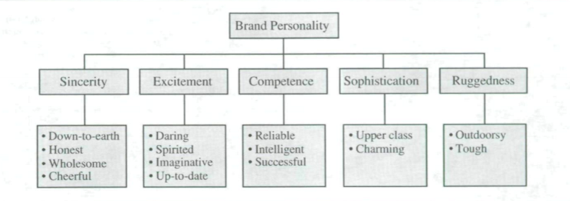

3) Perceptual Map
3.1) Perceptual Map Survey setup
Table 6: Survey setup
 | Variable | Description | Scale
Demographic Information | Age | How old are you?  Please select the age gap that encapsulates your current age. | Under 18;  18-25;  26-35;  36-45;  46-58;  Above 59
 | Gender | What gender do you identify as? | Woman;  Man;  Other
 | Nationality | What is your nationality? | Portuguese;  German;  French;  Other
Service Characteristics This section of the survey aims to assess the perception that respondents have of the logistics and cultural activities provided by the theatre, cinema, museums and concerts in Portugal. | Frequency | How frequently do you attend the following cultural events? | Once a year;  2-3 times a year;  4 or more times a year;  Never been
 | Category | To what category do you associate each one of these cultural events? | Fun;  Formal;  Educational;  Boring
 | Price | How satisfied are you with the Prices* in Portugal for the following cultural events?  Average ticket price for Theatre in Portugal is 11,8€ (2020).  Average ticket price for Cinema in Portugal is 6,6€ (2020).  Average ticket price for Concerts in Portugal is 20,4€ (2020).  Average ticket price for Museums in Portugal is not defined.  *It does not include promotions/discounts | 1-Not Satisfied  To 4-Highly Satisfied;  Never been
 | Service Quality | How satisfied are you with the overall Service Quality in these cultural events in Portugal?  By service quality, it is understood: how easily you can obtain your tickets, the quality of the facilities, security during the events, the plays/movies/exhibition/band/musician, how punctual it is,... (Everything that happens from the moment the client buys the ticket until the end of the play). | 1-Not Satisfied  To 4-Highly Satisfied;  Never been
 | Promotions | How satisfied are you with the Promotions in these cultural events in Portugal?  By promotions, it is understood: discounts set (family pack, senior discount, student discount, etc.), periodic promotions, events' partnerships,.. | 1-Not Satisfied  To 4-Highly Satisfied;  Never been
 | Channels of Communication | How satisfied are you with the Channels of Communication of these cultural events in Portugal?  By channels of communication, it is understood: social media ads, posters, tv advertisement,... | 1-Not Satisfied  To 4-Highly Satisfied;  5- Never been
 | Variety of Offers | How satisfied are you with the current Variety of Offers in these cultural events in Portugal?  By diversity of options, it is understood: number of different genres of plays, variety of movie genres, availability of different types of exhibitions in the museums, number of different genres of musicians and bands,... | 1-Not Satisfied  To 4-Highly Satisfied;  5- Never been
 | Customer Service | How satisfied are you with the overall Customer Service in these cultural events in Portugal?  By customer service, it is understood: quality of employee's services (e.g: orientating people to their seats), customer support (dealing with client’s complaints), efficiency tracking problems and solving them,... | 1-Not Satisfied  To 4-Highly Satisfied;  5- Never been
 | Location and the Conditions of the Facilities | How satisfied are you with the Location and the Conditions of the Facilities of these cultural events in Portugal?  By location & facility conditions, it is understood: accessibility, place of the several events (city-center or far away) and amenities of the spaces (e.g.: free parking or not, elevators for elderly and disabled people, etc.). | 1-Not Satisfied  To 4-Highly Satisfied;  5- Never been
Brand Personality  This section of the survey aims to evaluate to each personality dimension do the respondents associate theatre, cinema, museums and concerts in Portugal. | Rugged | How Rugged do you think these cultural events are?  By ruggedness, it is understood: strong presence/structure, vigour, resistance, portrays a sense of strength, firmness,… | 1-Very Frail  To 4-Very Sturdy;  Never been
 | Sincere | How Sincere do you believe these cultural events are?  By sincerity, it is understood: the feeling of originality, honesty, emotional, influence, trust. | 1-Very Unreliable  To 4-Very Sincere;  Never been
 | Enthusiastic | How Enthusiastic do you imagine these cultural events to be?  By enthusiasm, it is understood: challenging, young, creative, unique, spirited. | 1-Very Dull  To 4-Very Enthusiastic;  Never been
 | Competent | How Competent do you consider these cultural events to be?  By competence, it is understood: reliability, confidence, coherence, success, intelligence, successful. | 1-Very Incompetent  To 4-Very Competent;  Never been
 | Sophisticated | How Sophisticated do you suppose these cultural events are?  By sophistication, it is understood: modern, charming, elegant, glamorous. | 1-Very Basic  To 4-Very Sophisticated;  Never been

3.2) Perceptual Map Results
Table 7: Respondents age groups and their corresponding percentage distribution (N=146)
Age
 |  | Frequency | Percent | Valid Percent | Cumulative Percent
Valid | 1 | 18 | 12.3 | 12.3 | 12.3
Valid | 2 | 71 | 48.6 | 48.6 | 61.0
Valid | 3 | 17 | 11.6 | 11.6 | 72.6
Valid | 4 | 40 | 27.4 | 27.4 | 100.0
Valid | Total | 146 | 100.0 | 100.0

Table 8: Respondents gender and their corresponding percentage distribution (N=146)
Gender
 |  | Frequency | Percent | Valid Percent | Cumulative Percent
Valid | 1.00 | 90 | 61.6 | 61.6 | 61.6
Valid | 2.00 | 55 | 37.7 | 37.7 | 99.3
Valid | 3.00 | 1 | .7 | .7 | 100.0
Valid | Total | 146 | 100.0 | 100.0

Figure 24: Respondents histogram gender distribution (N=146)
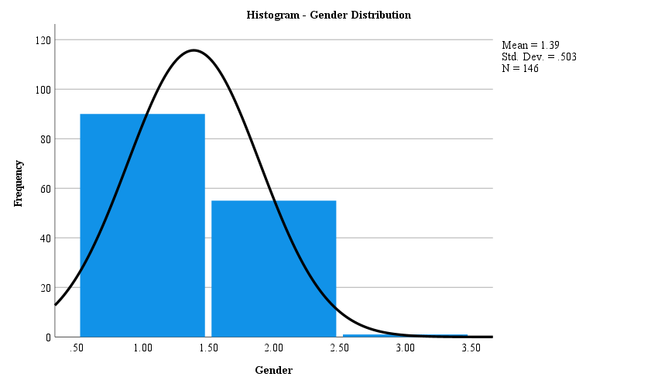
1= Women
2= Men
3= Other

Figure 25: Respondents histogram nationality distribution (N=146)

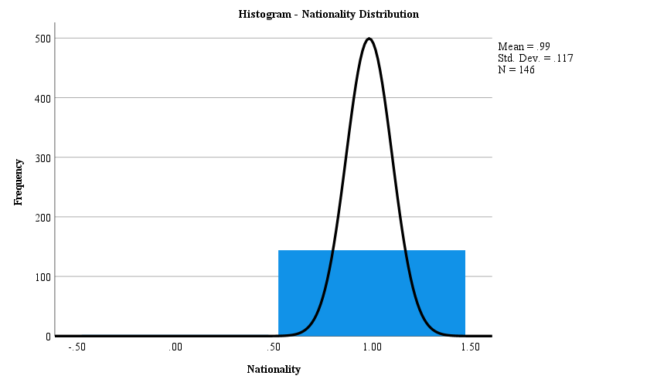
0= No response
1= Portuguese
´

Table 9: Frequency distribution of nationality

Nationality
 |  | Frequency | Percent | Valid Percent | Cumulative Percent
Valid | .00 | 2 | 1.4 | 1.4 | 1.4
Valid | 1.00 | 144 | 98.6 | 98.6 | 100.0
Valid | Total | 146 | 100.0 | 100.0

Table 10: Respondents frequency of attendance to theatre and their corresponding percentage distribution (N=146)
Frequency_Theatre
 |  | Frequency | Percent | Valid Percent | Cumulative Percent
Valid | 1.00 | 84 | 57.5 | 57.5 | 57.5
Valid | 2.00 | 44 | 30.1 | 30.1 | 87.7
Valid | 3.00 | 18 | 12.3 | 12.3 | 100.0
Valid | Total | 146 | 100.0 | 100.0

Table 11: Respondents frequency of attendance to cinema and their corresponding percentage distribution (N=146)
Frequency_Cinema
 |  | Frequency | Percent | Valid Percent | Cumulative Percent
Valid | .00 | 2 | 1.4 | 1.4 | 1.4
Valid | 1.00 | 30 | 20.5 | 20.5 | 21.9
Valid | 2.00 | 52 | 35.6 | 35.6 | 57.5
Valid | 3.00 | 62 | 42.5 | 42.5 | 100.0
Valid | Total | 146 | 100.0 | 100.0

Table 12: Respondents frequency of attendance to museums and their corresponding percentage distribution (N=146)
Frequency_Museums
 |  | Frequency | Percent | Valid Percent | Cumulative Percent
Valid | .00 | 8 | 5.5 | 5.5 | 5.5
Valid | 1.00 | 56 | 38.4 | 38.4 | 43.8
Valid | 2.00 | 54 | 37.0 | 37.0 | 80.8
Valid | 3.00 | 28 | 19.2 | 19.2 | 100.0
Valid | Total | 146 | 100.0 | 100.0

Table 13: Respondents frequency of attendance to concerts and their corresponding percentage distribution (N=146)
Frequency_Concerts
 |  | Frequency | Percent | Valid Percent | Cumulative Percent
Valid | .00 | 10 | 6.8 | 6.8 | 6.8
Valid | 1.00 | 50 | 34.2 | 34.2 | 41.1
Valid | 2.00 | 62 | 42.5 | 42.5 | 83.6
Valid | 3.00 | 24 | 16.4 | 16.4 | 100.0
Valid | Total | 146 | 100.0 | 100.0

Table 14: Respondents category association to theatre and their corresponding percentage distribution (N=146)
Category_Theatre
 |  | Frequency | Percent | Valid Percent | Cumulative Percent
Valid | 1.00 | 69 | 47.3 | 47.3 | 47.3
Valid | 2.00 | 39 | 26.7 | 26.7 | 74.0
Valid | 3.00 | 33 | 22.6 | 22.6 | 96.6
Valid | 4.00 | 5 | 3.4 | 3.4 | 100.0
Valid | Total | 146 | 100.0 | 100.0

Table 15: Respondents category association to cinema and their corresponding percentage distribution (N=146)
Category_Cinema
 |  | Frequency | Percent | Valid Percent | Cumulative Percent
Valid | 1.00 | 139 | 95.2 | 95.2 | 95.2
Valid | 2.00 | 5 | 3.4 | 3.4 | 98.6
Valid | 3.00 | 2 | 1.4 | 1.4 | 100.0
Valid | Total | 146 | 100.0 | 100.0

Table 16: Respondents category association to museums and their corresponding percentage distribution (N=146)
Category_Museums
 |  | Frequency | Percent | Valid Percent | Cumulative Percent
Valid | 1.00 | 6 | 4.1 | 4.1 | 4.1
Valid | 2.00 | 14 | 9.6 | 9.6 | 13.7
Valid | 3.00 | 117 | 80.1 | 80.1 | 93.8
Valid | 4.00 | 9 | 6.2 | 6.2 | 100.0
Valid | Total | 146 | 100.0 | 100.0

Table 17: Respondents category association to concerts and their corresponding percentage distribution (N=146)
Category_Concerts
 |  | Frequency | Percent | Valid Percent | Cumulative Percent
Valid | 1.00 | 138 | 94.5 | 94.5 | 94.5
Valid | 2.00 | 3 | 2.1 | 2.1 | 96.6
Valid | 4.00 | 5 | 3.4 | 3.4 | 100.0
Valid | Total | 146 | 100.0 | 100.0

Figure 34: Cumulative Variance Screen Plot - attributes

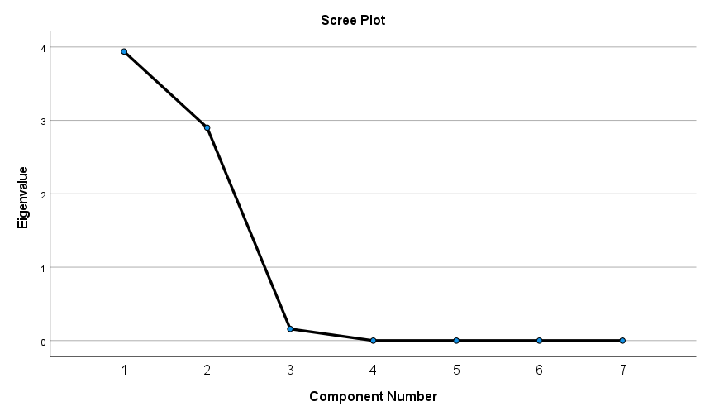

Figure 35: Cumulative Variance Screen Plot - personality
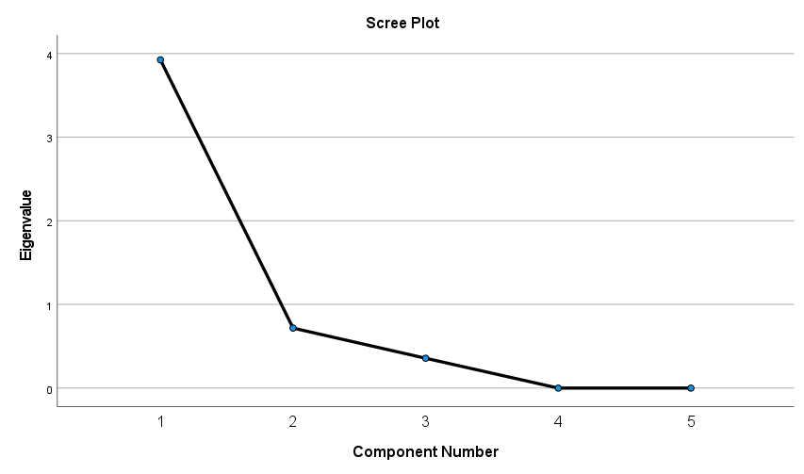
Table 22: Cultural Activities Coordinates within Attributes Analysis
 | Dimension 1 | Dimension 2
Theatre | 0.88 | -0.86
Cinema | -0.12 | 1.33
Museums | 0.60 | 0.21
Concerts | -1.36 | -0.68

Table 23: Cultural Activities Coordinates within Personality Analysis
 | Dimension 1 | Dimension 2
Theatre | 0.47 | -1.47
Cinema | -0.86 | 0.40
Museums | 1.19 | 0.33
Concerts | -0.79 | 0.75

Bibliography
Keller, Kevin L. 2001. Building Customer-Based Brand Equity: A Blueprint for Creating Strong Brands. Cambridge: Marketing Science Institute.
Aaker, Jennifer L. 1997. “Dimensions of Brand Personality.” Journal of Marketing Research 347-356.
Tarver, Evan. 2021. Investopedia. 1 September. Accessed November 19, 2022. https://www.investopedia.com/terms/b/brand-personality.asp.
Mercadal, Trudy. 2021. “Brand Personality.” Salem Press Encyclopedia.
Cliff, Norman. 1988. The eigenvalues-greater-than-one rule and the reliability of components. Accessed 2022. https://psycnet.apa.org/record/1988-15792-001.
Nemoto, T, and D Beglar. 2014. “Developing Liker-Scale Questionnaires.” JALT2013 Conference Proceedings. Tokyo: JALT. 1-8. https://jalt-publications.org/sites/default/files/pdf-article/jalt2013_001.pdf.
Bandeira, Ana Raquel Almeida Santos. 2020. Captação e formação de públicos no teatro: o Projeto Primeira Vez. Master's Thesis, Lisbon: ISCTE.
European Investment Fund. 2022. Market Analysis of the Cultural and Creative Sectors in Europe: A Sector to Invest In. Study, European Investment Fund.
Dinis, Rita, and Sara Otto Coelho. 2016. Mais dinheiro para a Cultura mas... ainda só vale 0,1% do PIB. 15 October. Accessed October 12, 2022. https://observador.pt/2016/10/15/mais-dinheiro-para-a-cultura-mas-ainda-so-vale-01-do-pib/.
Garcia, José Luís, João Teixeira Lopes, Teresa Duarte Martinho, José Soares Neves, Rui Telmo Gomes, and Vera Borges. 2016. Mapping cultural policy in Portugal: From incentives to crisis. International Journal of Cultural Policy, 8.
Lourenço, Jorge. 2012. Sobre o investimento público no teatro em Portugal - Estatística e contra-estatística. 27 May. Accessed October 8, 2022. https://www.esquerda.net/artigo/sobre-o-investimento-p%C3%BAblico-no-teatro-em-portugal-estat%C3%ADstica-e-contra-estat%C3%ADstica/23270#sdfootnote7anc.
PPMI, KEA European Affairs. 2022. The situation of theatres in the EU Member States. Study, European Comission.
Direção-Geral das Artes. 2022. PROGRAMA DE APOIO SUSTENTADO ÀS ARTES 2023-26 COM AUMENTO DE VERBA DE 114%. 26 September. Accessed October 13, 2022. https://www.dgartes.gov.pt/pt/node/5649.
Bowen, William J. Baumol, and William G. 1968. Performing arts: the economic dilemma. A study of problems common to theater, opera, music and dance. Study, Cambridge: M.I.T. Press.
Mikuličin, A. 2013. “Only in Croatia and Germany is the popularity of theater growing.”
Helm, R. 2009. Marketing: Strategische Analyse und Marketorientierte Umsetzung. Stuttgart: Lucius & Lucius Verlagsgesellschaft mbH (Publishing Comapny).
Schweiger, G., and G. Schrattenecker. 2009. Werbung: Eine Einführung. Stuttgart: Lucius & Lucius Verlagsgesellschaft mbH.
Rekettye, G., and and Liu J. 2001. “Segmenting the Hungarian Automobile Market Brand Using Perceptual And Value Mapping.” Journal of Targeting, Measurement and Analysis for Marketing 241–253.
Hair, J. F., R. E. Anderson, R. L. Tatham, and W. C. Black. 1992. Multivariate data analysis. New York: Macmillan.
Gower, J., P. J. F. Groenen, M. Van de Velden, and K. Vines. 2010. Perceptual Maps: The Good, the Bad and the Ugly. ERIM Report, SSRN (online).
Chadha, S. K., and D Kapoor. 2008. “An Attribute Based Perceptual Mapping Of The Selected Private Life Insurance Companies: An Empirical Study In Ludhiana.” VISION - The Journal Of Business Perspective.
Gigauri, Iza. 2019. “Perceptual mapping as a marketing research tool for brand positioning.” International Journal of Economics and Management Studies.
Dash, A. 2015. “Quality-Based Perceptual Mapping of Leading Banks in India: An Empirical Study.” The IUP Journal of Management Research 14 (4).
Najafizadeh, Nadereh Sadat, Mohammad Elahi, Abdolreza Moemeni, and Zahra Lotfi. 2012. “A model for brand positioning of hygienic products using the most effective factors on competitive position and perceptual map technique.” African Journal of Business Management 6 (27): 8102-8117.
Chiang, I-Ping, Chih-Ying Lin, and Kaisheng M. Wang. 2008. “Building online brand perceptual map.” CyberPsychology & Behavior 11 (5): 607-610.
PORDATA. 2022. Quantas pessoas assistem, em média, a cada exibição de teatro? . 30 September. Accessed October 12, 2022. https://www.pordata.pt/Portugal/Teatro+n%c3%bamero+m%c3%a9dio+de+espectadores+por+sess%c3%a3o-597.
—. 2022. Quantas são as exibições de teatro, concertos e outros eventos artísticos ao vivo e quanto público têm? . 30 September. Accessed October 12, 2022. https://www.pordata.pt/Portugal/Espect%c3%a1culos+ao+vivo+sess%c3%b5es+e+espectadores-583.
Lusa/TSF. 2022. Nove em cada dez portugueses têm "baixo consumo cultural". 16 Fevereiro. Accessed October 15, 2022. https://www.tsf.pt/portugal/cultura/nove-em-cada-dez-portugueses-tem-baixo-consumo-cultural-14593053.html.
Teatro Nacional D. Maria II. 2018. Plano de Atividades e Orçamento 2018. Budget, Lisbon: Teatro Nacional D. Maria II.
Observatório Português das Atividades Culturais. 2022. Teatro em Portugal. 7 August. Accessed October 14, 2022. https://www.opac.cies.iscte-iul.pt/teatro-em-portugal.
DN/Lusa. 2020. Espaços culturais antecipam horários de eventos para responder a restrições . 3 November. Accessed October 14, 2022. https://www.dn.pt/cultura/espacos-culturais-antecipam-horarios-de-eventos-para-responder-a-restricoes--12995350.html.
Maia, Marta. 2019. Descubra quanto custa um bilhete de cinema em Portugal . 11 October. Accessed October 14, 2022. https://www.e-konomista.pt/quanto-custa-um-bilhete-de-cinema/.
Indeed Editorial Team. 2022. Service Quality: Definition, 5 Dimensions and Implementation . 16 June. Accessed October 15, 2022. https://www.indeed.com/career-advice/career-development/service-quality.
N., Ramya. 2019. “SERVICE QUALITY AND ITS DIMENSIONS.” EPRA International Journal of Research and Development 40-41.
NOS. 2022. Aproveite a oportunidade e use o Cartão NOS em formatos especiais . Accessed October 17, 2022. https://www.nos.pt/particulares/pacotes/paginas/cartao-nos.aspx.
Lourenço, Paulo. 2022. Viagem aos 100 anos do Parque Mayer. 14 June. Accessed October 17, 2022. https://www.noticiasmagazine.pt/2022/viagem-aos-100-anos-do-parque-mayer/historias/276677/.
David, Cara Joy. 2022. Is Streaming Theatre Over? 28 November. Accessed November 28, 2022. https://www.broadwayworld.com/article/Is-Streaming-Theatre-Over-20221128.
Lévy-Garboua, Louis, and Claude Montmarquette. 2002. The Demand for the Arts. London: Handbook of Cultural Economics.
Heilbrun, James, and Charles Gray. 2001. The Economics of Art and Culture. Canadian Journal of Sociology.
Bourdieu, Pierre. 1984. A Social Critique of the Judgement of Taste. Cambridge, Massachusetts: Harvard University Press.
Kapferer, Jean-Noël. 2012. The New Strategic Brand Management: Advanced Insights and Strategic Thinking. Kogan Page.
Berger, Jonah A., Michaela Draganska, and Itamar Simonson. 2006. The Influence of Product Variety on Brand Perception and Choice. INFORMS.
Agustí, Daniel Paül i, Teresa Guilera, and Montserrat Guerrero Lladós. 2022. “Gender differences between the emotions experienced and those identified in an urban space, based on heart rate variability.” Cities.
Johnston, Keith M., Ed Vollans, and Fred L. Greene. 2016. “Watching the trailer: Researching the film trailer audience.” 56-85.
Fort, Rodney. 2004. “Inelastic sports pricing .” In Managerial and Decision Economics, 87-94. Wiley.
INE. 2021. Estatísticas da Cultura 2020. Lisboa: Instituto Nacional de Estatística.
Maehle, Natalia, Cele Otnes, and Magne Supphellen. 2011. “Consumers' perceptions of the dimensions of brand personality.” Journal of Consumer Behaviour 290-303.
Brockett, Oscar G., and Franklin J. Hildy. 2007. History of the Theatre. Pearson.
Eurostat. 2018. “ersons working as creative and performing artists, authors, journalists and linguists (with EU-28).” Cultural Employment. Accessed November 2022. https://ec.europa.eu/eurostat/documents/341465/8484734/cult_emp_art_EU_28.csv/b92feed8-1d33-aca6-0418-c6bdb223987e.
Angione, Marina. 2017. Consumer Response to different pricing systems in the Performing Arts' industry. Maste's Thesis, Lisbon: Universidade Católica Portuguesa.
Sarstedt, Erik Mooi & Marko. 2010. A concise Guide to Market Research. 14 October. Accessed 2022. https://link.springer.com/chapter/10.1007/978-3-642-12541-6_8.

