Effect of ultrasonic spot welding on the mechanical behaviour of NiTi shape memory alloys
W. Zhang¹, S.S. Ao^{1,*}, J.P. Oliveira^{2, 3}, Z. Zeng^{4,*}, Z. Luo¹, Z.Z. Hao¹
- School of Material Science and Engineering, Tianjin University, Tianjin 300072, China
- Department of Materials Science and Engineering, The Ohio State University, 1248 Arthur E. Adams Drive, Columbus, OH 43221, USA
- UNIDEMI, Departamento de Engenharia Mecânica e Industrial, Faculdade de Ciências e Tecnologia, Universidade Nova de Lisboa, 2829-516 Caparica, Portugal
- School of Mechatronics Engineering, University of Electronic Science and Technology of China, Sichuan 221116, China
Abstract
NiTi shape memory alloy joints were obtained using ultrasonic spot welding and the effect of this manufacturing process on the mechanical behaviour was investigated. Comparing to the as-received NiTi, the welded material presented increasing austenite transformation temperatures and decreasing martensite finish transformation temperature. No detrimental intermetallic compounds were found at the weld interface due to the advantages of this solid-state welding technology. A typical interfacial fracture mode was observed at the fracture surface with numerous cleavage planes and micro cracks. Additionally, plastically deformed regions were observed in the weld spot. Ultrasonic welding can be used to effectively join NiTi shape memory alloys.
Keywords: NiTi shape memory alloy; Ultrasonic spot welding; Phase transformation; Phase composition; Interfacial fracture

1. Introduction
NiTi is one of the most important shape memory alloys due to its functional properties, namely superelasticity and shape memory effect, high strength and biocompatibility, and it has been widely applied in the automotive, biomedical and aeronautical fields as actuators, sensors and structural elements [1,2]. To achieve successful fabrication of complex parts with NiTi, it is necessary to develop effective and efficient processing technologies. Mechanical crimping is a common method used to achieve the connection of NiTi parts [3]. However, the poor workability of NiTi alloys requires the development of proper welding and joining methods which can ensure that the functional properties of these alloys are kept after processing [4]. The main problem of the traditional fusion welding techniques for NiTi is the formation of brittle intermetallic compounds (IMCs), such as Ti₂Ni, which deteriorate the mechanical properties of the joints [5-7]. Fusion-based welding methods can also result in significant changes in transformation behaviour from the austenitic to the martensitic phase [5,8,9], which may significantly affect the application conditions of the welded NiTi structures.
Since NiTi is highly sensitive to the temperature history experienced during thermomechanical processing [10], a low heat input welding process can restrict the physical deterioration of the alloy properties, especially the shape memory effect and superelasticity, in the weld zone [11]. Consequently, to achieve sound structures based on these materials, several solid-state processes, such as explosive welding [12], friction stir welding [13], brazing and soldering [14] have been applied to join NiTi. Ultrasonic spot welding (USW) is a rapidly developing non-melting joining method with advantages of a shorter welding time, a lower energy consumption and no requirement for filler metal, which makes the process more efficient [15,16]. Therefore, USW is especially suitable for welding of small parts and thin materials, which make this process particularly interesting to weld materials with reduced weldability such as NiTi. Some researchers have attempted to improve the bonding quality of metallic matrix composites reinforced with NiTi wires using ultrasonic additive manufacturing [17,18]. To the best of the author’s knowledge, there are no reports on the weldability and mechanical behaviour of NiTi joints obtained by USW. For this reason, we carried out a detailed experimental study on the effect of USW on NiTi shape memory alloys, which could develop potential applications in distinct smart materials and structures. The effects of USW process on NiTi material performance are investigated in detail.

2. Methods
50.8Ni-Ti (at. %) sheets with an approximate thickness of 100 μm were used. The as-received sheets were subjected to cold-rolling and stress-relieving annealing by heat treatment at 400°C for 45 min in Ar atmosphere. Before welding, the oxidized layer on the material surface was removed by etching in a mixed solution of 7.5% HF, 20% HNO₃ and 72.5% H₂O (in volume) for 40-50 s. Specimens of a 100 mm length and 25 mm width were machined.
The USW process was carried out by using a SONICS MW-20 machine with a sonotrode tip size of 8 mm × 8 mm. The USW system is schematically shown in Figure 1(a). The ultrasonic vibration direction is perpendicular to the rolling direction of NiTi, and the schematic diagram of weldment obtained is shown in Figure 1(b).

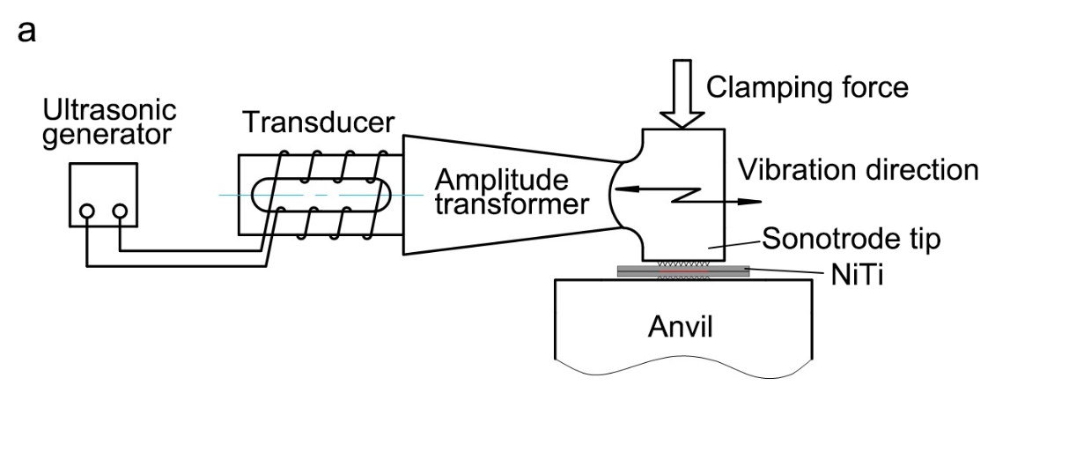
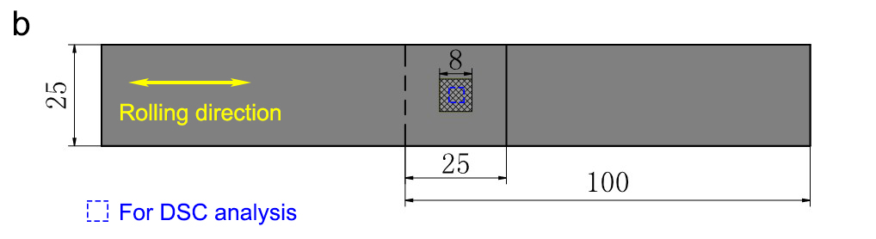
Figure 1. (a) Schematic illustration of USW, (b) schematic diagram and dimensions of NiTi weldment.

Initially, trial experiments were performed to optimize the welding parameters window: different welding energies (500, 750 and 1000 J), amplitudes (40, 50 and 60 μm) and pressures (0.30, 0.34 and 0.38 MPa) were adjusted by using the ultrasonic welder. A L9 orthogonal test was carried out and the detailed experimental parameters are listed in Table 1. According to the data analysis of the welds quality in terms of their mechanical resistance, it can be concluded that the welding energy has the most significant influence on the weld quality. Therefore, the main process parameters selected were a welding amplitude of 60 μm and a constant clamping pressure of 0.38 MPa with the energy varying from 500 J to 2000 J.

Table 1 - L9 orthogonal array with inputs and responds values
Exp. No | Welding energy (J) | Clamping pressure (MPa) | Vibration amplitude (μm) | Failure load (N)
1 | 500 | 0.30 | 40 | 76.4
2 | 500 | 0.34 | 50 | 77
3 | 500 | 0.38 | 60 | 83
4 | 750 | 0.30 | 50 | 100
5 | 750 | 0.34 | 60 | 105.6
6 | 750 | 0.38 | 40 | 77.8
7 | 1000 | 0.30 | 60 | 148.6
8 | 1000 | 0.34 | 40 | 93.4
9 | 1000 | 0.38 | 50 | 142

The phase transformation temperatures of the NiTi alloy were measured by differential scanning calorimeter (DSC). Test specimens were cut across the welding region with a total mass of approximately 10 mg. The analysed region is depicted by the blue dotted line in Figure 1(b). DSC measurements were performed at a controlled heating/cooling rate of 10 °C/min from –90 °C to 250 °C. Tensile lap shear tests were performed with a constant displacement rate of 0.1 mm/min at room temperature, and the tensile direction was set perpendicular to the direction of ultrasonic vibration. Dimensions of the tensile test specimen are given in Figure 1(b) and three specimens for each welding condition were examined. The fracture surface was characterized by scanning electron microscopy (SEM), and the phase composition at the weld interfaces was identified by X-ray diffraction (XRD) analysis on the fracture surfaces of the tensile specimens.

3. Results and discussion
A typical macro-morphology of the top surface and the cross-section for the ultrasonic spot welded NiTi joint is presented in Figure 2(a)-(c), and obvious indentations due to the effect of sonotrode tip and anvil can be observed. The cross-section of the weld exhibits a partially bonded interface with the existence of weak bonded regions along the weld interface as shown in Figure 2(c).

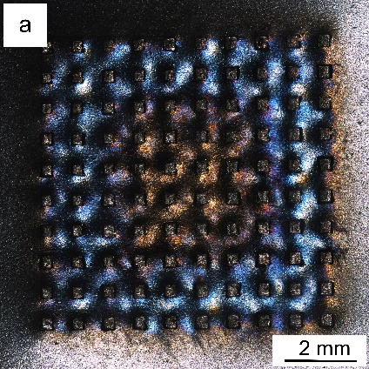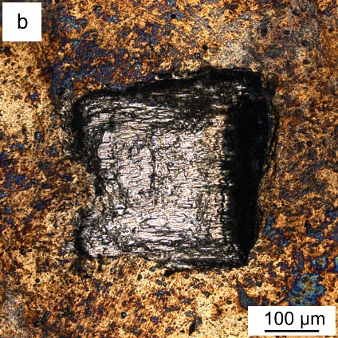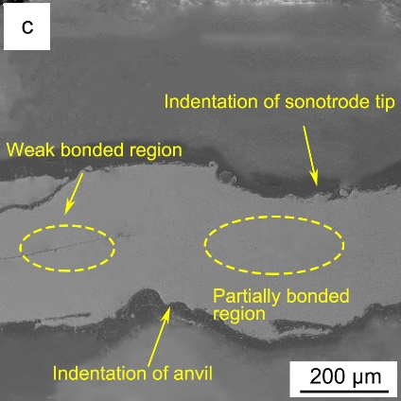
Figure 2. (a) Macro-morphology of top surface for NiTi weld produced at 500 J, (b) magnified image of a welded spot in (a), (c) cross-section of ultrasonic spot welded NiTi.

Figure 3(a) shows the thermal transformation behaviour of the base material (BM) and welded samples obtained via DSC analysis. Since there are no changes in the phase transformation behavior beyond room temperature, the temperature scale of DSC analysis has been stopped at 100 °C rather than 250 °C (the maximum heating temperature) to make the transformation peaks are clear and visible. Upon cooling, the BM exhibits a one-step transformation from B2 austenite to B19’ martensite, which exhibits the typical behaviour of a NiTi alloy [19]. At room temperature the base material is fully austenitic. In opposition to the DSC results of the base material, the samples welded at different energies present two exothermic peaks, which potentially indicates the presence of R-phase transformation during cooling before the martensitic transformation. The partial overlap between the first exothermic peak during cooling and the endothermic peak upon heating, further emphasizes the possibility of R-phase is present in the welded joint because of the USW process. For Ni-rich NiTi, it is known that the presence of R-phase is associated with the formation of the Ni₄Ti₃ precipitates, as reported in the literature [10,20,21]. In this study, it is possible that the USW process contributed to the formation of Ni₄Ti₃ precipitates, which results in the occurrence of R-phase transformation.
The detailed phase transformation characteristics, that is, the initial and final temperatures of austenite (A_{s}, A_{f}), R-phase (R_{s}, R_{f}) and martensite (M_{s}, M_{f}) were determined by the intersection of the tangents to the slope of a peak with a baseline, according to the ASTM-F2004-00 standard, and the results are plotted in Figure 3(b). The calculated values show that the martensite to austenite transformation temperatures of the welded region increased when compared to the base material. Such, can be related to changes in the chemical composition of the joint, namely trough preferential Ni depletion due to Ni-rich precipitation, which can increase the transformation temperatures in NiTi shape memory alloys [2]. Furthermore, residual stresses, which would occur from the welding process may also drastically change the transformation temperatures of the welded joint [22, 23]. Such change in the transformation temperatures may be critical for the functional properties of the welded joints [24]. However, despite the increase of the transformation temperatures of the welded joint, the A_{f} temperature in all welded samples is still below room temperature.
In addition, decreasing martensite transformation temperatures can also be observed for the ultrasonic spot welded NiTi welds. The occurrence of such phenomenon is associated with local stress fields caused by thermo-mechanical effect of the USW process, which increases the driving force for phase change and hinders the martensitic transformation. Additionally, the existence of containments such as oxygen, nitrogen, and hydrogen in the welded materials may also affect the transformation temperature and the shape memory effect [8].
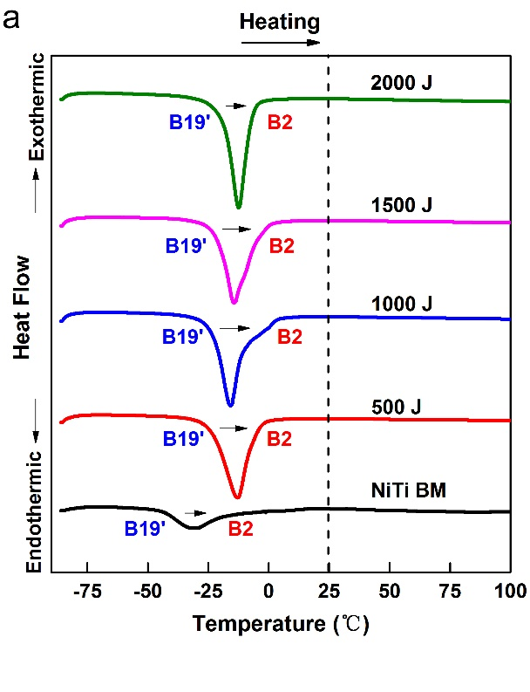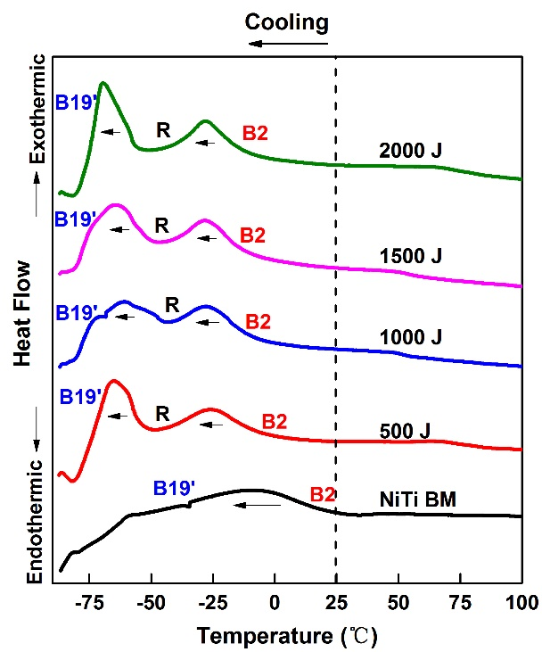
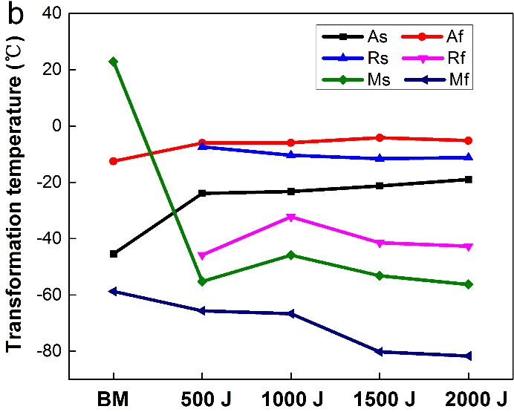
Figure 3. (a) DSC curves (heating on the left, cooling on the right; and B19’ for martensite, B2 for austenite) and (b) phase transformation temperatures of NiTi base material and different welded samples.

XRD was conducted at room temperature to evaluate the influence of USW on the stable phases of the NiTi joint, and the diffraction patterns of BM and welds obtained at different parameters are shown in Figure 4. The indexed pattern of the BM and welds are similar and consist of B2 cubic austenite only, without traces of B19’ monoclinic martensitic phase. No intermetallic phases, such as Ti₂Ni, which are usually formed during some fusion welding processes [5-7], were detected in the weld region. These results are consistent with the DSC results, where it was expected that both the welded joints and the base material would be fully austenitic, despite the differences in the A_{f} temperatures of both regions. It is noteworthy that no Ni₄Ti₃ precipitates was detected by XRD due to the potential low volume fraction (since the thermal cycle is very short), or the peak intensity is too low to differ from background noise. Thus, further microstructural analysis is needed to identify and observe the presence of precipitates in the joints.
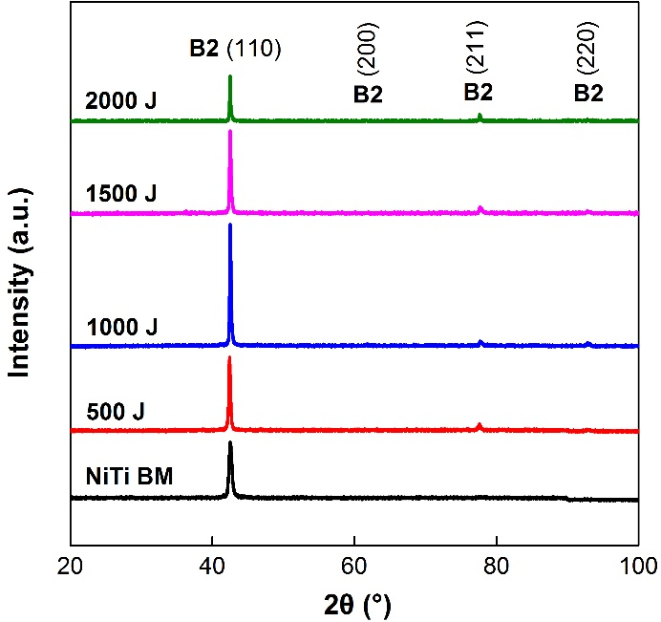
Figure 4. XRD patterns of NiTi base material and fracture surfaces of different joints.

The fracture location of all the joints in this study occurred at the welded interface, and Figure 5 presents the tensile test results, a schematic diagram of fracture mode and the microscopic fracture surface of the tensile test sample, which exhibits a typical interfacial fracture mode and is characteristic of a brittle fracture.

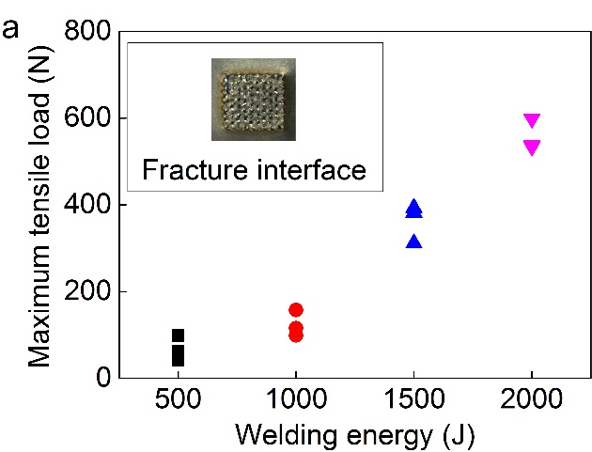
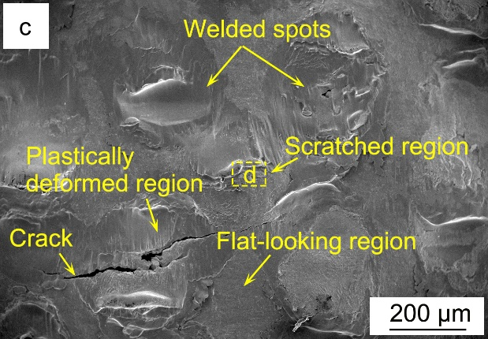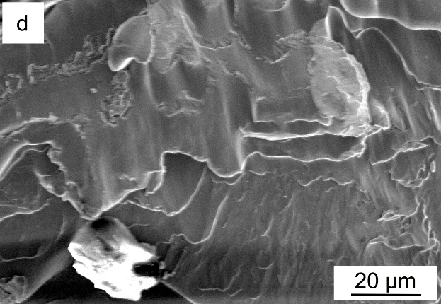
Figure 5. (a) Tensile test results of NiTi welded at different welding energies, (b) schematic diagram of fracture mode, (c) microscopic photographs of fractured surface, (d) magnified portion of d in (c).

From Figure 5(a), it can be noticed that the maximum tensile load of NiTi joints exhibited a gradually increasing trend as the welding energy increased, and the 2000 J joint showed the highest tensile strength with a mean value of 556.8 N. The lower failure load of ultrasonic spot welded NiTi joints compared to the base material (1063 N) is attributed to the partially bonded weld interface, which can bear limited load during the tensile shear test. Figure 5(c) shows that some micro cracks were presented in the welded spot at a higher welding energy of 2000 J because of its direct contact with the sonotrode tip. The microstructures of the scratched region and plastically deformed region presented numerous cleavage planes. The fracture surface in the region around the welded spot is significantly smoother macroscopically. These flat-looking regions, whose relative locations are far from the point of the sonotrode tool, are formed due to the reduced effect of ultrasonic vibration, and only some particles bind on the material surface.
The plastically deformed zone in the welded spot indicates that, during the welding process, the NiTi interface is heated by ultrasonic vibration friction to a certain temperature so that shear softening is induced, which requires further investigation.

4. Conclusions
In the present study, the influence of ultrasonic spot welding on mechanical properties of NiTi shape memory alloys was analyzed. The following major conclusions can be drawn:
1. Ultrasonic spot welding has a significant effect on the phase-transformational behaviour of NiTi, with an increase in the A_{f} temperatures occurring in the welded joint for all welding parameters tested.
2. Despite the change in the transformation temperatures, both the base material and welded joint were still fully austenitic at room temperature which was confirmed by X-ray diffraction analysis.
3. All joint fractures occurred at the weld interface. Cracks and a plastically deformed zone were observed in the welded spot.

Acknowledgements
This work was supported by Natural Science Foundation of China (No. 51775091, 51405335 & 51575383) and Science and technology project of Guangdong Province (No. 2013B090600149). JPO acknowledges Fundação para a Ciência e a Tecnologia (FCT - MCTES) for its financial support via the project PEst-OE/EME/UI0667/2014.

References:
1. Jani JM, Leary M, Subic A, et al. A review of shape memory alloy research, applications and opportunities. Mater Des. 2014;56:1078-1113.
2. Otsuka K, Ren X. Physical metallurgy of Ti-Ni-based shape memory alloys. Prog Mater Sci. 2005;50:511-678.
3. Zeng Z, Panton B, Oliveira JP, et al. Dissimilar laser welding of NiTi shape memory alloy and cooper. Smart Mater Struct. 2015;24:125036.
4. Oliveira JP, Miranda RM, Braz Fernandes FM, Welding and joining of NiTi shape memory alloys: a review. Prog Mater Sci. 2017;88:412-466.
5. Yang D, Jiang HC, Zhao MJ, et al. Microstructure and mechanical behaviours of electron beam welded NiTi shape memory alloys. Mater Des. 2014;57:21-25.
6. Fox G, Hahnlen R, Dapino MJ. Fusion welding of nickel-titanium and 304 stainless steel tubes: Ⅱ. tungsten inert gas welding. J Intell Mater Syst Struct. 2013;24:962-972.
7. Tam B, Khan MI, Zhou Y. Mechanical and functional properties of laser-welded Ti-55.8 wt pct Ni nitinol wires. Metall Mater Trans A. 2011;42:2166-2175.
8. Chan CW, Man HC, Yue TM. Effects of process parameters upon the shape memory and pseudo-elastic behaviors of laser-welded NiTi thin foil. Metall Mater Trans A. 2011;42:2264-2270.
9. Oliveira JP, Braz Fernandes FM, Miranda RM, et al. Effect of laser welding parameters on the austenite and martensite phase fractions of NiTi. Mater Charact. 2016;119:148-151.
10. Ben Fraj B, Gahbiche A, Zghal S, et al. On the influence of the heat treatment temperature on the superelastic compressive behavior of the Ni-rich NiTi shape memory alloy. J Mater Eng Perform. 2017;26:5660-5668.
11. Frick CP, Ortega AM, Tyber J, et al. Thermal processing of polycrystalline NiTi shape memory alloys. Mater Sci Eng A. 2005;405:34-49.
12. Xing TY, Zheng YJ, Cui LS. Transformation and damping characteristics of NiTi/NiTi alloys synthesized by explosive welding. Mater Trans. 2006;47:658-660.
13. Mani Prabu SS, Madhu HC, Perugu Chandra S, et al. Microstructure, mechanical properties and shape memory behaviour of friction stir welded nitinol. Mater Sci Eng A. 2017;693:233-236.
14. Grummon DS, Shaw JA, Foltz J. Fabrication of cellular shape memory alloy materials by reactive eutectic brazing using niobium. Mater Sci Eng A. 2006;438-440:1113-1118.
15. Haddadi F, Abu-Farha F. Microstructural and mechanical performance of aluminium to steel high power ultrasonic spot welding. J Mater Process Technol. 2015;225:262-274.
16. Patel VK, Bhole SD, Chen DL. Ultrasonic spot welded AZ31 magnesium alloy: Microstructure, texture, and lap shear strength. Mater Sci Eng A. 2013;569:78-85.
17. Kong CY, Soar RC, Dickens PM. Ultrasonic consolidation for embedding SMA fibres within aluminium matrices. Compos Struct. 2004;66:421-427.
18. Friel RJ, Harris RA. Ultrasonic additive manufacturing a hybrid production process for novel functional products. Proc CIRP 6. 2013:35-40.
19. Tuissi A, Besseghini S, Ranucci T, et al. Effect of Nd-YAG laser welding on the functional properties of the Ni-49.6 at.% Ti. Mater Sci Eng A 1999;273- 275:813-817.
20. Wang X, Verlinden B, Humbeeck JV. Effect of post-deformation annealing on the R-phase transformation temperature in NiTi shape memory alloys. Intermetallics 2015;62:43-49.
21. Kus K, Brwczko T. DSC investigations of the effect of annealing temperature on the phase transformation behaviour in Ni-Ti shape memory alloy. Mater Phys Mech. 2010;9:75-83.
22. Liu Y, Galvin SP. Criteria for Pseudoelasticity in near-equiatomic NiTi shape memory alloys. Acta Mater. 1997;45:4431-4439.
23. Oliveira JP, Cavaleiro AJ, Schell N, et al. Effects of laser processing on the transformation characteristics of NiTi: A contribute to additive manufacturing. Scripta Mater. 2018, 152: 122-126.
24. Oliveira JP, Miranda RM, Schell N, et al. High strain and long duration cycling behaviour of laser welded NiTi sheets. Int J Fatigue. 2016;83:195-200.

